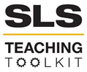 | Teaching Local/Global SDG Connections Though Case Studies
Discipline: All | Type: Discussion, In-class reading, Writing prompt | Time Commitment: 90 -120 minutes | Category: UN Sustainable Development Goals (SDGs)
OVERVIEW:
The UN’s Sustainable Development Goals (SDGs) are a collection of 17 interlinked global goals designed to be a “blueprint to achieve a better and more sustainable future for all” (United Nations). Students completing this lesson will be able to:
- Describe the goals and targets of SDGs Zero Hunger, Gender Equality, and Industry, Innovation and Infrastructure.
- Compare global and local examples of initiatives that advance these SDGs.
- Evaluate the efficacy of alternative approaches to advancing these SDGs.
This tool was contributed by Michelle Ramirez.
SUMMARY INSTRUCTIONS:
This teaching tool may be adjusted based on course focus & class length. The following instructions are suitable whether you choose to teach one SDG or all three.
- Before class, ask students to watch the following videos:
  - How We Can Make the World a Better Place (14:39) - Explanation of the SDGs and if they are achievable
  - SDG 2, Zero Hunger (1:52)
  - SDG 5, Gender Equality (1:23)
  - SDG 9, Industry, Innovation and Infrastructure (1:27)
- Ask students to create a post that answers this question: “how does this course’s subject matter relate to the SDG goal(s) and to Georgia Tech’s commitment to ‘making a positive impact in the lives of people everywhere’”? Consider using Note.ly or a discussion tool in Canvas.
- Begin class by sharing student responses and invite students to elaborate on their posts. Depending upon class size and classroom options, structure small group or whole group discussions of the videos using the questions below. See CTL’s Facilitating Group Discussion resources.
- Assign case studies as homework or read in class to facilitate an in-class discussion.
- (Optional) Following in-class discussion, ask students to complete a writing assignment, detailed below.
SLS STUDENT LEARNING OUTCOMES & ASSESSMENT:
The Serve-Learn-Sustain toolkit teaching tools are designed to help students achieve not only SLS student learning outcomes (SLOs), but the unique learning outcomes for your own courses. Reflection, concept maps, rubrics, and other assessment methods are shown to improve student learning. For resources on how to assess your students’ work, please review our Assessment Tools.

This tool achieves SLO 1. See the end of this tool for further details.

Want Help?
Rebecca Watts Hull is the contact for this tool. You can reach her at rwattshull@gatech.edu

DETAILED INSTRUCTIONS:
Discussion Activity: (50-75 minutes) *
PART I (10 minutes): This tool introduces students to three SDGs (Zero Hunger, Gender Equality, and Industry, Innovation, and Infrastructure) and related local and global case studies (provided below). Students will discuss and evaluate a variety of approaches that organizations are using to advance progress toward these ambitious global goals. Additionally, students will compare alternative solutions and identify connections between these SDGs and their course of study.
Select one or more SDGs based upon alignment with course content and available time. If you only have a single class period to devote to the activity it may be best to limit your discussion to one SDG. If time permits, consider extending the tool by facilitating a brief discussion in which you invite students to view the 17 SDGs and identify others that most closely intersect with the cases you examined.
Begin class with a group discussion of the assigned video(s) & student response posts. The goal of the discussion is to help students understand the SDGs, their purpose, and how they intersect with their major/career interests.
PART II (40-55 minutes): After selecting which SDG(s) to discuss in class, ask students to read through the selected one, two, or three SDGs, their targets, and global and local case studies. After students have read the case studies, have them form small groups or pairs to consider the following questions (or a subset of them, as time permits):
- What is the importance of each SDG profiled, and how does it relate to your everyday life?
- For each local and global case study, which of the SDG targets does the initiative aim to accomplish?
- How do the SDG goals & targets relate to this course? How do they relate to your major? How could you integrate the SDG goal and targets into your future career path or everyday life?
- Compare and contrast the local & global initiatives. What are the similarities and differences in their approaches to meeting SDG targets? What are each of the projects’ strengths and weaknesses?
- Identify at least one Georgia Tech student-led organization whose mission relates to the SDG. How does the student-led organization’s approach compare with that of the local initiative?
- What do you see as the value of a global framework like the SDGs in relation to the work of community-based organizations working for social change? What is the value of the SDGs to research, education, and service at Georgia Tech? What limitations do you see to using a global framework like the SDGs to guide action toward sustainable development?
- There are important connections to be found among the 17 SDG (read more in the Optional Extension.) For example, how do you think gender equality impacts the other SDGs and targets?
- (SDG 9 only) After watching Adam Greenfield’s speech, what are some potential cautions to consider in the local & global Smart Cities case studies?
* Note: The timeframe for this activity assumes that reading each case study will take about five minutes, with discussion at 20-30 minutes. However, if you select videos, bear in mind this will increase the activity length in relation to video length.
Take-Home Writing Assignment (optional)
As an optional extension to the in-class discussion, you may also wish to assign students one or more of the discussion questions above as a brainstorming, blogging, or more formal writing activity.
Writing Prompt: Write 500 words about the ongoing work in a global and local context towards achieving the UN’s Sustainable Development Goals. Explain how the case studies advance progress toward the goals & their targets. Discuss pitfalls, shortcomings, or criticism of the approaches profiled in each case study. Compare the efforts of local and global initiatives, including their objectives and methods. What have you learned from the case studies? Reflect on ways in which these case studies help you identify ways that you might use your knowledge and skills to advance sustainable development. What are some challenges to advancing sustainable development that seem clear to you after reading the case studies?
Sustainable Development Goals
The United Nations Sustainable Development Goals (SDGs) are a set of 17 desired outcomes that are intended to guide policy based on the UN’s 2030 Agenda. The SDGs were adopted in 2015 and have been accompanied by multiple strategies for implementation at scales from the national level to the local level. The SDGs recognize that “ending poverty deprivations must go hand-in-hand with strategies that improve health and education, reduce inequality, and spur economic growth – all while tackling climate change and working to preserve our oceans and forests.” (United Nations) To learn more about each goal and their targets, see “Teaching about the UN Sustainable Development Goals (SDGs): Resources.”
Zero Hunger
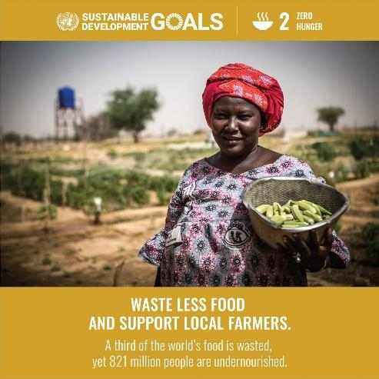
According to the World Food Programme, 135 million people suffer from acute hunger largely due to human-caused conflicts, climate change and economic downturns. “The COVID-19 pandemic could now double that number, putting an additional 130 million people at risk of suffering acute hunger by the end of 2020. With more than a quarter of a billion people potentially at the brink of starvation, swift action needs to be taken to provide food and humanitarian relief to the most at-risk regions” (Anthem).
The purpose of SDG 2: Zero Hunger is to “end hunger, achieve food security and improved nutrition and promote sustainable agriculture” by meeting the following targets:
Target 2.1 – By 2030, end hunger and ensure access by all people, in particular the poor and people in vulnerable situations, including infants, to safe, nutritious and sufficient food all year round

Target 2.2 - By 2030, end all forms of malnutrition, including achieving, by 2025, the internationally agreed targets on stunting and wasting in children under 5 years of age, and address the nutritional needs of adolescent girls, pregnant and lactating women and older persons

Target 2.3 - By 2030, double the agricultural productivity and incomes of small-scale food producers, in particular women, indigenous peoples, family farmers, pastoralists and fishers, including through secure and equal access to land, other productive resources and inputs, knowledge, financial services, markets and opportunities for value addition and non-farm employment

Target 2.4 - By 2030, ensure sustainable food production systems and implement resilient agricultural practices that increase productivity and production, that help maintain ecosystems, that strengthen capacity for adaptation to climate change, extreme weather, drought, flooding and other disasters and that progressively improve land and soil quality

Target 2.5 - By 2020, maintain the genetic diversity of seeds, cultivated plants and farmed and domesticated animals and their related wild species, including through soundly managed and diversified seed and plant banks at the national, regional and international levels, and promote access to and fair and equitable sharing of benefits arising from the utilization of genetic resources and associated traditional knowledge, as internationally agreed
Target 2.a - Increase investment, including through enhanced international cooperation, in rural infrastructure, agricultural research and extension services, technology development and plant and livestock gene banks in order to enhance agricultural productive capacity in developing countries, in particular least developed countries

Target 2.b - Correct and prevent trade restrictions and distortions in world agricultural markets, including through the parallel elimination of all forms of agricultural export subsidies and all export measures with equivalent effect, in accordance with the mandate of the Doha Development Round

Target 2.c - Adopt measures to ensure the proper functioning of food commodity markets and their derivatives and facilitate timely access to market information, including on food reserves, in order to help limit extreme food price volatility.

Global Case Study: El Salvador
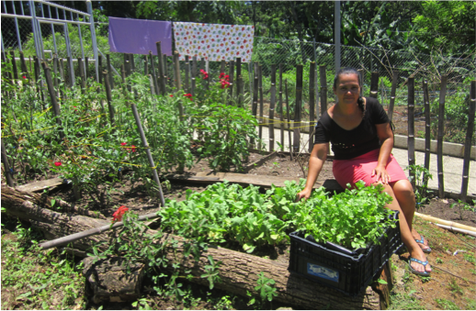
A 2012 National Household Survey in El Salvador found that 34.5% of the population lives in extreme poverty, ranging from 47.2% to 60% in the most vulnerable municipalities, where chronic child malnutrition is prevalent (Sustainable Development Goals Fund). The impact of chronic infant malnutrition can be lifelong. Long-term effects can include reproductive issues, unhealthy eating during pregnancy, limited access to health care, and low rates of exclusive breastfeeding.
In 2014, the United Nations Sustainable Development Goals Fund promoted the joint program between Nutritional and Food Security for Children in Salvadoran Homes (SANNHOS)” and El Salvador’s Government Plan, “El Salvador Adelante,” to combat malnutrition. The objective of working with national and local authorities was to strengthen results and help ensure long-term sustainability. The joint program’s goals were to:
- Strengthen public policy on food and nutrition
- Improve local food production to reduce food imports
- Increase communities’ resilience to climate change and reduce vulnerabilities to food production
- Improve access to information about nutrition
- Improve access to health services and promoting women-owned micro-enterprises

Below are the steps taken to make progress toward each goal.
Strengthen Public Policy
- Eighty-six women were trained in technical issues and joined three Municipal Committees on food and nutrition security.
- Training activities strengthened knowledge of 13 institutional leaders (governmental and non-governmental) for the development of the 2016-2020 Operational Plan on food and nutrition security, school alimentation and maternal breastfeeding. A training program in food and nutrition was provided for government officials to help them with policy work, which benefited 1,135 employees (SDG Fund).
Improve Local Food Production
- The program helped support diversification of production by creating fruit orchards and vegetable gardens and tilapia farming.
Increase Communities Resilience
- Five rainwater collection tanks were built in coordination with local governments, serving more than 500 families in three municipalities.
Improve Access to Information about Nutrition
- Families participated in training sessions where they were provided educational materials on water and sanitation, food, nutrition, and health.
- Ten schools created vegetable gardens to promote learning, production techniques and knowledge about nutrition.
- Another 15 schools received basic kitchens to promote food safety.
Improve Access to Health Services and Promoting Women-Owned micro-enterprises
- More than one hundred twenty families were supported in developing micro-enterprises in farm and non-farm activities, 80% of whom were led by female heads of households (SDG Fund).
From 2015 to 2017, the program reached 608 families and directly impacted 2,182 individuals, specifically 871 women, 856 men, 248 girls and 207 boys (SDG Fund). At the beginning of the program, 64% of families suffered from food insecurity and by the end this rate dropped to 14% (SDG Fund).
Local Case Studies: Second Helpings Atlanta & Urban Recipe
According to the U.S. Department of Agriculture, food insecurity is a household-level economic and social condition of limited or uncertain access to adequate food. In 2019, 10.5% of U.S households were food insecure and 6.4% of households were low food insecure, meaning their eating patterns were significantly impacted or their intake was significantly reduced (USDA). In 2016-2018, 11.3% of Georgia’s households were food insecure (USDA). While food insecurity in Georgia has declined in the past 10 years, projected food insecurity rates show an increase in outer suburbs, most noticeably in Paulding, Cherokee, Gwinnett, Walton, Rockdale, and Henry counties (Shannon).
Second Helpings Atlanta
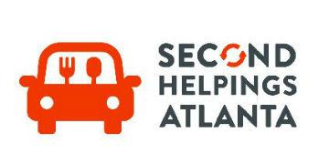
Second Helpings Atlanta (SHA) is a nonprofit food rescue organization whose mission is to reduce hunger and food waste in the Metro Atlanta area by rescuing surplus food and distributing it to those in need (Second Helpings Atlanta). SHA operates in the Metro Atlanta area, including Fulton, Dekalb, Gwinnett, Fayette, and Coweta counties.
SHA offers a variety of programs for individuals and organizations to become involved to support their mission. Its four programs include: the 90-minute model, Large Event Food Rescue, Corporate Engagement, and Food for Thought.
SHA’s 90-minute meal model
The food rescue network starts with food donations by established food donors. Currently, SHA has over 80 food donors across metro Atlanta: grocery stores, wholesale food warehouses, corporate kitchens, school cafeterias, stadium venues and restaurants. Typical food donations include fresh produce, dairy, deli, bakery, proteins, and frozen prepared food. SHA’s model uses volunteers to transport surplus food from food donors to partner agencies in 90 minutes or less.
Large Event Food Rescue
SHA partners with Atlanta’s largest venues and provides a year-round source of nutritious foods such as: prepared foods, proteins, bakery, produce, dairy, and shelf-stable items.
Corporate Engagement
SHA partners with companies that are passionate about serving their communities and providing ways for their employees to engage with SHA’s mission. SHA provides on-campus presentations where employees can learn about hunger, food waste, and the impact on the environment, and how they can make a difference. The Adopt a Route program allows employees to rescue food on SHA’s behalf. Surplus food from the company’s employee dining hall can be rescued and delivered by employees or SHA volunteers. Community Service Projects allow employees to participate in large group projects that support SHA’s mission such as assembling bags of nonperishable foods and delivering them to a partner agency.
Food For Thought
The focus of Food for Thought is to recruit the next generation of volunteers to combat hunger and reduce food waste in metro Atlanta. SHA educates students about hunger and food waste and encourages students to act. Like Corporate Engagement, students and parents can adopt a route to deliver rescued foods, deliver surplus foods from cafeterias, and engage in large group projects that help SHA’s rescue mission.
In 2020, SHA diverted over 1.9 million pounds of surplus food from landfills and delivered almost 1.6 million meals to those in need through food rescue. In addition, SHA provided 400,000 prepared meals to partner agencies through a new meal delivery program.
Urban Recipe
Urban Recipe Food Co-op’s mission is to partner with members and supporters to create food security, build community, and provide a platform for personal development while affirming dignity (Urban Food Recipe). Established in 2001, Urban Recipe’s primary focus is forming food cooperatives for low-income families in Atlanta. A cooperative (co-op) is a network of voluntary individuals who own or control a business equally whose benefits could include “a share of surplus or profits, improved working conditions and benefits, lower prices, higher quality of product, product type and variety that better serve members’ preferences, and better access to credit” (Altman). Co-ops exhibit a higher degree of social responsibility since decisions are made by members, for members.
At Urban Recipe an individual or family becomes a member of a co-op composed of up to 50 families. Meeting every two weeks, members participate in a handful of different tasks such as setting out and organizing the correct number of empty boxes, bringing the food into the distribution room, sorting, and organizing the food into categories, and portioning out bulk items. Once all the day’s food and goods are loaded into boxes, a business meeting is held.
Led by the co-op’s elected leadership, the business meeting typically includes a reflection, community announcements, and on occasion an educational portion led by a guest speaker from one of Urban Recipe’s community partners. When the business meeting concludes, the fully stocked food boxes are assigned to each member and members take their boxes and disperse until gathering again in two weeks. The co-ops distribute an average of 3,000 pounds of food equitably and according to family size.

Gender Equality
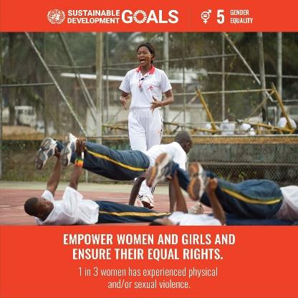
Gender Equality means that all genders have the same rights, status, and opportunities as others without any discrimination. While there has been progress over the last decades - more girls are going to school, fewer girls are forced into early marriage - many challenges remain: “discriminatory laws and social norms remain pervasive, women continue to be underrepresented at all levels of political leadership, and 1 in 5 women and girls between the ages of 15 and 49 report experiencing physical or sexual violence by an intimate partner within a 12-month period” (UN Women).

The goal of SDG 5, Gender Equality, is to “achieve gender equality and empower all women and girls” by accomplishing the following targets:
Target 5.1 - End all forms of discrimination against all women and girls everywhere
Target 5.2 - Eliminate all forms of violence against all women and girls in the public and private spheres, including trafficking and sexual and other types of exploitation
Target 5.3 - Eliminate all harmful practices, such as child, early and forced marriage and female genital mutilation
Target 5.4 - Recognize and value unpaid care and domestic work through the provision of public services, infrastructure and social protection policies and the promotion of shared responsibility within the household and the family as nationally appropriate
Target 5.5 - Ensure women’s full and effective participation and equal opportunities for leadership at all levels of decision-making in political, economic and public life
Target 5.6 - Ensure universal access to sexual and reproductive health and reproductive rights as agreed in accordance with the Programme of Action of the International Conference on Population and Development and the Beijing Platform for Action and the outcome documents of their review conferences
Target 5.a - Undertake reforms to give women equal rights to economic resources, as well as access to ownership and control over land and other forms of property, financial services, inheritance and natural resources, in accordance with national laws
Target 5.b - Enhance the use of enabling technology, in particular information and communications technology, to promote the empowerment of women
Target 5.c - Adopt and strengthen sound policies and enforceable legislation for the promotion of gender equality and the empowerment of all women and girls at all levels
Global Case Study: Stand to End Rape
According to the United Nations, Gender Based Violence (GBV) refers to a “harmful act of violence that results in, or is likely to result in, physical, sexual, or mental harm or suffering to women, including threats of such acts, coercion or arbitrary deprivation of liberty, whether occurring in public or private life.” This can include intimate partner violence, sexual violence, child marriage, female genital mutilation and so-called “honor crimes” (UNHCR).

In Nigeria GBV remains a challenge that significantly constrains women’s autonomy and opportunities. The Nigeria Demographic Health Survey of 2018 indicates that 31% percent of women in Nigeria have experienced physical violence since age 15 (NCP & ICF). Fourteen percent of women experienced physical violence within 12 months prior to the survey. The most common perpetrator of physical violence against married women is the current husband/partner (58%) and among unmarried women the most common perpetrator is the mother/stepmother (35%) (NCP & ICF).
In response to GBV, Stand to End Rape Initiative (STER) – a Nigerian youth-led social enterprise - advocates against sexual violence, provides prevention mechanisms, and supports survivors with psychosocial services (Stand to End Rape). STER advocates for rape survivors who can’t speak about their ordeal due to stigmatization and enlightens their community on the need to end rape and victim-blaming (SDG Action Awards). Their mission is to “catalyze innovative programs, policies, and public engagement efforts and create transformative policy-wide behavioral and systemic changes in the lives of women and girls in Nigeria” in order to create an “equitable, safe and resilient society where all persons are free from sexual violence” (STER).

Winners of the 2020 SDG Action Award for Mobilize, STER began publishing educative content on social media to raise awareness about the Sexual Harassment in Tertiary Educational Institutions Prohibition Bill 2016 that came before the Nigerian National Assembly (ANEEJ). The bill was not passed due to Academic Staff Union of Universities claiming that sexual harassment was not an issue. In response, STER partnered with the BBC Africa Eye Team in 2018 to conduct an investigative exposé on sexual harassment in academic institutions, “Sex for grades: Under Cover in West African Universities”(BBC News). STER worked with survivors of sexual harassment from the University of Lagos to gain evidence against abusive lecturers. The BBC documentary released in 2019 has over 5 million views and led to the re-introduction of the Sexual Harassment Bill by the Nigerian Senate following increased pressure and scrutiny through awareness and advocacy efforts.

STER offers an array of programs and services focused on strengthening and empowering survivors of rape and emphasizes preventative programming targeting sexual violence and abuse. These programs include:

- Sexual and Reproductive Rights – provide a range of prevention & treatment services.
- Awareness Seminars - focus on engaging people on the roles everyone plays in prevention, recognizing potential risk factors in the community, and where to go if an incident occurs.
- Sexual Violence and Abuse Education - provide a series of resources and educational materials to educate communities on rape prevention and sexual violence and abuse. STER partners with local, public, and private institutions to better disseminate information in the community.
- Peer Mentoring - provide a platform for peer engagement, so survivors know they are not alone. Participants are encouraged to share their experiences and learn from others.
- Therapy - work with healthcare professionals to provide therapeutic services. Individuals can get continual counseling, support, and treatment.

STER provides extensive resources for survivors to help them in times of crisis. These resources include providing a list of general hospitals and health care centers, police stations, mental health toolkit, and survivor-centered programs. Central to its mission, STER engages individuals, groups, and key stakeholders in the community to raise awareness and prevent education activities that utilize participatory action methods (STER).

Local Case Study: SisterLove Inc.

According to the Centers for Disease Control and Prevention’s 2019 HIV Surveillance Report, one in nine women with HIV are unaware they have it (CDC). Additionally, the state of Georgia has the second highest rate of HIV infection in the U.S. among female adults, second to the District of Columbia (CDC). According to Carlos del Rio, Hubert Professor at Rollins School of Public Health and co-director of the Emory Center for AIDS Research: “some zip codes in the Atlanta area have rates of HIV/AIDS that are six- to eight-times higher than the national average…and by the time patients in Atlanta are diagnosed as HIV positive, about a quarter have AIDS, which means they have likely been living with the virus for eight to 10 years” (cited in McKenzie).

SisterLove, Inc. (SisterLove) was founded by Dr. Dázon Dixon Diallo in 1989 to eradicate the impacts of HIV and advocate justice for women and the LGBTQ+ community. SisterLove is an Atlanta-based nonprofit organization that began as a volunteer group of women interested in educating communities of women about HIV prevention, self-help, and safer sex techniques. It is the first women’s HIV/AIDS and Reproductive Justice organization in the southeastern United States and offers a variety of programs to address women’s needs, including the following:

Healthy Love Workshop (HLW)

The HLW workshop is an interactive and community-focused intervention. To better speak to the realities of African American women’s lives. HLW conducts “house calls,” meaning facilitators will go to locations requested by participants. In these familiar environments, participants learn preventative strategies to help them face and overcome challenges posed by the AIDS epidemic. In 2009, the HLW was evaluated by the Centers for Disease Control as an innovative group-level HIV prevention program. The HLW was determined to be effective in reducing risk-taking behaviors, reducing numbers of sexual partners, increasing condom use, and increasing testing with results among Black women (CDC).

Healthy Love Youth Advocates
This program is a 10-month fellowship for youth ages 15-25 living in the state of Georgia aiming to teach youth skill sets in activism, grassroots organizing, and public policy through a reproductive justice lens.

Health Education and Protection (HEAP)

While SisterLove’s original mission was focused on providing preventative education to women of color in metro Atlanta, the group expanded its mission and services to meet the needs of transgender and gender variant individuals, lesbians, bisexual, gay, and queer-identified youth, women and men. HEAP services include empowerment groups for women living with HIV/AIDS, free HIV/STI Testing and risk reduction counseling, prevention education, community outreach, and assistance with case management and community resources.

Policy & Advocacy Programs (PAP)
SisterLove Inc approaches advocacy through the lens of Reproductive Justice & Human rights to conceptualize HIV policy issues and innovative community-based solutions to those issues from the grassroots up. To this end, SisterLove works in four broad advocacy areas: HIV/AIDS Prevention Treatment and Care, Health Inequities and Disparities, Intersection of Sexual & Reproductive Health, Rights, and Justice, Stigma Discrimination and Violence.

Industry, Innovation Infrastructure

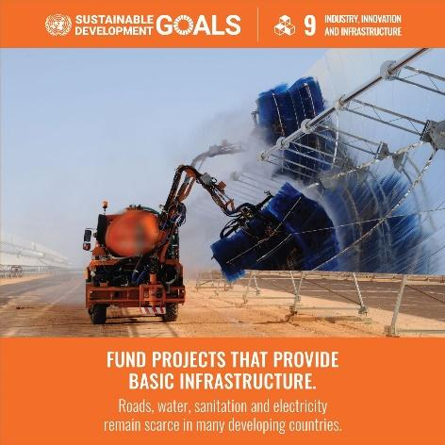
A functioning and resilient infrastructure is the foundation of every successful community (Global Goals).

In order to meet future challenges, industries and infrastructure must be upgraded to ensure equal and universal access to information and financial markets. This will bring prosperity, create jobs and support the development of stable and prosperous societies across the globe (United Nations). The goal of SDG 9 is to “build resilient infrastructure, promote inclusive and sustainable industrialization and foster innovation” by accomplishing the key targets and indicators:

Target 9.1 - Develop quality, reliable, sustainable and resilient infrastructure, including regional and transborder infrastructure, to support economic development and human well-being, with a focus on affordable and equitable access for all

Target 9.2 - Promote inclusive and sustainable industrialization and, by 2030, significantly raise industry’s share of employment and gross domestic product, in line with national circumstances, and double its share in least developed countries

Target 9.3 - Increase the access of small-scale industrial and other enterprises, in particular in developing countries, to financial services, including affordable credit, and their integration into value chains and markets

Target 9.4 - By 2030, upgrade infrastructure and retrofit industries to make them sustainable, with increased resource-use efficiency and greater adoption of clean and environmentally sound technologies and industrial processes, with all countries taking action in accordance with their respective capabilities

Target 9.5 - Enhance scientific research, upgrade the technological capabilities of industrial sectors in all countries, in particular developing countries, including, by 2030, encouraging innovation and substantially increasing the number of research and development workers per 1 million people and public and private research and development spending

Target 9.a - Facilitate sustainable and resilient infrastructure development in developing countries through enhanced financial, technological and technical support to African countries, least developed countries, landlocked developing countries and small island developing States

Target 9.b - Support domestic technology development, research and innovation in developing countries, including by ensuring a conducive policy environment for, inter alia, industrial diversification and value addition to commodities

Target 9.c - Significantly increase access to information and communications technology and strive to provide universal and affordable access to the Internet in least developed countries by 2020

Global Case Study: Smart City- Ahmedabad
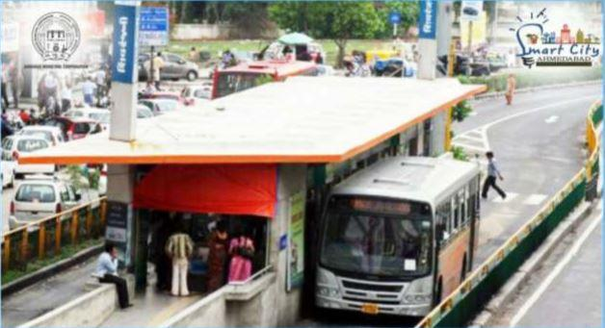
In 2016 Ahmedabad was selected as one of the first 20 Smart Cities in India as a part of the government’s SMARTNET Project. As the largest city in the state of Gujarat and a UNESCO World Heritage City, Ahmedabad hoped to become a major tourist destination as well as improve the current standard of living of residents (Solanki, et. al).
The objective of SMARTNET’s Smart Cities is to implement sustainable and inclusive development that provides core infrastructure and gives a decent quality of life to its citizens, as well as a clean and sustainable environment (Ministry of Urban Development, Government of India). As a part of the pan-city initiative, the Smart City Ahmedabad Development Limited (SCADL) partnered with NEC – a Japanese information technology and electronics corporation – to upgrade the city’s transit infrastructure.
Ahmedabad has two major bus services – Bus Rapid Transit (BRT) and city bus AMTS - that operate 1,000 buses and transport 0.8 million passengers daily (NEC). While the ticket prices are affordable, bus services were underutilized due to poor route planning, a lack of advertised bus schedules, bus-bunching, excessive wait time, rough driving, stop skipping, and inconvenient or inconsistent cash collection (NEC). Further, 66% of citizens believed traffic management in the city is poor, 57% of citizens believe the BRT project has increased the traffic issues in the city, and 73% of citizens faced insufficient public parking (Patel & Joshi).
The SCADL and NEC partnership implemented an intelligent transport management system (ITMS) which gathered transit data/intelligence from real-time operations and provided timely feedback to traffic managers and commuters (Smart City Ahmedabad). The new system improved bus resources management, bus maintenance, transport information, and personnel, and collected and analyzed data to help optimize resources, and boost ticket sales.
An integral component of ITMS is the Automated Fare Collection System (AFCS) which aims to automate fare collection mechanism and technology within the transport ecosystem to improve ease of operations and remove revenue leakages. The Common Card Payment System (CCPS) is an open loop smart card that allows citizens a common platform for payments such as transport, parking, bills, entertainment, and amusement (Ahmedabad Municipal Corporation).
ITMS gathers transit data and intelligence and provides timely feedback to traffic managers who monitor fleets in real-time. This enhances reliability and punctuality of bus operations. Additionally, AFCS is integrated with city wide CCPS which supports cashless travel while using a single card. According to Smart City Ahmedabad, benefits from ITMS & AFCS project are:
  - Pre-trip information: passengers get information about the transportation system and traffic status before they begin their trip so they can make more informed decisions
  - On-route information: passengers are provided travel-related in-bus announcements and display boards
  - Real time calculation of bus arrival time
  - In-bus and bus station surveillance system for citizen safety
  - Real-time driver behavior analysis for enhancing road safety
This work has reduced ticket issuance time, avoided bus bunching, improved real-time passenger data, and controlled station skipping (Shankar). In 2020, Smart City of Ahmedabad was awarded 3rd place in Urban Mobility for its automated parking system and 1st place in Smart Cities Leadership by India Smart Cities Awards Contest (ISAC).
Local Case Study: Smart City- Sandy Springs

In 2020, the City of Sandy Springs (the City) was one of four communities selected by the Georgia Smart Communities Challenge (Georgia Smart) program for their “Streamlining Suburban Transit” proposal (APAGA). The Georgia Smart program provides technical and financial assistance to communities which enables them to envision, explore, and plan for their “smart” future (Smart Cities and Inclusive Innovation). Resources include a partnership with a Georgia Tech research team, networking opportunities, and access to unique partnerships to complete projects over the course of a year (Georgia Smart).

The “Streamlining Suburban Transit” proposal aims to accomplish two of the City’s “The Next Ten” goals: mobility (improve city-wide mobility) and transit (maximize potential of transit infrastructure) (City of Sandy Springs). The 10 goals provide an overarching framework for the Comprehensive Plan for the next 10 years and were created based on extensive community input.

The City, in partnership with MARTA, the City of Dunwoody, and Georgia Tech researchers, is conducting a study to “test transit signal priority (TSP) technology using bus location data published through an application program interface (API) instead of communicating with a unit on board the bus” (Georgia Smart Communities Challenge 2020). A benefit of TSP is its ability to improve the existing transit system without new infrastructure. It also has the potential to shift drivers to transit riders which improves transit and vehicular mobility. The reduction in vehicular reliance allows the transportation system to prioritize other users and modes, such as walkers in more dense areas. The fewer single occupancy vehicle drivers could improve air quality which in turn creates a healthier environment for active transportation users (Georgia Smart Communities Challenge 2020).

This project will test TSP on MARTA Bus Route 5 which connects the Dunwoody and Lindbergh MARTA rail stations and operates with a 15-minute headway. This is an important route as it travels through Sandy Springs, the Perimeter and the I-285 interchange at Roswell Road. (Georgia Smart Communities Challenge 2020).

Georgia Tech research partners will design and conduct the study to ensure the results are representative of real conditions. Based on the data results, best practices, and public feedback, the City will then develop an implementation plan on how and where to execute TSP in both cities. This in turn supports Sandy Spring’s goal of improving mobility, maximining the existing transit system, and improving walkability and a sense of place in the Perimeter and Roswell Road Areas.

The study is ongoing and will conclude at the end of 2021. On September 9, 2021, City of Sandy Springs Transportation and Traffic Unit Manager, Kristen Wescott, and Georgia Institute of Technology Professor, Dr. Michael Hunter, will present the findings and progress of this project. Find more information on the upcoming presentation here.
.

Smart City Cautions

While Smart Cities programs include exciting technology that can improve the health and wellbeing of society, their ethical and equity implications should be carefully evaluated. Social context and power relations of a particular community should be taken into consideration for all projects. For a broader discussion of technology and social context, instructors are encouraged to review SLS’s Teaching Toolkit, “Technology and Social Context.” This lesson enables students to critically evaluate various technological applications with attention to the context of the communities in which engineers are working.

In 2014, Adam Greenfield spoke at reSITE: Cities and Landscapes of the New Economy. reSITE is an international platform that investigates how design can provide a positive impact in our lives in cities (reSITE). Adam Greenfield is an American urbanist, writer, author of the books “Against Smart City” and “Radical technology: The Design of everyday life.” In this 24-minute video, Adam challenges the popular concept of smart cities and warns against the dangers it poses of strictly central planning. He answers the questions “What is a smart city?” “Where are they?” “For whom are they intended?” “By whom were they developed?”

Discussion Questions:
- What is the purpose of a Smart City?
- What is IBM’s description of its urban initiative and what flaws does Greenfield point out? What is Greenfield’s critique of CISCO’s description of the Smart City Effort?
- How does Siemens describe a Smart City and its purposes? How does Greenfield challenge this definition?
- Describe and respond to Greenfield’s argument about who the Smart City is built for, its goals, its benefits, and what he describes as its “real problem.”
- What alternatives does Greenfield propose to the Smart City approach? What values are represented by his proposal? What is your response to his proposed focus on justice?
- Explain Greenfield’s argument about data as “not neutral.” What questions does he suggest individuals should raise about data?

Optional: Additional Reading:
- “The Dangers in Smart Cities” by John II Breeden.
- “The ethics of Smart City (EoSC): moral implications of hyperconnectivity, algorithmization and the datafication of urban digital society” by Patrici Calvo.

Optional Extension
While the Sustainable Development Goals are individual goals with specific targets, they are situated in a framework of five themes: People, Planet, Prosperity, Peace and Partnerships. These themes, like the SDGs themselves, intersect in many ways, with challenges or progress in one area having significant impacts on other areas. For that reason, it is helpful to view the complex global challenges addressed by the SDGs through a transdisciplinary and intersectional lens.

Intersectionality is “an approach to research that focuses upon mutually constitutive forms of social oppression rather than on single axes of difference. [It] is not only about multiple identities but is about relationality, social context, power relations, complexity, social justice, and inequalities” (Hopkins). In the context of the SDGs, it is important to consider how meeting targets toward one goal impacts progress toward another. For example, it is challenging to achieve Zero Hunger without addressing Gender Equality and Decent Work & Economic Growth.
This video by UN Women explains how SDG 5: Gender Equality is vital to accomplish all the goals as “there can be no sustainable development without gender equality.” The video helps illustrate the many interconnections among SDGs.

Activity:
Using the case studies from one of the above SDGs, ask students to explain how progress toward SDG 5 can positively impact the other Goals. Additionally, ask them to explain how achieving one or two other SDGs can further promote Gender Equality.
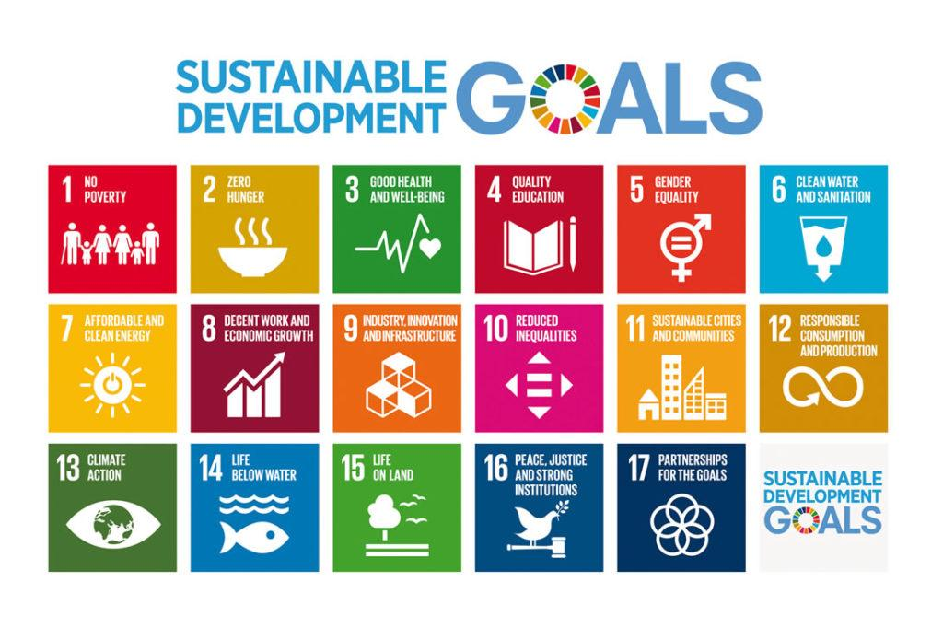
Further Reading
Africa Network for Environment & Economic Justice (ANEEJ). “Sexual harassment Bill.” (2016).

Altman, Morris. “Cooperatives, History and Theories Of.” International Encyclopedia of Civil Society, Springer US, pp. 563–70, doi:10.1007/978-0-387-93996-4_102.

Amdavad Municipal Corporation. “Smart City Ahmedabad: My Heart Ahmedabad, My Smart Ahmedabad.” (2015)

Ahmedabad Municipal Corporation. “Common Card Payment System (CCPS): Ahmedabad.” (2018).

Anthem, Paul. “Risk of hunger pandemic as coronavirus set to almost double acute hunger by end of 2020.” United Nations World Food Programme. April 16, 2020.
Atlanta Community Food Bank. “Facts and Stats: Hunger by the Numbers.”(2020).
BBC News. “‘Sex for Grades’: Undercover in West African universities.” (2019).

Breeden, John,II. "The Dangers in Smart Cities." Nextgov.com (Online), Sep 04, 2019. ProQuest, https://go.openathens.net/redirector/gatech.edu?url=https://search.proquest.com/magazines/dangers-smart-cities/docview/2284787532/se-2?accountid=11107.
City of Sandy Springs. “The Next Ten: Comprehensive Plan. Sandy Springs, Georgia.” (2017).

Georgia Smart Communities Challenge 2020. “Streamlining Suburban Transit: Transit Signal Priority – Proof of Concept.” (2020).
Hopkins, Peter. “Social Geography I: Intersectionality.” Progress in Human Geography, vol. 43, no. 5, Oct. 2019, pp. 937–947. EBSCOhost, doi:10.1177/0309132517743677.
Ministry of Urban Development, Government of India. “Smart Cities Mission Statement & Guidelines.” (2015).
India Smart Cities Awards Contest (ISAC). “ISAC Awards 2020.” (2020).
National Population Commission (NPC) [Nigeria] and ICF. “2018 Nigeria DHS Key Findings.” (2019).
NEC. “Smart City Ahmedabad gets IoT-driven buses” (2018).

Patel A., Joshi M. “Use of ICT for Development of Smart City-Ahmedabad.” Proceedings of International Conference on Communication and Networks. Advances in Intelligent Systems and Computing, vol 508. Springer, Singapore. Edited by Modi N., Verma P., Trivedi B. (2017).

Patrici, Calvo. "The Ethics of Smart City (EoSC): Moral Implications of Hyperconnectivity, Algorithmization and the Datafication of Urban Digital Society." Ethics and Information Technology, vol. 22, no. 2, 2020, pp. 141-149. ProQuest, https://go.openathens.net/redirector/gatech.edu?url=https://search.proquest.com/scholarly-journals/ethics-smart-city-eosc-moral-implications/docview/2406441406/se-2?accountid=11107, doi:http://dx.doi.org/10.1007/s10676-019-09523-0.

reSITE

Samuel, Molly. “Food Insecurity Projected to Grow More in Atlanta’s Suburbs.” WABE. June 22, 2017.
SDG Action Awards. “Mobilize: The Sexual Harassment Project” (2020).
Second Helpings Atlanta.
Shankar, Rakesh. “Ahmedabad ITMS- AFCS & CCPS in World Economic Forum Report for Data Driven Cities.” Amdavad Municipal Corporation. (2018).

Shannon, Jerry. “Mapping Food Insecurity in Metro Atlanta.” Atlanta Studies. June 20, 2017.
SMARTNET.com
Smart City Ahmedabad. “Success Story of SMART CITIES.” (2017).
SMARTNET. “Smart City Ahmedabad: Project Details.” (2019).
Smart Cities and Inclusive Innovation. “Georgia Smart Communities Challenge.” Georgia Institute of Technology. (2020).
Solanki, Aniket Singh, et al. “Smart Cities-A Case Study of Porto and Ahmedabad.” Procedia Computer Science, vol. 160, Elsevier B.V, 2019, pp. 718–22, doi:10.1016/j.procs.2019.11.021.
Stand to End Rape
Sustainable Development Goals Fund. “Food Security and Nutrition for Children and Salvadoran households (SANNHOS).”(2017).

The Georgia Planning Association (APAGA). “Georgia Smart Communities Challenge Final Presentation: Streamlining Suburban Transit in Sandy Springs.” (2021).
The Global Goals
United Nations

United Nations. “SDG 2: Zero Hunger.” (2021).

United Nations. “SDG 5: Gender Equality.” (2021).

UNHCR, the UN Refugee Agency. “Gender-Based Violence.” (2021).

UN Women. “Gender Equality Women’s Rights In Review: Key Facts & Figures.” (2020)

Urban Food Recipe

USDA. “Interactive Charts and Highlights.” (2019).

USDA. “Food Security Status of U.S. Households in 2019.” (2019).

USDA. “Definitions of Food Security.” (2020).

Wheatley, Thomas. “Atlanta remains a hotspot for new AIDS/HIV cases.” Atlanta Magazine. October 14, 2020.
World Food Programme. “2020 Global Report on Food Crisis.” (2020).
https://government.economictimes.indiatimes.com/news/smart-infra/ahmedabad-named-best-smart-city-in-project-implementation/76325010).

SLS Learning Outcomes
- Identify relationships among ecological, social, and economic systems.
- Demonstrate skills needed to work effectively in different types of communities.
- Evaluate how decisions impact the sustainability of communities.
- Describe how to use their discipline to make communities more sustainable.*
* Note: SLO 4 is intended to be used by upper division, project-based courses such as Capstone.

