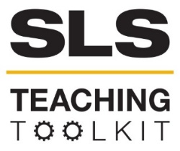 | ReGenesis Case Study:  Creating a Sustainable Community through Collaborative Problem-Solving
Discipline: All | Type: Reading; Assignment; In-class Exercise & Discussion | Time Commitment: 60 mins | Category: Case Studies on Sustainable Communities; Equity, Justice & Sustainability; Community Health
Big Ideas: Environmental Justice & Citizen Science; Participatory Processes & Collaborative Governance
OVERVIEW:
This tool uses the ReGenesis case study from Spartanburg, South Carolina, to explore what it means to “create sustainable communities” through broad stakeholder engagement. Due to chemical plants and other pollutants in the area, Spartanburg experienced high levels of health issues. ReGenesis, a community-based organization led by community member Harold Mitchell – now a member of the South Carolina legislature – worked with the EPA to use their Collaborative Problem Solving methodology to expose the inequity and turn the community around.
This tool was contributed by Kari Watkins and Delaney Rickles. The affiliated case study, “ReGenesis—A Practical Application of the CPS Model,” was written by the EPA.
INSTRUCTIONS:
- Ask students to read the EPA’s case study, “ReGenesis – A Practical Application of the CPS Model,” either before or during class (Chapter 4 of EPA’s Environmental Justice Collaborative Problem-Solving Model). Also suggest that they watch this 1-hour video before or after class, featuring ReGenesis’ founder, Rep. Harold Mitchell, sharing his experiences during a visit to Georgia Tech in Spring 2016.
- Distribute the “Community Engagement Module: Stakeholder Mapping and Planning Exercise” worksheet, included with this tool below. Modify the worksheet as desired beforehand.
- Discuss answers in class.
SLS STUDENT LEARNING OUTCOMES & ASSESSMENT:
The Serve-Learn-Sustain toolkit teaching tools are designed to help students achieve not only SLS student learning outcomes (SLOs), but the unique learning outcomes for your own courses. Reflection, concept maps, rubrics, and other assessment methods are shown to improve student learning. For resources on how to assess your students’ work, please review our Assessment Tools.
This tool achieves SLO 2. See the end of this tool for further details.
Want Help?
Contact SLS for tips on how to use this tool. Email us at serve-learn-sustain@gatech.edu

Community Engagement Module:
Stakeholder Mapping and Planning Exercise
Overview
Before class, please review the case study on the ReGenesis project in Spartanburg, South Carolina. While reading the case study, write down the relevant stakeholders to the project and complete the following stakeholder analysis.
Stakeholder Analysis Phase 1: Stakeholder Identification
Before stakeholders can be engaged, their roles, responsibilities, priorities, and perspectives must be identified. Which stakeholders did you identify while reading the case study? Please use the following table to brainstorm and categorize stakeholders and then answer the questions on the following pages
Category | Subcategory/  Description | List
Private Entities | Involved in Project
 | Affected by Project (Directly or Indirectly)
Community Based Organizations (CBO’s) | Organization that works at local level to improve life for residents.
Governmental Organizations & Authorities | Local Government
 | Regional Government
 | Federal Government
Other Institutions

Questions
- Which stakeholders do you feel had the greatest impact or were most important to this conflict? Are there stakeholders that ReGenesis should not have worked with?
- How did ReGenesis engage stakeholders in the issue at hand? What other methods would you use to work with stakeholders?
- Are there any stakeholders that you feel could have been called on for help that were not mentioned in the case study?
Stakeholder Analysis Phase 2: Stakeholder Mapping
Now that stakeholders have been identified, use the following grid to determine the connection stakeholders have with the project. Place stakeholders on the power-interest spectrum after determining the amount of influence each can have on project outcomes and their corresponding interest in the project. Sort them by the maximum influence they could have had on the project rather than their true impact.
More Power

Less Interest
More Interest

Less Power
Questions
- Why do you feel that more powerful entities did not use their full resources to help Spartanburg?
- How should stakeholders or other investors decide to what extent they will involve themselves in a conflict? What types of factors play into that decision?
Stakeholder Analysis Phase 3: In-Class Discussion
- Lead the class in a discussion of their assignments (Phase 1 & 2 above). Have them work first in pairs or small groups to compare their assignments. Give them the following instructions:
  - Compare your assignments overall.
  - Talk more about points where your assignments differ (for example, you placed stakeholders in different categories or different places on the mapping grid).
  - Together, reflect on the assignment and your discussion and determine 1-2 key takeaways about stakeholder engagement to share with the class. These may be lessons learned or questions you still have.
- Reconvene as a full group and have each pair or small group share their takeaways. Then, put the community involvement spectrum graphic (next page) up on a slide and lead the class in a final discussion of this question: “Where would you place the ReGenesis project along this spectrum and why?”
- Wrap up with a short discussion connecting this exercise with the class topic, focused on the question: “How can our discussions today inform our thinking and work during on [class topic] throughout the rest of the semester?”

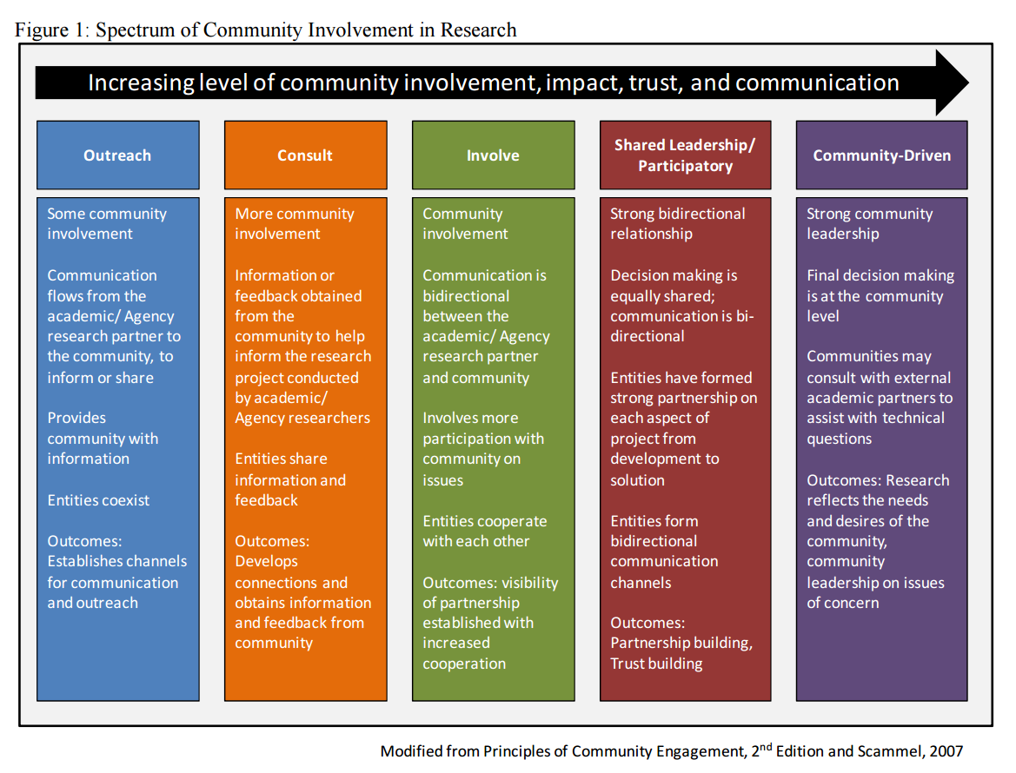
Figure 1: Spectrum of Community Involvement Research, from Schematic of Community Engagement Continuum (EPA, 2015; NCER CEnR Primer)

SLS Student Learning Outcomes
- Identify relationships among ecological, social, and economic systems.
- Demonstrate skills needed to work effectively in different types of communities.
- Evaluate how decisions impact the sustainability of communities.
- Describe how to use their discipline to make communities more sustainable.*
* Note: SLO 4 is intended to be used by upper division, project-based courses such as Capstone.

