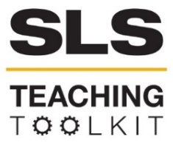 | MARTA: The History and Future of Transportation in Atlanta
Discipline: Computing | Type: Take-home assignment, project | Time Commitment: 10 mins-4 hrs. | Category: Civic Data; Sustainability in Atlanta
Big Ideas: Sustainable Urban Development; Understanding Local History and Context; Infrastructure: Physical, Technological, Social
OVERVIEW:
This is a collection of assignments about public transportation in Atlanta. The assignments are designed to 1) develop mapping and data analysis skills, 2) form an understanding of how MARTA is used today and how the system evolved to be in its current state, and 3) foster thinking about sustainable transportation. The problems are based on the IoT (Internet of Things) datasets of MARTA, which includes passenger counts of vehicles and Breeze card swipes at terminals. Reflection questions about the history of transportation are based on the 2017 report Opportunity Deferred: Race, Transportation, and the Future of Metropolitan Atlanta.
This tool was contributed by Ellen Zegura and Phan Anh Nguyen.
INSTRUCTIONS:
- Read the brief motivation of the problem.
- Review the data sets (by looking at their size, columns and records / shape files) and select a set of them to be the focus of data exploration.
- Based on the time commitment and effort the students are expected to make, compile a list of questions selected from phase 1-4, where 1 represents a small time commitment, and 4 represents a large time commitment. A combination of technical questions about the explored data set(s) and reflection questions is recommended.
- Ask students to complete the assignment.
SLS STUDENT LEARNING OUTCOMES & ASSESSMENT:
The Serve-Learn-Sustain toolkit teaching tools are designed to help students achieve not only SLS student learning outcomes (SLOs), but the unique learning outcomes for your own courses. Reflection, concept maps, rubrics, and other assessment methods are shown to improve student learning. For resources on how to assess your students’ work, please review our Assessment Tools.
This tool achieves SLO 3. See the end of this tool for further details.
Want Help?
Ellen Zegura is the contact for this tool. You can reach her at ellen.zegura@gatech.edu

MARTA: The History and Future of Public Transportation in Atlanta

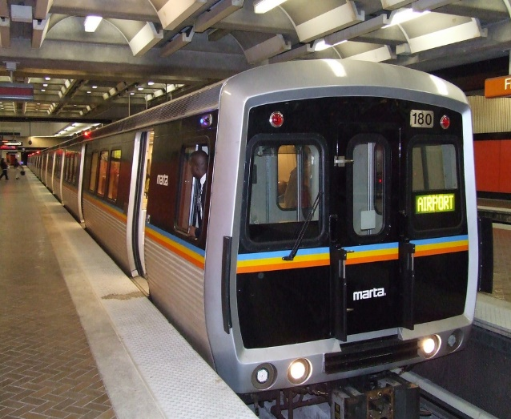
Instructions
- Read the brief motivation of the problem.
- Review the data sets: examine the records / shape files.
  - Data Set A - Usages of Breeze Cards on trains and buses: Automated Fare Collection
  - Data Set B – Passenger Counts of buses: Automated Passenger Count
  - Data Set C – Atlanta Census Tracts Income by Location
- Complete the assignments based on the data.

Motivation

Bridge collapse. On the evening of March 30, 2017, the Interstate 85 Bridge collapsed in Atlanta after a massive fire This disaster forced around 243,000 vehicles that traveled there daily to find an alternative route [1]. Surrounding neighborhoods felt the effect of drivers looking for a new route. One Atlantan remarked that, “The traffic around here just got to the point where it was just total chaos” [2].
Response of MARTA. For some, MARTA became their alternative commute plan. To accommodate the higher traffic, MARTA added more trains and buses, and adjusted the schedule to the higher demand [3]. They also added 1,200 parking spots at five stations [4], allowing more citizens to drive to the nearest station and get into the city by train. For MARTA, the bridge collapse served as an opportunity for development, and the initial 25% jump in ridership seemed promising. Although they made efforts to encourage the new riders to keep using their service, following the reopening of the I-85 bridge, the ridership returned to pre-collapse numbers [5].
(Un)sustainable transportation. Even after an impressive 6-weeks restoration, “the quick fix to I-85 only restores commuting to its usual state of misery” [6]. Atlanta was recently ranked 8th among the top most congested cities in the world [7], with the average commuter spending 70.8 hours in traffic each year. But the Atlanta Regional Commission’s long-term transportation plan calls for spending $85 billion through 2040 to fix traffic by building new lanes on key arterial roads. Atlanta and Fulton County voters also approved new sales taxes for a MARTA expansion [6].
The following questions and assignments explore how the MARTA bus and train system operate in Atlanta. They also encourage students to explore how the transportation system evolved into its current state, why automobiles are the preferred transportation method, and who are the veteran riders of the public transportation system.
Phase 1 (5-10 minutes, simple data set queries)

Review Data Sets A & B and answer the following questions.

Discovering the MARTA system
- Are you using MARTA? Have you used MARTA before? What is your general impression of public transportation in Atlanta?
- Draw a map of bus stations and routes based on the transportation activity data. Does it reflect the official system map?
- Represent each station with a circle and set the radius size proportional to its activity. Do you see anything surprising?
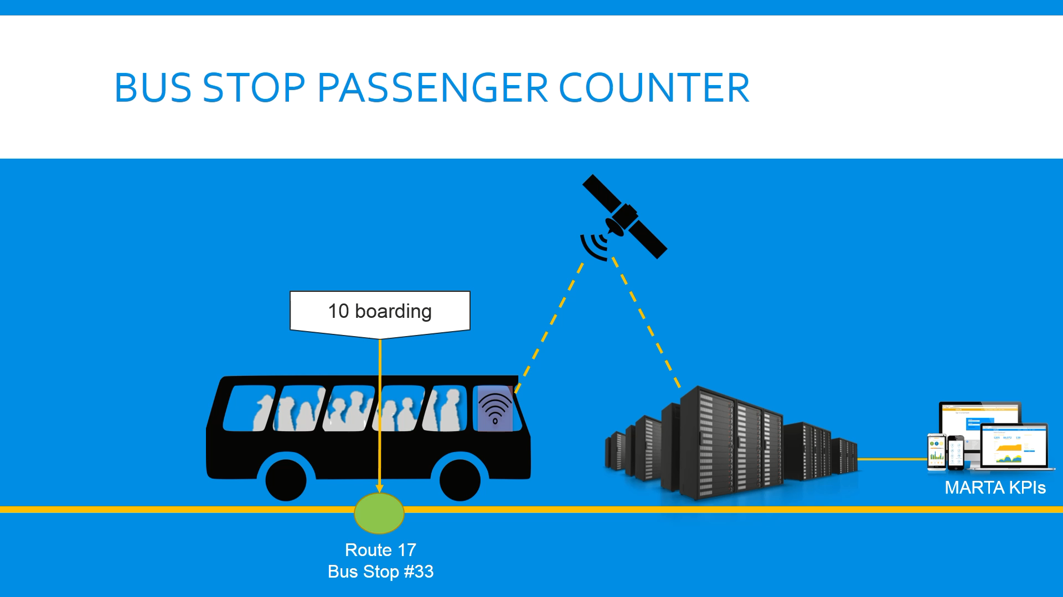
- How many train / bus stops are there?
APC Data from MARTA Hackathon Feb. 2017
- How many buses are there?

Automated Passenger Counter
- Which is the busiest route?
- Which is the busiest bus station? What are the least active bus stations? Are there stations that are not used at all?
- Draw a histogram of activities (getting on, getting off, both), where bins represent [30-minute] time slots. What are the busiest hours of public transportation?
- What is the average number of passengers by route and time of day?
- Is transportation activity balanced in both directions?

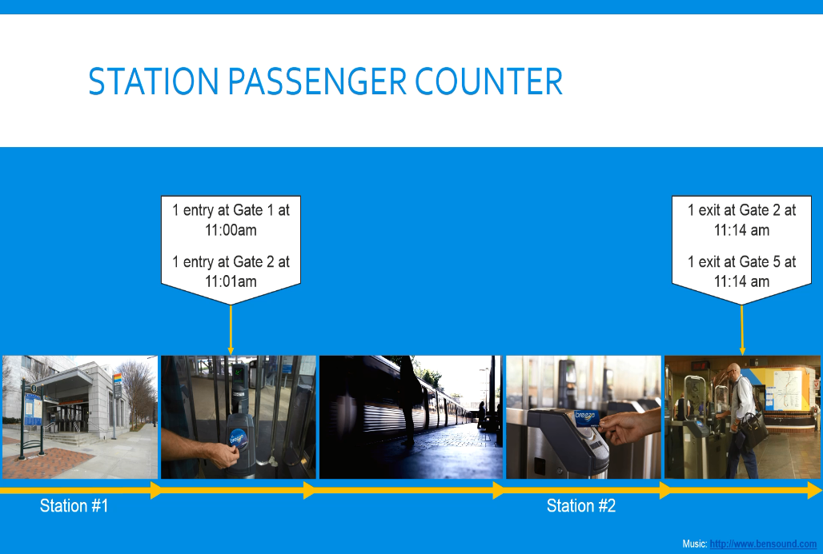
Automated Fare Collection
AFC Data from MARTA Hackathon Feb. 2017
- How many Breeze cards were used in the year?
- How many passengers use only bus / only train transportation? How many passengers use a combination of the two?
- What is the ratio of bus / train swipes?
Phase 2 (1-2 hours, intermediate data analysis)

Analyze Data Sets A & B and respond to the following prompts.
- Split the data into 80-20% train / test set. Based on the training data, predict the transport traffic for the test set. What days are predicted with the least accuracy? Are there any events on those days that could explain the divergence from the predictions?
- Cluster the riders into groups based on how often they use MARTA, such as riders who use it to commute to their workplace, riders who occasionally make a trip, and riders who are tourists and are only visiting the city for a short period of time.

Phase 3 (3-4 hours, advanced data analysis with geospatial data)

Review Data Sets A-C and answer the following questions.
- The Blue/Green Line runs East-West, while the Red/Gold Line runs North-South. Which directions shows higher activity?
Census tracts in Atlanta, GA colored by their Median Household Income.

- Read the section 1960s-1970s transit planning and the emergence of MARTA in Opportunity Deferred: Race, Transportation, and the Future of Metropolitan Atlanta. Which direction was built first? Why was that chosen?
- Group the transportation activities by median household income ranges. Is there a tendency to be observed?
- Atlanta ranked 1st in income inequality in 2014 and 2015, having the widest gap between its wealthiest and poorest residents [8]. How is this visible geographically? Read the section Federal policies in “Opportunity Deferred.” How does this illuminate income inequality and racial segregation in Atlanta?
Phase 4 (extensive design and implementation)

Review Data Sets A-C and respond to one of the following prompts.
- Tell the story of Atlanta in 2016. Animate the map of stations represented with circles, with the radius size proportional to the traffic. Pause at days with particularly high traffic, and search for events that explain the anomaly.
- Tell a friend how and why transportation in Atlanta works the way it does today, including the history of MARTA, and the development and consequences of highway construction. Explain how the economic gap widened between the Northern-Southern, Eastern-Western parts of the city. What information most surprised your friend?

Resources for Further Reading
Jennifer Peebles. "GDOT: 243,000 cars a day pass through stretch of I-85 near bridge collapse." Ajc. March 30, 2017. Accessed February 20, 2018. http://www.ajc.com/news/traffic/gdot-243-000-cars-day-pass-through-stretch-near-bridge-collapse/jU9qObnqRtuhApNpZLU82I/
Carr, Nicole. "ATLANTA BRIDGE COLLAPSE: Surrounding neighborhoods feeling traffic impact of I-85 bridge collapse." WSBTV. April 01, 2017. Accessed February 20, 2018. http://www.wsbtv.com/news/local/atlanta/surrounding-neighborhoods-feeling-traffic-impact-of-i-85-bridge-collapse/507953139.
EndPlay. "I-85 BRIDGE COLLAPSE: MARTA adds extra service lines after I-85 closure." WSBTV. April 24, 2017. Accessed February 20, 2018. http://www.wsbtv.com/news/local/atlanta/marta-adds-extra-service-lines-after-i-85-collapse/507795258
Jill Vejnoska 6:02 p.m Friday, April 7, 2017 AJC Homepage. "Atlanta I-85 collapse: MARTA adds 1,200 parking spots in time for Monday commute." Ajc. Accessed February 20, 2018. http://www.ajc.com/news/atlanta-collapse-marta-adds-200-parking-spots-time-for-monday-commute/H2LCfqaI1MqjyT4vkDVY1M/?ecmp=socialflow_ajclife
"July 4 MARTA glitch spotlights ridership drop." WXIA. July 05, 2017. Accessed February 20,2018.http://www.11alive.com/article/news/local/july-4-marta-glitch-spotlights-ridership-drop/454414739
"Atlanta traffic after I-85: It's going to get worse." Myajc. Accessed February 20, 2018. http://www.myajc.com/news/local/atlanta-traffic-after-going-get-worse/owcVOKGMhPZ9RUxG1k1VCI/
"Atlanta traffic after I-85: It's going to get worse." Myajc. Accessed February 20, 2018. www.ajc.com/news/local/atlanta-traffic-among-worst-the-world-study-finds/C6JR110E1z9xZeGGmjJ2HM/
Blau, Max. "Atlanta, once again the nation's leader in income inequality." Atlanta Creative Loafing. Accessed February 20, 2018. https://www.creativeloafing.com/article/13082214/atlanta-once-again-the-nations-leader-in-income-inequality

SLS Student Learning Outcomes
- Identify relationships among ecological, social, and economic systems.
- Demonstrate skills needed to work effectively in different types of communities.
- Evaluate how decisions impact the sustainability of communities.
- Describe how to use their discipline to make communities more sustainable.*
* Note: SLO 4 is intended to be used by upper division, project-based courses such as Capstone.

