Environmental Justice Resources

This tool provides a series of definitions, videos, and other resources for faculty and students who wish to learn more about Environmental Justice. This is an evolving resource, so please feel free to make recommendations in the Propose Your Own Tool field.

“Environmental Justice is concerned with making sure that (A) no community takes on an unfair share of environmental burdens and (B) environmental benefits are shared in an equitable way regardless of race, class, gender, or orientation” Christian Braneon, Serve-Learn-Sustain.
Definitions
Environmental Justice
“Environmental justice science [seeks to] understand how burden disparities lead to exposure, risk, and health disparities” (Majora Carter).
Marjora Carter
An environmental injustice exists when members of disadvantaged, ethnic, minority or other groups suffer disproportionately at the local, regional (sub-national), or national levels from environmental risks or hazards, and/or suffer disproportionately from violations of fundamental human rights as a result of environmental factors, and/or denied access to environmental investments, benefits, and/or natural resources, and/or are denied access to information; and/or participation in decision making and/or access to justice in environment-related matters.” (National Institute of Minority Health Disparities).
“Environmental justice science [seeks to] understand how burden disparities lead to exposure, risk, and health disparities” (Sacoby Wilson, Assistant Professor, Applied Environmental Health, University of Maryland School of Public Health, in “CAFOs and Environmental Justice: The Case of North Carolina”).
“Environmental justice is the fair treatment and meaningful involvement of all people regardless of race, color, national origin, or income, with respect to the development, implementation, and enforcement of environmental laws, regulations, and policies.
EPA has this goal for all communities and persons across this nation. It will be achieved when everyone enjoys:
- the same degree of protection from environmental and health hazards, and
- equal access to the decision-making process to have a healthy environment in which to live, learn, and work. (US Environmental Protection Agency (EPA).
For a more extensive definition of EJ, and examinations of equity and equality in relation to EJ, see the Department of Environmental & Occupational Health Sciences, University of Washington.
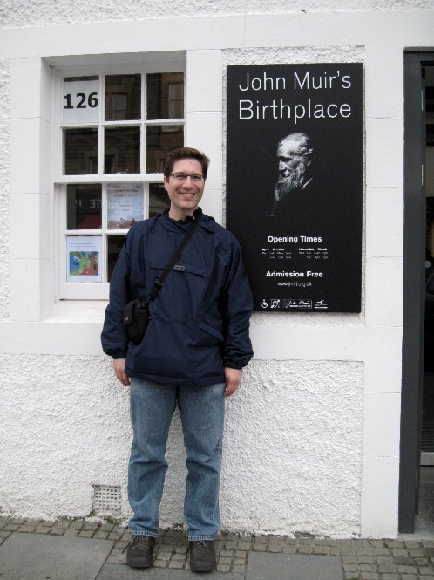
Environmental Racism
Carl Zimring
“Environmental racism is the systemic placing of toxic burdens upon people of color. It is an example of structural racism – not necessarily the conscious acts of individuals, but ways in which society is structured that creates patterns of unequal burdens.” (Carl A. Zimring, Associate Professor of Sustainability Studies, Department of Social Science and Cultural Studies, Pratt Institute, in “Flint’s Sorry Legacy of Environmental Racism”).
“‘Environmental racism’, the term used in the earliest literature in the field (e.g., Chavis 1987), describes the disproportionate effects of environmental pollution on racial minorities. Because it describes the disproportionate relationship between high levels of pollution exposure for people of color and the low level of environmental benefits they enjoy, environmental racism can be defined as the unequal distribution of environmental benefits and pollution burdens based on race. ‘Environmental inequality’ has emerged more recently to encompass both additional factors that associated with disproportionate environmental impacts such as class, gender, immigration status, as well as the inter-connections between these factors. ‘Environmental justice’ is the name of the social movement that emerged in response to these particular problems.” (“Environmental Justice at the Crossroads,” by Julie Sze and Jonathan K. London, University of California-Davis).

Video Resources on Environmental Justice, Equity, and Sustainability
- Animated Definition: Environmental Justice, Explained (3.5 min).
Presented by Grist, a non-profit news agency.
- The Beloved Community, Environmental Justice, and the Green Movement (6 min)
SLS partner PURE (Project Urban Renewable Energy) partners with The King Center to present Dr. Robert Bullard (often described as the father of environmental justice) Aaron Mair (President of The Sierra Club), Dr. Beverly Wright (founding director of the Deep South Center for Environmental Justice), Dr. Bernice A. King (CEO of The King Center), and Djuan Coleon (CEO of PURE).
- Environment and Equity: The Interface between Sustainability and Social Justice (1 hr)
Van Jones, attorney, activist, and nonprofit leader, speaks to students at Franklin & Marshall College.
- Environmental Justice: Peggy Shepard at TEDxHarlem (8 min)
Peggy Shepard
Peggy Shepard is the founder of WeACT for Environmental Justice, a leader in the EJ and climate justice movements. Here she discusses her work in Harlem, New York.
- Just Sustainabilities: Re-Imagining E/Quality with Julian Agyeman (1 hr)
Julian Agyeman, Professor of Urban and Environmental Policy and Planning at Tufts University, discusses the central role that justice plays in sustainability.
- Introducing 'The Doughnut': A safe and just space for humanity (4 min)
Kate Raworth, Senior Researcher at Oxfam Great Britain, introduces the Oxfam doughnut visual framework.
- MacArthur award-winner Majora Carter on Environmental Justice (2 min)
MacArthur award-winner Majora Carter discusses how she became involved in the fight for Environmental Justice, and what the term means to her.

Additional Resources on Environmental Justice, Equity, and Sustainability
- Principles of Environmental Justice
- Presidential Executive Order 12898 on Environmental Justice; Presidential Proclamation -- 20th Anniversary of Executive Order 12898 on Environmental Justice
- “Robert Bullard: The Father of Environmental Justice” (history, policy, and current movement)
- Linking ‘Toxic Outliers’ to Environmental Justice Communities (academic article)
- US EPA Environmental Justice
- Environmental Injustice and Health Disparities:
  - National Institutes of Health: Environmental Injustice
  - National Institute of Minority Health Disparities (NIMHD)
  - Urban Institute
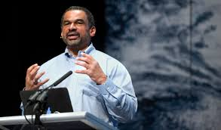
Blog Posts
Julian Agyeman
- “Equity? That’s not an issue for us, we’re here to save the world” by Julian Agyeman, Professor of Urban and Environmental Policy and Planning at Tufts University, and creator of the concept of “just sustainabilities.”
- Sustainability’s New Rules, 50 Years Old – Sustainability’s Caste System Can Go to Hell by Dave Newport, Director of the Environmental Center at University of Colorado Boulder and a leader in the campus sustainability field.
EJ Case Studies
Dumping in Warren County, NC:
  - PCB Contamination in Warren County, USA
  - Dumping in Dixie: Race, Class, and Environmental Quality
- Landfill siting in Houston
- Flint water crisis
- Indiana soil crisis
- Dakota Access Pipeline
Get Involved in Atlanta!
- Forever Family. This local organization serves the families of Georgia inmates.
- Partnership for Southern Equity. This Serve-Learn-Sustain partner focuses on various issues related to justice and sustainable communities.
- Proctor Creek Stewardship Council & West Atlanta Watershed Alliance. Both organizations are partners in the Georgia Tech-led Westside Communities Alliance, which focuses on Atlanta and the West End.
- PURE (Project Urban Renewable Energy). This Atlanta group focuses on justice and sustainable communities.

Note: We have constructed this tool in Microsoft word in order to make it easily modifiable for instructors. Please feel free to alter this tool according to the needs of your own course.
The Serve-Learn-Sustain toolkit teaching tools are designed to help students achieve not only SLS learning outcomes, but the unique learning outcomes for your own courses. Reflection, concept maps, rubrics, and other assessment methods are shown to improve student learning. For resources on how to assess your students’ work, please review our Assessment Tools at http://serve-learn-sustain.gatech.edu/tool-category/assessment.

