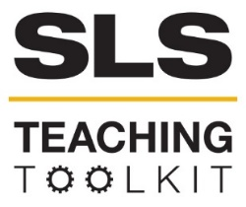 | Sustainable Cities and Communities: SDG 11
Discipline: All | Type: In-class exercise, virtual exercise, take-home assignment, discussion | Time Commitment: 20-40 minutes | Category: UN Sustainable Development Goals (SDGs)
OVERVIEW:
This tool will take a closer look at the 11th UN Sustainable Development Goal, Sustainable Cities and Communities, which aims to “make cities and human settlements inclusive, safe, resilient and sustainable.” Students will then use the elements that comprise progress towards the goal as a way to frame their reading of 3 large infrastructure projects, including the Los Angeles River Revitalization, the Cultural Trail, and the 5280 Trail, followed by two options for activities evaluating one or more of these projects according to the 10 Sustainable Cities and Communities Targets.
This tool was contributed by Bonnie Lapwood.
INSTRUCTIONS:
- Read the 10 targets associated with the Sustainable Cities and Communities SDG.
- Read the case study concerning three large infrastructure projects: the Los Angeles River Revitalization, the Indianapolis Cultural Trail, and Denver’s 5280 Trail.
- Complete a small group or whole class activity evaluating the assigned infrastructure project(s) using the 10 targets as a guideline for whether the project contributes to, detracts from, or does not have any impact on the development of a sustainable city and/or community. Comparisons with the Atlanta BeltLine can also be made if the class is also utilizing BeltLine-related materials.
SLS STUDENT LEARNING OUTCOMES & ASSESSMENT:
The Serve-Learn-Sustain toolkit teaching tools are designed to help students achieve not only SLS student learning outcomes (SLOs), but the unique learning outcomes for your own courses. Reflection, concept maps, rubrics, and other assessment methods are shown to improve student learning. For resources on how to assess your students’ work, please review our Assessment Tools.
This tool achieves SLOs 1 and 3. See the end of this tool for further details.

Want Help?
SLS is the contact for this tool. You can reach us at serve-learn-sustain@gatech.edu

Sustainable Cities and Communities
Introduction to SDG 11
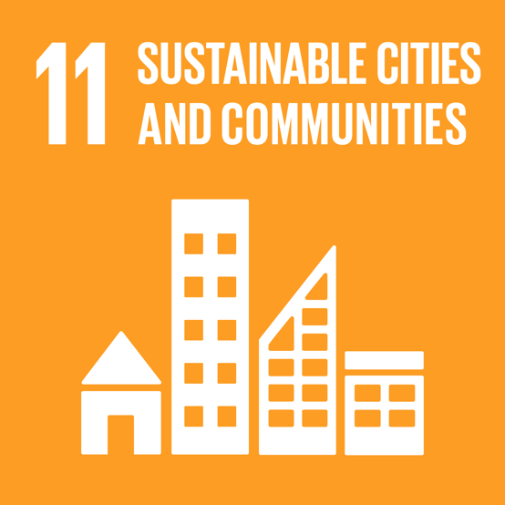
The United Nations Sustainable Development Goals (SDGs) are a set of 17 desired outcomes that are intended to guide policy based on the UN’s 2030 agenda. The SDGs were adopted in 2015 and have been accompanied by multiple strategies for implementation at scales ranging from the national level to the local level. Each of the 17 goals is further divided into sets of targets and indicators. The targets for each goal express actions that should be taken in the interest of working towards the goal, while the indicators provide metrics that can be used to quantitatively track data towards the goal.
Globalgoals.org

The eleventh Sustainable Development Goal is entitled Sustainable Cities and Communities. Its purpose is to “make cities and human settlements inclusive, safe, resilient and sustainable” (globalgoals.org). The following targets represent steps that the UN proposes can be taken towards completing SDG 11:

Target 11.1 | Safe and Affordable Housing  By 2030, ensure access for all to adequate, safe and affordable housing and basic services and upgrade slums.
Target 11.2 | Affordable and Sustainable Transport Systems  By 2030, provide access to safe, affordable, accessible and sustainable transport systems for all, improving road safety, notably by expanding public transport, with special attention to the needs of those in vulnerable situations, women, children, persons with disabilities and older persons.
Target 11.3 | Inclusive and Sustainable Urbanization  By 2030, enhance inclusive and sustainable urbanization and capacity for participatory, integrated and sustainable human settlement planning and management in all countries.
Target 11.4 | Protect the World’s Cultural and Natural Heritage  Strengthen efforts to protect and safeguard the world’s cultural and natural heritage.
Target 11.5 | Reduce the Adverse Effects of Natural Disasters  By 2030, significantly reduce the number of deaths and the number of people affected and substantially decrease the direct economic losses relative to global gross domestic product caused by disasters, including water-related disasters, with a focus on protecting the poor and people in vulnerable situations.
Target 11.6 | Reduce the Environmental Impact of Cities  By 2030, reduce the adverse per capita environmental impact of cities, including by paying special attention to air quality and municipal and other waste management.
Target 11.7 | Provide Access to Safe and Inclusive Green and Public Spaces  By 2030, provide universal access to safe, inclusive and accessible, green and public spaces, in particular for women and children, older persons and persons with disabilities.
Target 11.A | Strong National and Regional Development Planning  Support positive economic, social, and environmental links between urban, peri-urban, and rural areas by strengthening national and regional development planning.
Target 11.B | Implement Policies for Inclusion, Resource Efficiency, and Disaster Risk Reduction  By 2020, substantially increase the number of cities and human settlements adopting and implementing integrated policies and plans towards inclusion, resource efficiency, mitigation and adaptation to climate change, resilience to disasters, and develop and implement, in line with the Sendai Framework for Disaster Risk Reduction 2015–2030, holistic disaster risk management at all levels.
Target 11.C | Support Least Developed Countries in Sustainable and Resilient Building  Support least developed countries, including through financial and technical assistance, in building sustainable and resilient buildings utilizing local materials.

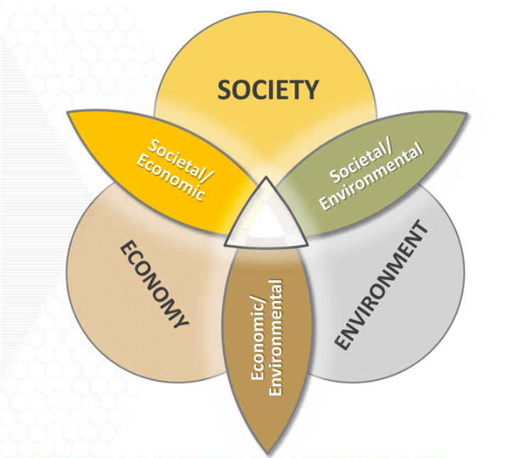
SDG 11 and Large Infrastructure Projects
This diagram shows the integrated system approach to sustainability used by Serve-Learn-Sustain.
The case studies that follow describe three large infrastructure projects similar to the Atlanta BeltLine that have been undertaken with the stated aim of contributing to a more sustainable community in the area surrounding them. As you read, consider the elements that make up Sustainable Cities & Communities target items and how each project may contribute to or detract from progress in each area. Each project is described in terms of its societal, economic, and environmental impact, in keeping with Serve-Learn-Sustain’s view of sustainability as an integrated system.

The LA River Restoration
Currently, the Los Angeles River bears little resemblance to the rivers that might be found in less urban settings. The majority of the river’s length is surrounded by concrete due to a channelization project that was completed in 1960 and designed to serve as flood control (LADPW). In the sixty years that followed, attitudes towards the integration of the built environment and natural resources have shifted greatly, prompting a re-thinking of the role that the LA River can play within the city of Los Angeles.

The result is the LARiverWay project, which will result in around 12.5 miles of new pedestrian and bike infrastructure along the LA River, which the city posits will increase connectivity and access to essential amenities and greenspace. The trail will connect diverse neighborhoods and will be constructed in tandem
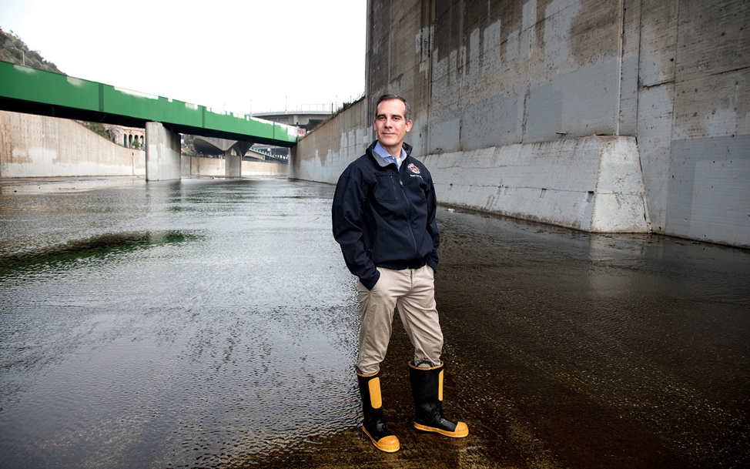
with new parks in areas that previously had little greenspace (Hahn). The restoration represents an attempt to integrate the LA River with the fabric of the city while providing space for recreation and alternative modes of transportation.
Los Angeles Mayor Eric Garcetti standing in the LA River (Hahn)

The revitalization project has also spurred development. Proposed housing developments near the trail have ranged from luxury condos that could be seen as a harbinger of gentrification to an attempt at an affordable mixed-use community (Hahn). However, some groups such as the Natural Resources Defense Council are proposing preemptive policy strategies to prevent displacement. Such strategies include required affordable housing and community planning (Nagami). This would require involvement from multiple stakeholders, including the City of Los Angeles and community groups.

In addition to the miles of trail that will be installed, changes to the channelization of the river will also have environmental benefits. The LARiverWay project will function as green infrastructure promoting better stormwater capture (City of Los Angeles Bureau of Engineering). In some areas, the concrete in place from channelization will be removed to allow the river to flow naturally (Hahn). This green approach to managing the watershed represents a vital shift away from the attempts at flood control that marked LA River infrastructure endeavors in the 20th century.

The Indianapolis Cultural Trail
In 2013, the city of Indianapolis completed the Cultural Trail, which spans 8 miles and connects six designated cultural districts (Indianapolis Cultural Trail). The trail provides pedestrian and bike infrastructure with an emphasis on public art and the city’s cultural amenities, while also connecting neighborhoods with greenspace.

The trail is intended for recreational purposes, allowing people to bike and walk around Indianapolis rather than drive, and also serves as a draw for tourists who come to the city. The Cultural Trail has been intended for cyclists since its inception but has recently expanded cycling amenities in terms of accessibility by offering an adaptive bicycle program (Benson), showing that the nonprofit which manages the trail is facilitating the trail’s use for everyone regardless of mobility level.

The trail has had an impact on the surrounding built environment, with an estimated 3,000 units of housing being built in adjacent neighborhoods (Litt). As with other large infrastructure projects of this kind, development along the trail has not been limited to housing alone. An estimated $100 million in development has been generated by the Cultural Trail (Litt). With this boom has come an estimated increase in property values of $1 billion, potentially increasing property tax assessments and putting a financial strain on long-term residents (Courage). One way that local residents are attempting to preserve affordability in the midst of these changes is through a land trust (Courage). Interestingly, the land trust that is part of the Artist and Public Life Residency (APLR) program is targeted towards providing affordable housing to local artists (bigcar.org). This drives home both the importance of art and culture to the city of Indianapolis and the irony that increased housing prices may drive artists away from the Cultural Trail.
The design of the Cultural Trail also emphasizes harmony with the environment. The 5 acres of gardens along the Cultural Trail include green infrastructure, such as rain gardens and swales that safely absorb stormwater and thus benefit the White River watershed, as well as plantings that attract pollinators (Indianapolis Cultural Trail). While the White River is not directly connected to the Cultural Trail, the trail indirectly effects the health of the river through these gardens.
Gardens along the Cultural Trail (Indianapolis Cultural Trail)

Denver’s 5280 Trail
The 5280 Trail was first envisioned as part of Denver’s Outdoor Downtown Plan, which called for a vast increase in the amount of greenspace within the center of the city, as well as a trail spanning at least 5 miles and connecting this new greenspace to surrounding neighborhoods (Baumann). The trail will be constructed over the next decade (Murray). It is an effort to bring an element of nature into a downtown area that lacks a significant natural element.
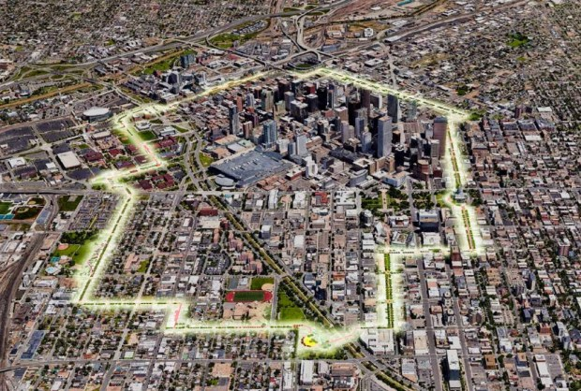
The planned route for the 5280 Trail (Murray)
The 5280 Trail is envisioned as a pedestrian and bicycle trail with a linear park structure. City residents are hopeful that this new infrastructure will not just serve as a means for recreation, but also as an alternative to driving; however, planners involved with the trail specifically state that it is not intended for bicycle commuting in the way that on-street bicycle lanes are (Murray). This indicates that recreation is envisioned as being the main purpose of the trail.

While the trail is still in the planning stages and its impact on development is yet to be known, the 5280 Trail is being modeled along the lines of the Indianapolis Cultural Trail rather than Atlanta’s BeltLine or New York City’s High Line (Murray), both of which have become associated with rising property values and subsequent displacement.

In terms of environmental impact, the greenspace that would be served by the 5280 Trail would exist not only as recreational space, but also as a means of expanding urban tree cover (Baumann). Such an increase in the amount of tree canopy would provide increased shade and potentially modulate the increased temperatures that usually occur in downtown areas. The influence of the Cultural Trail also shows in the way that the planners of the 5280 Trail aim to include landscaping that functions as green infrastructure.

Evaluation Activities
Small Group Activity
Divide students into small groups to be assigned one of the three case studies. Have students discuss and record their evaluation of the project according to the ten targets that make up SDG 11, Sustainable Cities and Communities. Students can disregard targets that do not seem relevant and focus on those that seem particularly connected (whether positively or negatively) with their assigned infrastructure project.

Class Activity
Select several of the most relevant targets (this can be done using class input) and create a matrix on the board/in a virtual drawing board comparing the three infrastructure projects in these areas. If students have been learning about the Atlanta BeltLine as part of the class, this can be added as a fourth item to compare and contrast and to include in discussion.

Discussion Questions
Can be used with either activity
- What are some of the benefits for local governments and planners of connecting local infrastructure projects with a broad global goal such as SDG 11? What are some of the drawbacks?
- Thinking in depth about one of the targets, what are some metrics that you would propose to quantify progress towards it? For example, how should housing affordability be measured or tracked?
- Many large infrastructure projects are undertaken using funds from private donors. How could this impact the expected outcomes that planners and designers try to achieve with the projects?
- How do green infrastructure improvements such as rain gardens and increased tree canopy reduce cities’ environmental impact? Is the reduction in environmental impact from trails significant for cities?
- What is gentrification? What is displacement? What kinds of strategies can cities use to mitigate the effect that large infrastructure projects have on surrounding neighborhoods and long-term residents?
- Are you familiar with a similar infrastructure project in another city? How does it compare with the three projects profiled here, both in general and in terms of alignment with the SDG 11 targets?

Further Reading

The Global Goals

Baumann, Joella. “20-year blueprint for Denver parks envisions 5 mile path around downtown, other changes” (Denver Post, 2017).

Benson, Darian. “Cultural Trail Launches Adaptive Bike Program” (WFYI, 2019).

Big Car. “APLR affordable artist housing.”

City of Los Angeles Bureau of Engineering. “Los Angeles River Valley Bikeways and Greenways Design Completion Project.”

Courage, Cara. “Why Indianapolis is a test case for a fairer form of gentrification” (The Guardian, 2015).

Hahn, Jonathan. “Efforts to Restore the Los Angeles River Collide With a Gentrifying City” (Sierra Club, 2018).

Indianapolis Cultural Trail. “History.”

Litt, Stephen. “The New Indianapolis Cultural Trail is a masterpiece of bike-friendly design Cleveland should emulate” (Cleveland.com, 2019).
Los Angeles Department of Public Works (LADPW). “History of the Los Angeles River.”

Murray, Jon. “5280 Trail aims to be Denver’s answer to New York City’s High Line” (Denver Post, 2019).

Nagami, Damon. “Planning for Equitable Development Along the LA River” (NRDC, 2019).

