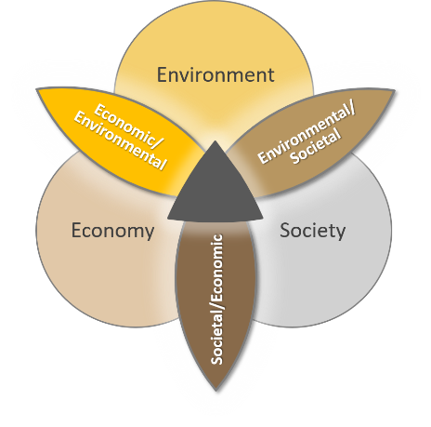
Equitable & Sustainable Development Framework
As cities across the U.S. address the challenges of sustainability, they often turn to large infrastructure projects intended to support natural systems (e.g., air, water, green space) and improve quality of life for residents. Urban infrastructure is defined as the systems of facilities and services that allow cities to function, such as the energy grid, road and trail networks, water systems, storm water systems, and waste systems. For many, these projects have become a key component of what we think of as “sustainable development”:
“Sustainable development is development that meets the needs of the present without compromising the ability of future generations to meet their own needs.”
Many of these development projects have garnered international attention - such as New York City’s High Line, the River District in Portland, Oregon, and Discovery Green of Houston, Texas. Here in Atlanta, we also have one such project that has put Atlanta on the global map for sustainable development: The BeltLine, an urban redevelopment project that is turning 22 miles of abandoned railways into a corridor connecting 45 neighborhoods via transit, multi-use trails, and parks.
The BeltLine evokes a lot of excitement, but it also raises concerns, particularly about how such large infrastructure projects can lead to gentrification and displacement: the process whereby high income, predominantly white residents move into newly developed areas, replacing low income or working-class residents and business owners - particularly those of color. In losing the latter, we also lose valuable, valid, and existing community culture.
As students in the iGniTe Sustainability Track, you’ll have the opportunity this summer to explore how environment, economy, equity and society shape large infrastructure projects like the BeltLine and are shaped by them. In your courses, you’ll explore this and related questions from different academic perspectives and, through interactions and partnerships with community organizations, through the lens of their particular work on development challenges. The special events we’ve planned for you outside of class will bring students from all the sustainability courses together with some key partners to give you a birds-eye view of these questions, transcending disciplines and demonstrating the importance of bringing together multiple types of experience and expertise to understand and collaboratively solve such large, complex challenges.

Equitable and Sustain Development:
Key Concepts
In the coming weeks, consider how the issues we’re discussing connect to you. You are many things: a citizen, a human being, and a future professional in your discipline. In all of those capacities, you have a responsibility to think about the impacts of your choices on society, culture, the economy, and the environment. Let the key concepts below guide your thinking and learning as we move forward.
#1 | Infrastructure serves multiple purposes. | Sometimes we look at a major infrastructure project and focus on one of its functions, but good infrastructure can serve several functions. The BeltLine provides a transportation corridor for transit, walking, and biking, while it also mitigates flooding, creates business opportunities, restores greenspace, and showcases artists.
#2 | Development decisions impact both human and non-human life. | Humans are just one piece of a complex and dynamic system. Therefore, our decisions need to take all forms of life into consideration. For example, the City of Seattle requires a proportion of new development to include vegetation, which offsets a portion of habitat loss attributed to development.
#3 | Values influence development decisions. | Individuals and communities (professional, geographical, cultural, socioeconomic) bring their values and beliefs to every decision, whether they mean to or not. These values impact infrastructure development. For instance, a city may transform a vacant lot into a community garden, but if neighborhood residents do not value farming or lack proper guidance, then the garden may fall into disrepair.
#4 | Infrastructure development impacts different communities in different ways. | Because infrastructure projects have multiple uses and multiple effects, we must consider why each project is being built, and whom it serves. Development outcomes have different impacts on different groups, and what may be useful to one group may be neutral or even harmful to another. For example, the Old Fourth Ward Skate Park serves as a social and recreational space for youth, but some nearby homeowners view it as a nuisance because it brings noise.
#5 | Your voice is a powerful and necessary tool in assuring that large development projects benefit existing communities and benefit nature. | Government and business entities almost always end up controlling large development projects. To ensure that these projects benefit communities, individuals and communities need to organize and act. They must use their experiences and expertise to contribute a strong voice, one that will influence the direction of projects that impact, for example, the closing of neighborhood schools, a large infrastructural endeavor that impacts local educational practices and access to quality schooling in one’s neighborhood.

WHO WE ARE
Georgia Tech’s motto is “Progress and Service” – and we are upping the ante through Serve-Learn-Sustain, a campus-wide academic initiative working with all six colleges to offer courses and programs connecting sustainability and community engagement with real-world partners and projects. The result? Georgia Tech graduates are using their disciplinary expertise related to science and technology to help “create sustainable communities” where humans and nature flourish, now and in the future, in Georgia, the U.S., and around the globe.
Visit our website to browse over 100 affiliated courses, check out our Events Series, and sign up for our newsletter!
Name | Background & Contributions
Dave Ederer | Graduate student in Civil & Environmental Engineering. Planning the BeltLine tour and developing teaching resources on BeltLine history and values-based design.
Maria Del Mar Ceballos | Architect in Facilities Management and Co-chair of the Facilities Sustainability Committee. Teaching GT1000.
Jennifer Hirsch | Director of Serve-Learn-Sustain. Leading SLS course collaboration around the Sustainability theme.
Allen Hyde | Assistant Professor in History & Sociology. Teaching HTS 3012: Urban Sociology.
Bethany Jacobs | SLS Toolkit Manager. Leading the development of teaching tools and workshops.
Jamie Jones | Sr. Administrative Professional in Serve-Learn-Sustain. Teaching GT1000.
Kevin Lanza | Graduate student in City & Regional Planning. Developing teaching resources on urban heat islands.
Yanni Loukissas | Assistant Professor in Literature, Media and Communication. Teaching LMC 2400: Introduction to Media Studies.
Lauren Neefe | Instructor in Writing and Communication Program. Teaching ENGL 1101: Sound of Equity in the Living Building.
Yelena Rivera-Vale | TV and Web Operations Coordinator, Georgia Tech Cable Network. Teaching GT1000.
McKenna Rose | Instructor in the Writing and Communication Program. Teaching ENGL 1101: Sustaining Ecologies.
Nicholas Sturm | Instructor in the Writing and Communication Program. Teaching ENGL 1102: Poetics of Sustainability: Environment & Immigration.
Shane Totten | Director, Research & Innovation at Southface Energy Institute, an SLS partner. Advising on SLS teaching approach to equitable and sustainable development.
Joycelyn Wilson | Assistant Professor in Literature, Media and Communication. Developing teaching resources that use media artifacts to examine sustainability and gentrification.

World Commission on Environment and Development. Our Common Future. Oxford University Press (1987).

