Community Health

Individual
Health
Health Outcomes

Agency
Access
Resources
Justice & Equity

1. Identify Community-Specific Goals:
- CBPR (Community-Based Participatory Research)
- Facilitators & Barriers/bottlenecks – communication, community leadership, adversity to outsiders making changes
2. Identify Resources Internal & External to the Community:
- Internal to community (asset-based approach)
- Individual skills – “head, hands, heart”… time?
- Local health department/clinics
- Professional organizations
- Local businesses
- Global-local connections
- Survivorship support groups
- External support
- Federal/state initiatives
- Grants/funding
- Federal programs available
- Foundations’ support
- GIS (Geographical Information Systems)/Public health datasets
3. Brainstorm, Evaluate and Choose Solution
- Consider sustainability, empowerment, efficacy
- Consider broad-based cost-benefit analysis

4. Implement Intervention
With those in the community as co-producers implement:
- Behavioral change/lifestyle modification promotion – health clinics, re-education programs
- Environmental enhancement – parks, sidewalks, transportation
- Community gardens, farmers markets, 5K race
5. Evaluate, Monitor & Maintain
- Metrics, surveys, other community sentiment, etc.

- Identify Community-Specific Goals
Understand and describe the community.
- Use GIS (geographical information systems), public health datasets, previous studies
- Develop communication methods to promote interest, and encourage community participation
- Conduct public forums, listening sessions, surveys, interviews, asset mapping, and other CBPR (Community-Based Participatory Research)
- Identify facilitators and barriers

- Identify Resources Internal & External to the Community
- Internal to community
- Recruiting and organizing leaders and volunteers from the community
- Individuals – “head, hands, heart”
- Local health department/clinics
- Professional organizations
- Local businesses
- Global-local connections
- Survivorship support groups
- External support
- Federal/state initiatives
- Grants/funding
- Federal programs available
- Foundations’ support
- Brainstorm, Evaluate and Choose Solution
- Analyze community goals to design choose and adapt interventions
for different cultures and communities
- Consider sustainability, empowerment, efficacy
- Consider broad-based cost-benefit analysis
- Implement Intervention
- Empower the community through education and skill enhancement
- Improve support, incentives and resources
- Increase access and opportunities and remove barriers
- Change policy
- Change the physical and social environment
- Use community building events
- Develop proper methods of media and communication to advocate intervention
- Evaluate, Monitor & Maintain
- Gather and use community-level indicators, surveys, interviews and other feedback
- Routinely reevaluate implementation
- Create a formal public reporting process

Empathy &
Reflection

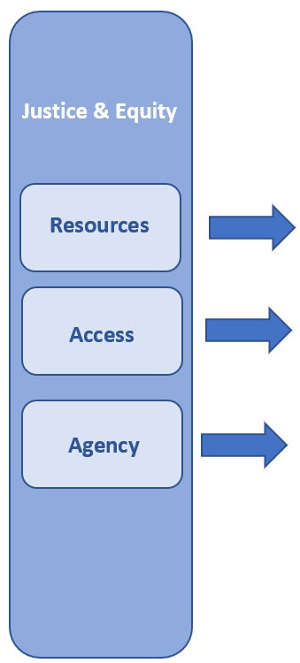
Community Health

Individual
Health
Health Outcomes
Reflection
Empathy &

