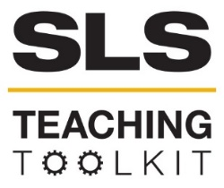 | Communicating Sustainability
Discipline: All | Type: In-Class Exercise; Discussion; Reading | Time Commitment: 50-100 min | Category: Introduction to SLS & Creating Sustainable Communities
Big Ideas: Environmental Justice and Citizen Science; Collaborative Problem-Solving; Information Visualization; Voice & Agency; Technology for Social Good
OVERVIEW:
In recent years, a variety of disciplines in the sciences have made achieving sustainability one of their foundational values. Scholars within these disciplines have devoted their expertise to developing programs and campaigns for achieving a more sustainable world. But these campaigns need broad public support to succeed, and academic scholarship isn’t always written with a public audience in mind. How can scholars present their ideas so as to make them widely accessible and thus, more successful? This tool will introduce you to important concepts in science communication, and guide you through an analysis of real-world examples of sustainability-related science communication. It also includes wrap-up questions, additional resources, and suggestions for collaborative learning opportunities.
This tool was contributed by Christina M. Colvin and Matthew Dischinger.
INSTRUCTIONS:
- Per Part 1 below, use this PowerPoint, to lead an introductory discussion about science communication with students.
- Referring to Part 2, have students read and analyze a set of real-world, disciplinary-specific pieces of sustainability communication. Do this in class or as a take-home assignment.
- Lead a wrap-up discussion per Part 3.
- To extend this lesson beyond one class, refer to the “Additional Resources” and “Suggestions for Collaborative Learning Opportunities” sections.
SLS STUDENT LEARNING OUTCOMES & ASSESSMENT:
The Serve-Learn-Sustain toolkit teaching tools are designed to help students achieve not only SLS student learning outcomes (SLOs), but the unique learning outcomes for your own courses. Reflection, concept maps, rubrics, and other assessment methods are shown to improve student learning. For resources on how to assess your students’ work, please review our Assessment Tools.
This tool achieves SLO 2. See the end of this tool for further details.
Want Help?
Serve-Learn-Sustain is the contact for this tool. You can reach us at serve-learn-sustain@gatech.edu

Communicating Sustainability

Part 1: Introduction
This tool begins with a group discussion (10 minutes) about the links between sustainability and communication. The goal of the discussion is to help students begin to consider the ways sustainability projects require broad support to be effective. The attached PowerPoint takes you and your students through these questions and offers space for you to add notes. The PowerPoint also includes notes that you should review ahead of the presentation.

Part 2: Exploration of Real-World Examples: Sustainability Communication in Action
The second part of this tool is a worksheet that students can respond to either as a take home assignment, or in class. The worksheet is located at the end of this tool. This worksheet provides students with:
- a visual framework by the American Association for the Advancement of Science (AAAS), which shows the differences between how researchers communicate about science and how popular sources communicate about science to a broader, public audience.
- An array of popular and scholarly texts that show the different ways that we communicate about sustainability efforts and issues. You can do Part II in class, or have students complete the exercise as a take-home assignment and then bring their results to the next class to discuss and wrap up.
We have designed this tool to be flexible and adaptable to sustainability-related courses from multiple disciplines. Therefore, while this tool provides a range of suggestions for science communication texts to assign students, you may find that selecting disciplinary-specific texts makes more sense for your course. If you use the options provided, consider assigning texts to be sure that all texts are analyzed by your class.

Part 3: Wrap-Up
After students complete their analyses via the worksheet at the end of this tool, consider concluding class with a discussion session in which you ask students to reflect on what they learned. Possible reflective questions for you to pose to students include:

- How might you revise the AAAS’ science communication framework to demonstrate a more nuanced view of public audiences? Or to better represent some of the varied forms of public science communication you reviewed in this class?
- How might you transform the text you studied into a different medium? For example, if you studied the podcast segment, how might you adapt it into a video essay? How would you take advantage of the features of this different medium?
- What is the primary audience for the medium you selected? Is that medium primarily used in a certain venue for a specific type of audience?
- What do you remember most about the content and/or structure of the text you studied? What was its most essential concept?
- What would be the best medium to tell broad, public audiences about the bottom line of that essential concept?
Additional Resources
Encourage your students to continue learning about communicating sustainability through a selection of additional resources or by incorporating a collaborative learning opportunity into your course.
“Communicating Sustainability: How to Produce Effective Public Campaigns,” (United Nations Environment Programme, 2005).
Hayden, Adam. “Exploring the citizen-science partnership through narrative-based science communication,” (PLOS Blogs, 2017).
Jahng, Mi Rosie and Namyeon Lee. “When Scientists Tweet for Social Changes: Dialogic Communication and Collective Mobilization Strategies by Flint Water Study Scientists on Twitter,” (Science Communication, 2018).
Meisner, Mark. “Environmental Communication: What it is and Why it Matters,” (International Environmental Communication Association, 2015).
Miah, Andy, and Erinma Ochu. “Women in #SciComm,” (The #SciComm Space, 2017).
Union of Concerned Scientists. “Science Communication Tips.”
Yale Program on Climate Change Communication
Suggestions for Collaborative Learning Opportunities
Invite a local science communicator to talk to students
Georgia Tech employs a number of in-house science communicators to promote the research of its faculty and students. Consider inviting one of them to speak with your students about their work. Provide them an overview of the scope of your course as well as potential questions to answer for students during their visit.
Questions of particular interest for the invited science communicator might include:
  - How do you determine the “bottom line” in a piece of science communication you are adapting for a public audience?
  - How closely do you collaborate with the researchers involved in a study you are adapting?
  - What is the biggest challenge of adapting scientific research for the public?
Take a walk (or browse online) with students to examine campus-based pieces of science communication.
Georgia Tech’s own campus is replete with pieces of public science communication. Student researchers regularly hang posters displaying their work near the science labs in the Clough Undergraduate Learning Commons, for example. The Undergraduate Research Opportunities Program holds symposia showcasing student research in the Spring; consider taking your class to visit these student researchers and analyze how they represent and translate their data for an interested audience. Finally, the Georgia Tech News Center provides a regularly-updated repository of public pieces of science communication involving Georgia Tech researchers (both students and faculty). Consider having students analyze a few of these texts using the guided questions from Part II, Section 3 of this tool.
Collaborate with a community partner
Many community organizations are already dedicated to communicating their sustainability goals in engaging, public-facing ways. Contact Dr. Ruth Yow (the Service Learning and Partnerships Specialist at SLS) to learn how your students might help one of these organizations with communication projects. In the past, Georgia Tech students and faculty have conducted interviews with community members and helped craft information pamphlets and other materials for and with community partners.
Schedule a class visit with a science lab at Georgia Tech to learn how we produce data
Many students, faculty, and staff at Georgia Tech conduct research related to sustainability in campus labs and other facilities. Visiting a lab with students will help them see how their course work might already fit into citizen science frameworks under discussion. Consider having students prepare questions for laboratory researchers at Georgia Tech. Those questions might include: What is the bottom line takeaway of the research conducted in this lab? Why should people beyond this discourse community care about the research findings? After answering these and other questions, talk with your students about different mediums through which they could disseminate the information they gathered.

Exploration of Real-World Examples: Sustainability Communication in Action Worksheet
Part I.
Read the AAAS’s introduction to science communication, “Communicating to Engage.” (Note: If this is a take home assignment, also explore the AAAS’s Communication Toolkit more thoroughly, particularly “Communication Fundamentals” and “Using Multimedia and Visuals.”)
Part II.
The AAAS also provides a visual framework (below) for conceiving the structure of science communication based on intended audience. Briefly, the framework suggests that public audiences read for a text’s “bottom line” first, while texts intended for researchers invert this structure, prioritizing background and discussing the “bottom line” last.
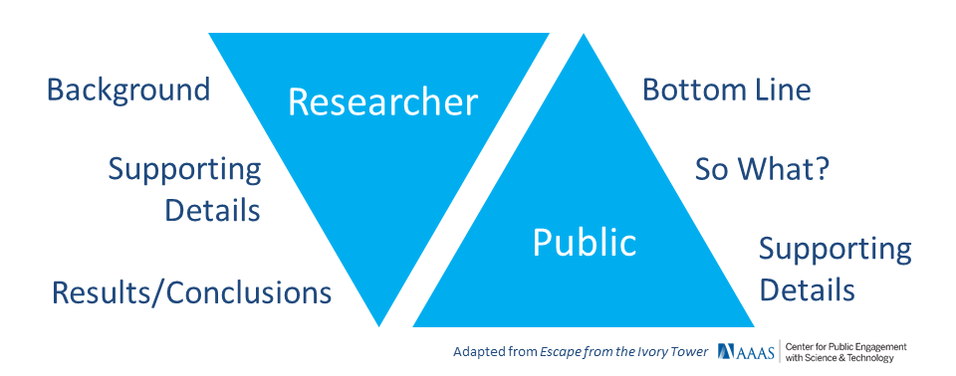
Part III.
In small groups (in class) or individually (outside of class) select one of the following forms of science communication.
Infographic: “Think You Need Eight Glasses of Water a Day? Think Again” (Nature Conservancy)
Comics: “Fracking” by Darryl Cunningham from Science Tales
News article, popular venue: “Scientists are Scrutinizing City Sewage to Study our Health” (Popular Science)
News article, specialized venue: “Running Dry” (Nature News and Views)
Video essay: “Flint’s Water Crisis, Explained in 3 Minutes” (Vox)
Peer-reviewed article: “Drought risk and water conservation expenditures as a household production problem” by John Janmaat (Water Resources and Economics)
Podcast (segment length: 11 minutes): “How Beavers Help Save Water” (Living on Earth, Public Radio International)
Part IV.
Review the features of the AAAS’S science communication framework.
Part V.
Answer the following questions about the text you just studied. Write your answers in complete sentences.
  - What is the “bottom line” or major takeaway from the text? Put the “bottom line” into your own words and/or quote directly from the text.
  - How closely does the text follow one of the two frameworks of science communication provided by the AAAS? Approximately where in the text is the “bottom line” located?
  - Who is the audience for this text? How do you know? Does the text’s language, publishing venue, structure, and/or focus provide you clues?
  - Does the text incorporate multiple forms of communication (i.e., text, images, audio, etc.)? Why are these forms of communication included? How do they work together to engage an audience or to enhance your understanding of the science described?
  - Describe the forms of evidence (expert testimony, peer-reviewed citations, etc.) the text provides. Why do you think the text exercises these forms of evidence? How do these enhance your understanding of the science described?
Does your text include a way for interested audience members to get involved? If so, what is the nature of that involvement?

SLS Student Learning Outcomes

- Identify relationships among ecological, social, and economic systems.
- Demonstrate skills needed to work effectively in different types of communities.
- Evaluate how decisions impact the sustainability of communities.
- Describe how to use their discipline to make communities more sustainable.
* Note: SLO 4 is intended to be used by upper division, project-based courses such as Capstone.

