 | Land Use, Urban and Environmental Economics Theories in Transportation Planning
Disciplines: CEE, city & regional planning, public policy, environmental science, history & sociology | Type: Flipped classroom /in-class activities | Time Commitment: 1.5 hours of students preparation + 1.5 hours of lesson | Category: Equitable and Sustainable Development
OVERVIEW:
This tool is designed to help students identify connections between the disciplines of planning, transportation engineering, environmental studies, public policy, land use planning, and environmental economics. The goal of the tool is to support students with different backgrounds to understand basic concepts from these related fields and be able to apply them in their subject area. The concepts involved help explain congestion, emissions, urban sprawl, and other common phenomenon in urban transportation systems. The knowledge developed through this tool will help students understand how to make transportation systems more sustainable.
This tool uses pre-recorded lecture videos and in-class activities to allow students to manage their learning of land use, urban, and environmental economics concepts in transportation planning. Before the formal class time, students with varied prior knowledge will watch the pre-recorded lecture videos at their own pace. They will be asked to post at least one question on the Canvas discussion thread and answer at least one of their peers' questions. These will become the basis for designing the in-class discussion session. A one-hour “jigsaw” discussion or a half-hour game will help students to further apply, migrate and transfer their knowledge.
INSTRUCTIONAL PLAN:
- Knowledge Acquisition: Have students review the pre-recorded lecture videos one to two weeks before the class.
- Knowledge Consolidation: One week before the lecture, ask students to post a question on the Canvas discussion thread and answer a question from a peer; facilitate in-class discussions.
- Knowledge Migration (in-class activity):
  - For Transportation Engineering and Urban Planning students: Jigsaw discussion about applying the knowledge to a real-life problem
  - For Environmental Science, Public Policy, and other Liberal Arts students: a game on public goods
- Conclusion: Have students complete a cheat sheet that summarizes the contents of the video and class activity.
STUDENT LEARNING OUTCOMES:
This tool is expected to serve four student groups: graduate and senior undergraduate students in (1). Transportation engineering who are interested in learning about land use and how it influences urban transportation plans ("transportation engineering"); (2). Urban planning or urban studies, interested in land use economics and their implications for transportation systems ("urban planning"); (3). Environmental science, environmental studies, or environmental management, to learn how economics principles explain the phenomenon of urban land use and transportation development and how they interact with cities' carbon footprints ("environmental studies"); and (4). Public policy, politics, or social sciences interested in understanding interactions between the urban environment and policy making ("public policy").
This tool may also benefit (1). Students in history, humanity, and anthropology to understand the evolution of urban settlement and transformation of urban forms; (2). Students in geography and geosciences to understand the reason behind urban layout; and (3). Students in economics to apply economic models to practical problems in urban settings. However, these applications will require further extension of the tools beyond this toolkit development's scope. Therefore, these are not the focal point of discussion in this toolkit, but instructors are welcome to re-evaluate and continue developing the tool where they see fit.
Note that the goal of the lesson as it is developed is not for economics students to understand the sophisticated theories behind the model but for students in other majors who need to apply these concepts to have a starting point of understanding them, gradually adding complexity as appropriate. The lesson's goal is to train students to identify the question behind the problem they want to solve and the embedded assumptions and mechanisms they may neglect.
After completing this lesson and its associated activities and practices, students will be able to:
Transportation Engineering:
- Describe, with some graphics or visual aids, the urban externality model, monocentric city model, and spatial segregation model and be able to communicate with planners and decision-makers in economic language.
- Apply these models to explain why congestion and emissions, shift in modes, and spatial segregation exist in cities across the U.S. and globally.
- Students reflect on how disciplinary models influence the ways in which professionals approach transportation planning challenges.
Urban Planning:
- Describe, with some graphics or visual aids, the central place model, monocentric city model, and spatial segregation model discussed in the class, and be able to communicate with decision-makers and urban economists in economic language.
- Apply these models to compare cities in terms of their characteristics and differences in land use development patterns/trends.
- Students reflect on how disciplinary models influence the ways in which professionals approach transportation planning challenges.
Environmental Studies:
- Describe, with some graphics or visual aids, the social welfare theory, externality model, and public good theories discussed in the class, and be able to communicate with decision-makers and other professionals in the economic language.
- Apply these models to understand the source of real-life environmental problems and make policy recommendations based on urban economic dynamics.
- Students reflect on how disciplinary models influence the ways in which professionals approach transportation planning challenges.
Public Policy:
- Describe, with some graphics or visual aids, the social welfare theory, externality model, public good theories, and spatial segregation model discussed in the class, and be able to communicate with other professionals in economic language.
- Apply these models to analyze public issues in urban settings and the source and mechanisms behind potential conflicts of interest.
- Students reflect on how disciplinary models influence the ways in which professionals approach transportation planning challenges.

Land Use, Urban and Environmental Economics Theories in Transportation Planning
Contents
Summary of Process 6
Detailed Instructions 8
Part I. Knowledge Acquisition: Pre-recorded Lecture Videos 8
1. Economics Overview (optional) 8
2. Economics Principles (optional) 8
3. Economics Market (optional) 9
4. Social Welfare 10
5. Externality 11
6. Public Goods (optional) 12
7. Land Use Definitions 13
8. Central Place Theory 14
9. Monocentric City Model 15
10. Spatial Segregation 15
11. Mega-region (optional) 16
Part II. Knowledge Consolidation: Canvas Questions and Discussion 17
Rationale for the Selection of Pedagogical Technique 17
Canvas Questions and Answer 18
Instructor’s Response and Discussion Preparation 18
In-class Discussion 19
Part III. Knowledge Migration: In-class Activity (Jigsaw Discussion) 22
1. Physical Boundary 25
2. Public Transit 25
3. Highway Improvements 26
4. Highway and Land Use 26
5. Sidewalk Maintenance 26
Part IV. Knowledge Migration: In-class Activity (Public Goods Game) 28
Part V. Conclusion: Summary Cheat Sheet 31
Possible Extensions and Substitutions 32
Pre-class Survey 32
Online Quiz 32
Instructions for Other Use Cases 34
Resources for Further Reading 34

Summary of Process
This tool is designed to be implemented in a flipped classroom format. Students are expected to review the course contents from pre-recorded lecture videos outside of class. The class time will be designated for discussion and in-class activities.
- Knowledge Acquisition: Have students review the pre-recorded lecture videos one to two weeks before the class.
- Knowledge Consolidation: One week before the lecture, have students post a question on the Canvas discussion thread and answer a question from a peer; Facilitate in-class discussions.
- Knowledge Migration (in-class activity):
  - For Transportation Engineering and Urban Planning students: Jigsaw discussion about applying the knowledge to a real-life problem
  - For Environmental Studies and Public Policy students: a game on public goods
- Conclusion: Have groups of students complete a cheat sheet that summarizes the contents of the video and class activity.
Table 1 summarizes the planned setup of the lesson for different student groups:

Table 1. Summary of the process for different student groups
 | Knowledge Acquisition | Knowledge Consolidation | Knowledge Migration | Conclusion
 | 1-2 weeks before class | 1 week before class, and 20/40 minutes in class | 40/60 minutes in class | 10-15 minutes in class
Transportation Engineering | Required: videos #5,8,10  Recommended: videos #3,4,8 | Canvas discussion: 1 week before class; in-class guided discussion: 15-20 minutes | Jigsaw discussion of the application of the knowledge in real-life | 10-15 minutes to complete a summary cheat sheet and post final questions
Urban Planning | Required: videos #7,8,9,10  Recommended: videos #4,5,6
Environmental Studies | Required: videos #4,5  Recommended: videos #1,2,3,10 | Canvas discussion: 1 week before class; in-class guided discussion: 35-40 minutes | Game on public goods
Public Policy | Required: videos #4,5,10  Recommended: videos #1,2,3

Detailed Instructions

Part I. Knowledge Acquisition: Pre-recorded Lecture Videos
The pre-recorded course content will include eleven videos:
- Economics Overview – provides an overview of microeconomics and the ground rules for the following videos (optional) (9 minutes)
- Economics Principles –the fundamental concepts, assumptions, and propositions in microeconomics (optional) (25 minutes)
- Economics Market –supply, demand, and market equilibrium (32 minutes)
- Social Welfare – consumer and supplier surplus, social welfare, and tax revenue (20 minutes)
- Externality – positive and negative externality and their examples (16 minutes)
- Public Goods – an example of the public goods game setup and implementation (12 minutes)
- Land Use Definitions – concepts of land use, land use modeling, and common land use models (18 minutes)
- Central place model – formation of cities, rank theory, gravity model (17 minutes)
- Monocentric city model – urban gradients, within city equilibrium model, bid-rent model, urban boundary (27 minutes)
- Spatial Segregation – Tiebout sorting, tipping model (19 minutes)
- Megaregion – definition, cases (optional) (6 minutes)

1. Economics Overview (optional)
This video serves as an introduction for videos 02. Economics Principles; 03. Economics Market; and 04. Social Welfare.
For possible extension into other use cases, this video can include the results of a pre-class survey (details: Pre-class Survey) and communicate the instructor's expectations, logistics, and housekeeping items.

2. Economics Principles (optional)
This video helps students lay a foundational understanding of microeconomic principles. The goal is to facilitate learning in subsequent videos. Although most content in subsequent videos are still within the reach of most students, instructors should be aware that the content of these videos includes some economic terms and assumptions that some students may find difficult. Therefore, it is recommended that instructors carefully review the video they want to provide students, identify those potential challenges, and use all or part of this video to help students gain the necessary prior knowledge.
The main content includes:
- Scarcity & Trade-off
  - Scarcity: the basic assumption in microeconomics is that society has limited resources. As a result, society can not produce all the goods that people want or consume all goods that people produce. Therefore, people face trade-offs.
  - Opportunity cost: the cost of something is what one gives up for it or what has to be given up in order to obtain something.
  - Efficiency: the property of an entity getting the most it can from scarce resources that they are given.
- Rationality & Incentives:
  - Rationality: rational people are able to purposefully do their best to achieve their objectives. Agents that we discuss in economics are rational. Rational people make decisions at marginal benefits and costs.
  - Sunk cost: a cost that has been incurred and can not be recovered or changed.
  - Incentives: something that motivates one to act. People respond to incentives.
- How do people interact?
  - Specialization: a production method where an individual or company only focuses on one or few limited goods where they gain high efficiency.
  - Absolute advantage: the ability to produce the same good with fewer inputs than others.
  - Comparative advantage: the ability to produce the same good with lower opportunity cost than others.
  - Trade makes everyone better off by allowing individuals to specialize in what they have a comparative advantage in.

3. Economics Market (optional)
This section provides an overview of components in a market – demand, supply, and equilibrium. There are numerous other teaching materials on this same topic that might provide better or more rigorous content than this video provided. This video aims to help students in the aforementioned groups gain familiarity with the topic. Instructors are welcome to substitute part or all of the contents in this material with others they find fit.
- Demand:
  - Law of demand: other things being equal, the quantity demanded for a good falls as the price rises.
  - Private demand and market demand
  - Demand shift
  - Example: travel demand
- Supply:
  - Law of supply: other things being equal, the quantity supplied for a good increases as price rises
  - Private supply and market supply
  - Supply shift
  - Example: part-time job
- Equilibrium:
  - Market equilibrium
  - Shortage and Surplus
  - Shift in supply and demand and their interaction with market equilibrium

4. Social Welfare
This section provides an overview of social welfare – consumer and supplier surplus, total surplus, and taxation. There are numerous other teaching materials on this same topic that might provide better or more rigorous content than this video provided. This video aims to help students in the aforementioned groups gain familiarity with the topic. Instructors are welcome to substitute part or all of the contents in this material with others they find fit.
- Social welfare:
  - Willingness to pay
  - Willingness to accept
  - Consumer surplus
  - Supplier surplus
  - Total surplus
- Taxation:
  - Tax burden: whether the tax is on producers or consumers, the tax burden is shared by both parties with the same impact on surplus.
  - The market is usually a good way to organize economic activities.

5. Externality
This section provides an overview of externality. There are numerous other teaching materials on this same topic that might provide better or more rigorous content than this video provided. This video aims to help students in the aforementioned groups gain familiarity with the topic. Instructors are welcome to substitute part or all of the contents in this material with others they find fit.
- Externality:
  - Definition: a transaction between two parties influences the third party.
  - Positive externality: the influence is in a positive way (e.g., education, research)
  - Negative externality: the influence is in a negative way (e.g., congestion, emissions, noise)
- Externality from social welfare perspectives:
  - Costs: social cost, private cost, total cost.
  - In a market with a negative externality, the equilibrium quantity decided by the private market tends to be higher than the true equilibrium decided by total cost, and the price tends to be lower. This will result in an over-production and a deadweight loss.
  - Demands: social demand, private demand, total demand
  - In a market with a positive externality, the equilibrium quantity decided by the private market tends to be lower than the true equilibrium decided by total cost, and the price tends to be lower. This will result in an under-production and a deadweight loss.
- Conclusion:
  - In a market with an externality, the equilibrium is decided by private cost and private demand.
  - Therefore, there is often an overproduction of goods with negative externality and an underproduction of goods with positive externality.
  - In both cases, social welfare will be reduced when externalized cost/benefit is unaccounted for

6. Public Goods (optional)
This section provides an overview of public goods. This video is optional for urban planning students. This video is unnecessary for environmental studies and public policy students as they will learn the concept in the in-class activity. There are numerous other teaching materials on this same topic that might provide better or more rigorous content than this video provided. This video aims to help students in the aforementioned groups gain familiarity with the topic. Instructors are welcome to substitute part or all of the contents in this material with others they find fit.
There are two general attributes of goods:
- Exclusion ability: the legal right of one to exclude others from using the good
- Rivalry: the quality where the use of the good diminishes the supply for others
These two attributes define the four types of goods for discussion (Table 2)

Table 2. Four types of goods are defined by the exclusion-ability and rivalry
 | Exclude-able | Non-exclude-able
Rival | Private goods | Common resources
Non-rival | Natural monopoly | Public goods

In a market of public goods:
- Free-riding: in the market of public goods, there is an incentive for people to free-ride (they get the same benefit at a lower cost)
- Tendency to under-invest in public goods
- Ways to reduce free-riding behavior:
  - Communication and mutual (legally binding) agreements
  - Continued collaboration over time

7. Land Use Definitions
The Concepts and Definitions section first identifies important definitions of land use and land use planning. Then, we introduce the three common urban structure models, followed by a discussion of generative and redistributive impacts.
The terms "urban activity system", "urban land use", or "urban form" refer to the spatial distribution of people and activities within a metropolitan area. Land use plans often take the form of land use types (e.g., residential, retail, government, and the like) being assigned to all land parcels in the jurisdiction. Land use and zoning laws involve real estate regulation, use, and development. The most common form of land use regulation is zoning. Land use modeling is a quantitative method that uses existing and projected data. This data is combined with economic and social behavior theories to predict changes in land use types and longer-term impacts. Transportation and land use interact in a complicated way through accessibility and activity patterns (Figure 1). Students should also be aware of the various land use models available today.
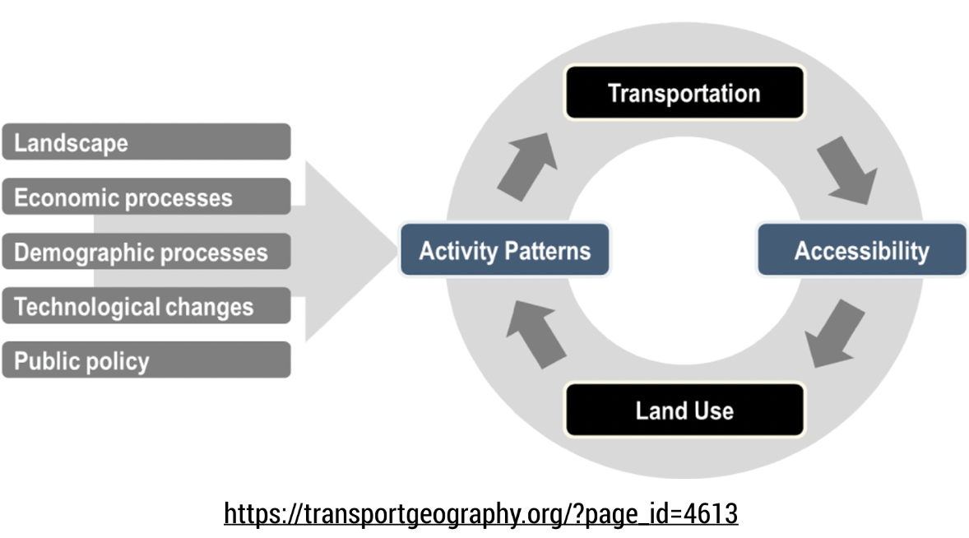
Figure 1. Interaction between Transportation and Land use

Three commonly discussed land use models are the Concentric Urban Model, the Hoyt Sector Model, and the Multiple Nuclei Model. The Concentric Urban Model understands the city as a series of concentric functional circles. Typically, CBD is at the middle of the circle, next to the transition zone, followed by multiple circles of decreasing density land uses. The Hoyt Sector Model tries to understand the influence of major transportation corridors. Industry develops along the major transportation corridor, around which different residential lands develop. The Multiple Nuclei Model assumes multiple urban centers around the city.
Generative impacts produce net economic growth and benefit in a region, such as travel-time savings, increased regional employment and income, improved environmental quality, and increased job accessibility. This is the only type of impact resulting in a net economic gain to society. Redistributive impacts account for locational shifts in economic activity within a region such that land development, employment, and income occur in a transit corridor or around a transit stop rather than being dispersed throughout a region. Transfer impacts involve the conveyance or transfer of money from one entity to another; for example, the employment stimulated by the construction and operation of a transit system financed through public funds, joint development income, and property tax income from development arc redistributed to a particular transit corridor. Transportation plans most often result in redistributive impacts.

8. Central Place Theory
Central Place Theory introduces how cities form and how urban hierarchy develops. It assumes rationality and a homogeneous surface. There are multiple sub-models under the central place theory:
- The market area of a single store: a store serves a certain population. Depending on the supplier's productivity (store) and the demand and density of the consumers (urban residents), the store serves a circle-shaped area.
- The market area of multiple stores of the same type: assuming uniform pricing, the market area becomes rectangular as the market area of any two stores' circle-shaped area intersects (people living at the intersection are indifferent about which store to go to).
- Stores of different types: when there are stores of different types (e.g., a pizza store and an opera house), each type has a different market area. Stores with smaller market areas will open more venues, each at the center of a smaller city/town. Stores with large market areas will open fewer venues at the center of the urban cluster (market-oriented firms only, other types are beyond the scope of the course).
- Rank theory: cities ranking higher tend to have more populations. The product between the size of the city and some exponential form of its rank is a constant. The higher-rank city offers more diversity of services.
- Gravity model: larger cities attract people from further distances because they have more "pull" (variety of products and services), just like planets' gravity.
- Product cycle and urban growth: industries experience a product cycle of incubation rapid growth increased competition maturity decline. So do cities, especially cities that rely upon a few industries. A city with more entrepreneurs, universities, etc., grows faster.

9. Monocentric City Model
The monocentric city model helps explain many phenomena of urban structure within a single city. Understanding the driver behind urban sprawl and how that influences urban transportation is useful. The monocentric city model includes several useful sub-models:
- Urban density gradients: most, if not all, cities have higher density in the urban center and lower towards the fringes.
- Within city equilibrium model – Alonso-Muth-Mills model: the total cost of living in a city remains constant. While transportation costs increase as one moves further away from the city center, housing costs decrease.
- Bid rent model: "A bid-rent curve is a line which indicates how much a person/industry is prepared to pay for a piece of a land at varying distance from the market / the city center." – land prices will decline as the distance increase from the CBD
- A city with satellite towns will likely have multiple peaks of land rent
- A city with multi-modal transportation: prices drop sharply near the urban center and then become flatter further out
- Urban boundary: the place where land rent falls to rural rent

10. Spatial Segregation
Spatial segregation by race, income, and preferences for public goods is prevalent in the U.S. and across the globe. The Tiebout model is a popular and well-recognized model to describe this phenomenon. The Tiebout model makes the following assumptions about communities:
- Countless homeowners and communities (an assumption to ensure perfect competition in the market)
- Communities offer various bundles (e.g., public schools, parks, etc.)
- Homeowners are fully mobile (they can move at 0 time and money cost)
- All homeowners have 100% transparent information about what is offered as a public good and the costs for them in any community
With these assumptions, Tiebout summarizes the following propositions:
- People "vote with their feet".
- People with similar preferences tend to choose the same bundle and thus live together.
- Property taxes fund local government, thus wealthy neighborhood has the incentives to flee out their poor neighbors ("free-riders" who enjoy the same public goods but pay less)
- By urging the local government to set design standards, e.g., minimum lot size, single-family units, maximum number of unrelated dwellers, etc.
- Prices in each community will end up being very similar, and every household will pay a similar share of public goods.
The Tiebout model is very helpful in understanding why people with similar preferences for public services tend to gather together and live in the same community. It also helps and provides implications for why people gather in income groups.
The Race and Tipping Model is another popular model that helps understand spatial segregation. It uses simple mathematical derivation to show that even a small preference to live within the same race group could lead to complete racial segregation.

11. Mega-region (optional)
Megaregions are clusters of two or more adjacent urban metropolitan areas that share some commonality of systems and, as a result, have blurred boundaries for funding, policy coordination, etc. Many megaregions were initially developed for jointly combating environmental issues. Megaregions also bring higher economic competitiveness for every participating metro area. The formation of megaregions is a natural process of regionalism that cannot be easily changed with plans. Some common ways to identify megaregion boundaries include using threshold, GIS mapping, defining functional or uniform regions, essentialist approach, and rational approach.

Part II. Knowledge Consolidation: Canvas Questions and Discussion

The Rationale for the Selection of Pedagogical Technique
For this lesson, the Canvas questions and discussions are designed to help instructors understand students' learning and to foster more in-depth consolidation of knowledge. Though it may appear easy for students, difficult to implement, and/or time-consuming for instructors, the toolkit developer has tested it out in a class and received positive feedback. This part should benefit students' learning in at least three aspects:
- Due to the lesson's interdisciplinary nature and the students' diverse backgrounds, there is a significant variation in their familiarity with the content. Interpreting students' learning progress can be particularly challenging, especially for instructors who may have reached an advanced level of understanding in their discipline, resulting in an "unconscious competence" stage. Consequently, students are highly likely to be confused about certain topics or assumptions that the instructors might not have anticipated. Therefore, fostering a two-way interaction becomes vital in this context, as instructors rely on students' inputs to grasp their learning process.
- The lesson follows a flipped classroom approach, wherein the initial stage (preparation) requires students to take the initiative and thoroughly review the provided material. Conducting an assessment to gauge students' understanding and foster their motivation to learn is essential. If circumstances permit, instructors may offer a bonus credit incentive to students who complete this stage within the given timeframe.
- The second stage of the lesson engages students in deep discussions and collaborative activities. Students derive maximum benefit when these discussions are both open and inclusive, providing a welcoming environment that encourages intellectual stimulation and challenges their thinking. Creating a safe space and fostering community is crucial for this stage. However, if this lesson occurs early in the semester when students are unfamiliar with one another, and the learning community is yet to develop, it can potentially hinder the quality of the discussion. To mitigate this, utilizing Canvas for question-and-answer sessions and facilitating structured short discussions can serve as a preparatory step, ensuring a welcoming atmosphere before delving into the more in-depth discussions that follow.

Canvas Questions and Answer
Starting a week before the class (a week after the students receive the pre-recorded lecture contents), the instructor should open a Canvas discussion thread to collect questions. At least 48 hours before the lecture, students are asked to post at least one question on Canvas; at least 24 hours before the lecture, students are asked to answer at least one question from their peers, also on Canvas discussion. This will be the starting point of discussion for the lecture on the next day. It will also serve as a basis for the instructor to understand where students get stuck and how to organize the lesson for the next day. Figure 2 is an example of the Canvas discussion thread.
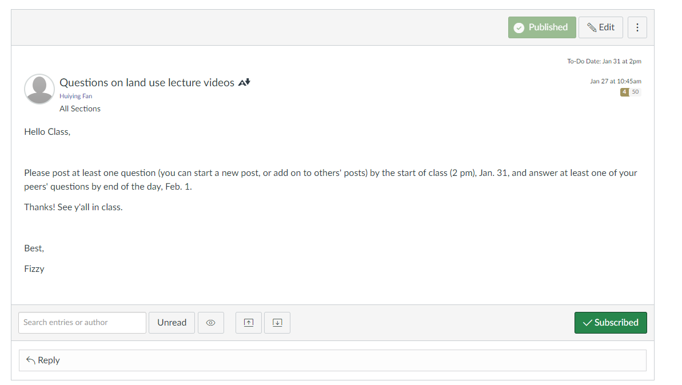
Figure 2. Canvas discussion thread

Instructor's Response and Discussion Preparation
The day before the lesson, the instructor will read the Canvas discussion thread, and identify common questions and students' answers, to evaluate students’ understanding and confusion about different topics. Instructors are welcome to develop their strategies to handle the questions, but here are some suggested strategies for instructors to choose from:
- For questions that are common among students and have already been answered well by others (highly general and within the class's capability), there are two recommended steps: a. Post a concise summary of the question, providing additional context and a few hints on how to approach it, either as a Canvas announcement or by editing the discussion post. b. Develop a real-life application case related to the topic in question, which can be a discussion topic during class. For example, if multiple students have questions about externality that have been adequately answered, the instructor can create an announcement highlighting the concept and develop a case study on how students can interpret transportation-related emissions.
- For questions common among students but not answered well by others, the following strategies are suggested: a. Develop a thought process outlining how the problem could be approached from the perspective of the student group's discipline. If the instructor comes from a different background than the students, it is advisable to seek input from colleagues or students who share the same background. b. Convert the thought process into 2-3 discussion prompts that guide students through problem-solving and encourage deeper thinking.
- For infrequent questions that have been answered well by other students, the instructor can choose either of the following based on the question's significance: a. Implement the strategies mentioned in point 1 for highly general questions. b.Summarize the question and provide hints within the specific discussion post dedicated to that student.
- For questions that are infrequent and have not been answered well by others, the instructor can choose either of the following based on the question's importance: a. Implement the strategies outlined in point 2 for highly general questions beyond the class's capability. b. Summarize the question and provide hints within the specific discussion post dedicated to the individual student. Additionally, encourage the student to seek further clarification during office hours to continue the discussion.

In-class Discussion
The in-class discussion is planned for the first half of the lecture, for 15-20 minutes for Transportation Engineering and Urban Planning students and 35-40 minutes for Environmental Studies and Public Policy students. The different time allocation is because Transportation Engineering and Urban Planning students will focus more on knowledge migration and transfer, to understand how to apply the new knowledge to solve real-life challenges in their disciplines. In contrast, for Environmental Studies and Public Policy students, the main focus is understanding the mechanisms and why things happen they way they do. Their content also involves greater detail in economics and some mathematics that many students may or may not be already familiar with. For these students, the highlight is less on knowledge migration and transfer and more on consolidating what they have learned and clarifying confusion.
The instructor should prepare 3-5 discussion topics for Transportation Engineering and Urban Planning students and 6-8 questions for Environmental Studies and Public Policy students, each with a prompt and some follow-up discussion points to facilitate students to think further and deeper. For a class with students from diverse backgrounds, there could be more questions than expected to be fully explored in a structured discussion. For time efficiency, the instructor can use a lecture instead. In the case when the instructor does not feel comfortable/have the time to implement a discussion, the students are not prepared, or when a discussion is not appropriate for some or all students, or in any other circumstances a discussion may be challenging, the instructor can consider using a quiz instead (details: Online Quiz).
Considering the stage of the discussion in the lesson, and the ease of implementation, the in-class discussion is recommended to be implemented among student groups with 2-3 students in each group, followed by a report-out of students and the class-level discussion and summarization. Instructors can propose and develop their discussion prompts, but here are three common types of questions as a starting point:
- Guided thinking process: this approach will guide students through a problem in a few steps. It is most appropriate for challenging questions or questions many students confuse. For example, in answering the question "Why do transit development and urban density often go hand in hand?" the instructor can guide students through the following discussion prompts: a. What are the determinants of urban housing density? (b). how is transit interacting with the factor you identified in the previous question? (c). how is transit different from other modes, e.g., walking and automobile? (d). what is a transit agency most concerned about when deciding if an area is viable for implementing transit development?
- Solving an example: this approach helps students consolidate and transfer their knowledge for already well-understood concepts. Similar to the previous type of questions, the instructor can provide a step-by-step discussion prompt to guide the students' thought process.
- Listing examples: this approach is the best for a class with less prior knowledge or a need for an ice-breaker. Instructors can ask for examples of a phenomenon to allow students to raise their hands and type the examples answered on the screen or write them down on the board as a "collective contribution" for students to take down later and bring home. Example questions include: what are some common externalities in transportation? Please provide justifications.

Part III. Knowledge Migration: In-class Activity (Jigsaw Discussion)
The Jigsaw Discussion aims to provide a few real-life cases in urban transportation, for students to migrate their knowledge of land use and economics to their own discipline. Each student will first be asked to become an "expert" in the case that they are assigned and then communicate with other students and learn from each other's cases. For a one-hour activity, an example schedule can be:
- Five minutes of individual exercise, where students reflect on the problem independently. This is to give students time to develop some initial thoughts before talking with others and will ensure that each student gets the opportunity to independently think about the question, even if they are not as comfortable in discussion as others might be. In this session, students cannot look at the hints for their questions.
- Ten minutes of paired discussion, where students who receive the same case will be paired to discuss the problem. At this stage, students can open the hints for their questions and refine their thoughts using the hints. The paired discussion will help students develop more systematic and in-depth thoughts about the question, and they will start to formulate the answers. Most students feel more comfortable discussing their ideas in small groups or pairs before entering a large discussion group. The paired discussion is also a step to prepare students in that sense.
- Fifteen minutes of the expert meeting, where all students that got the same case will discuss their thoughts and start to finalize their answers to the questions. The purpose of the expert meeting is for students to listen to their peers working on the same question and to identify where they missed in their earlier thought process. Discussion in large groups will also help stimulate creative ideas. At the end of the expert meeting, each student should have a pretty good understanding of their case with a solid answer to each question.
- Twenty minutes of knowledge share, where new student groups will be formed; each group will have at least a member from each case. In the new group, students will present their case and their thoughts to other members. At the end of the knowledge share, each student will have a good idea about each case and how to understand them under the land use and economics framework.
- 10 minutes exit quiz. Normally, the Jigsaw discussion is wrapped up by an exit quiz to ensure that each student has a solid understanding of their case and cases done by others. Considering the open-ended nature of this Jigsaw discussion, a summative assessment like a quiz may be less appropriate. Instead, students are asked to share at least one takeaway from the Jigsaw discussion on each quiz in a class Padlet (Figure 3). The student inputs are printed and attached to their course material for future reference.
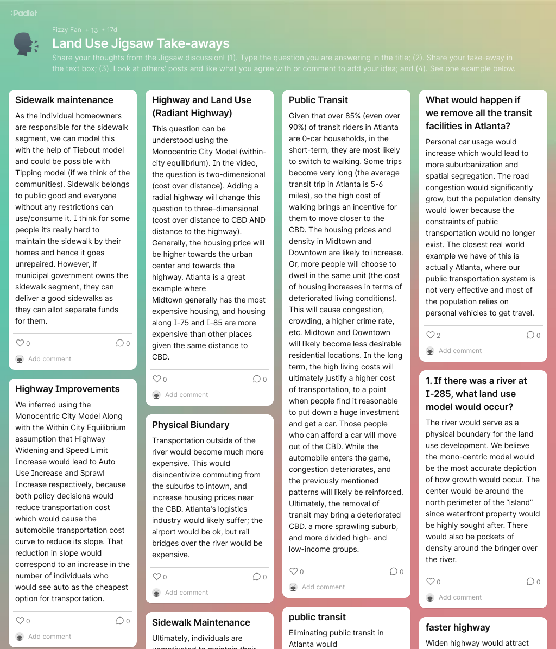
Figure 3. Jigsaw Discussion Takeaway Padlet
The five cases used in this Jigsaw Discussion are Physical Boundary, Public Transit, Highway Improvement, Highway and Land Use, and Sidewalk Maintenance. The question and hints are provided in detail below:

1. Physical Boundary
Question: What would Atlanta look like if there was a wide river around it at the location of the I-285 perimeter?
Hints:
- You may think of the river as a significant (and sudden) increase in transportation costs for people who want to travel to the city center.
- What would happen to the housing price in and out of the perimeter?
- What would happen to the density in and out of the perimeter?
- If the density will be different, what would happen to other aspects of land use and transportation in the city?
- Freight transportation is an important industry in Atlanta. If there was a river, would Atlanta still have the economic competitiveness that it has today? If not, what will it most likely look like?

2. Public Transit
Question: What would happen if we remove all the transit facilities in Atlanta? Think about it in short- (1 year) and long-term (5 years).
Hints:
- In the short term, how would transit users behave if transit options weren't available anymore? Which mode are they likely to switch to? How will this new mode influence land use patterns? How will land use again influence transportation?
- In the medium term, which mode will transit users likely switch to? How will this new mode influence land use patterns? How will land use again influence transportation?
- How will parking space change?

3. Highway Improvements
Question: Many economists and transportation and land use theorists argue that widened highways will bring more automobile use. Do you agree or disagree with this statement? Why? There is another popular proposition that an increased speed limit will bring more sprawl. Do you agree with this statement? Why?
Hints:
- Think of widened highways as reduced costs for automobile transportation (reduced time), what does the law of demand tell us?
- When plotting the cost (time) of driving against distance from CBD, what defines the slope? How will the diagram change with an increased speed limit?
- While you might have thought of the answers to this question, are there any theories (it could be economics, planning, engineering, or anything else) that say the opposite?

4. Highway and Land Use
Question: In the bid-Rent model, it is assumed that the land is homogeneous except distance to CBD. What if we add a highway in the city (a radial highway, like what we see in the Sector Model)? How is it going to influence the housing price and density?
Hints:
- Let's assume we have access to the highway along the way, so we don't have to worry about the location of the exits.
- And assume that every business and every person would like to be close to the highway.
- We have been talking about the bid-rent model in a two-dimensional space (cost over radial distance). Now, you will need to add one more dimension, so it will be - cost over radial distance AND spectral characteristics.
- The most difficult part is to draw the diagram :)

5. Sidewalk Maintenance
Question: In Atlanta, individual homeowners are responsible for maintaining the sidewalk segment in front of their property. What do you expect to see about the quality of sidewalks in Atlanta? Does your observation support your guess?
Hints:
- What type of good does the sidewalk belong to?
- What's special about the property of this type of good?
- How is a sidewalk network maintained by private homeowners different from a sidewalk network maintained by the municipal government, from an economic perspective? What are the challenges that each system faces?
- What will be some viable suggestions for Atlanta? How about cities where the municipal governments are responsible for maintaining the sidewalk?

For all five cases, the Jigsaw Discussion worksheet asks the same set of questions to guide students thinking processes:
- What is/are the applicable model(s) for this question?
- How do you frame this question under the propositions of the model(s) you identified?
- Can you try and plot your thoughts on a diagram (similar to what's used in the video)?
- What conclusions would you make about the question?
- Any real-world examples to support your conclusion?
An example of the worksheet can be found here.

Part IV. Knowledge Migration: In-class Activity (Public Goods Game)
For Environmental Studies and Public Policy students, the learning objectives highlight a solid understanding of the mechanism instead of migrating knowledge to any use cases. Therefore, a public good game is designed to more effectively support understanding of mechanisms. Another consideration arises from the different conceptualization these students may have about some questions and the topic given. Students in Environmental Studies and Public Policy are often trained to approach a problem from a public benefit perspective, and they may find it challenging to understand the thought process and behavior of individual players in the market. This game will help them understand the mechanism behind some of the phenomena they observe in the market.
The game is "Maximize your Chocolate (or Candy, etc.)". In this game, students will be asked to divide into groups of 4-8. The group designation is ideal when assigned to their groups for the final projects or based on some familiarity among the group, as the purpose is to introduce within-group collaboration and among-group competition. The entire game will last about 40 minutes, with 3-4 rounds of decision-making. The instructor will provide instructions in each round and dedicate 5-10 minutes for within-group discussion. Discussion time can vary where the instructor sees fit. After the within-group discussion, one representative from each group will come out for either among-group discussion or reporting of their decision. Instructors need to prepare a bag of chocolates, candies, or similar materials.
- The instructor introduces the rules. Each student group will be provided with one chocolate, candy, or any similar form of "resource" to start with. The instructor lets the students understand the assumption behind the game: rationale and scarcity. That is, the only goal of any group is to maximize the number of chocolate they gain in the end; there are limited chocolates, and the only way the groups can gain chocolate is through the game.
- Round 1:
  - Rule: There is a mutual fund. If the class collectively invests n chocolates into the fund (n needs to be a number smaller than the group count and larger or equal to half of the group count), at the end of the year (round), every group will receive 1 chocolate. Students can discuss within the group, but NOT with other groups.
  - Expected outcome: no group will commit to the mutual fund, and no group lose or receive chocolates.
  - Note: the number of chocolate needs to be set up so that if any group invests and successfully receives chocolate, they will not lose or gain, but the other groups who do not invest will gain. At this stage, the groups do not have trust, and the rational analysis will not permit their investment.
- Round 2:
  - Rule: There is a mutual fund. If the class collectively invests n chocolates into the fund (n needs to be a number smaller than the group count and larger or equal to half of the group count), at the end of the year (round), every group will receive 1 chocolate. The group can discuss within themselves AND with other groups.
  - Expected outcome: no group will commit to the mutual fund, and no group lose or receive chocolates.
  - Note: the number of chocolate needs to be set up so that if any group invests and successfully receives chocolate, they will not lose or gain, but the other groups who do not invest will gain. The groups may or may not trust each other at this stage, but the rational analysis will not permit their investment.
- Round 3:
  - Rule: There is a mutual fund. If the class collectively invests m chocolates into the fund (m needs to be a number that equals half of the group count or the closest smaller to it), at the end of the year (round), every group will receive 1 chocolate. The same mutual fund is repeated for 2 years. The group can discuss within themselves AND with other groups.
  - Expected outcome: (i). all groups will invest, and every group will benefit by receiving one extra chocolate. (ii). all groups but 1-2 will invest, and every group who invested will have the same number of chocolate as before, and the groups who did not invest will gain one extra chocolate.
  - Note: the number of chocolate needs to be set up so that if and only if everyone commits to the investment, everybody will benefit by having one extra chocolate. At this stage, the groups may or may not trust each other. If they trust each other, the rational decision is to invest, and if they do not, the rational choice is not to invest.
  - If outcome (ii) occurs, this triggers Round 4 of the game.
- Round 4:
  - Rule: There is a mutual fund. If the class collectively invests m chocolates into the fund (m needs to be a number that equals half of the group count or the closest smaller to it), at the end of the year (round), every group will receive 1 chocolate. The same mutual fund is repeated for 2 years. The group can discuss within themselves AND with other groups.
  - Additional rule: Everything the groups discussed and settled is legally binding. Groups that do not hold their promises will be charged with 2 chocolates
  - Expected outcome: all groups will invest, and every group will benefit by receiving one extra chocolate.
  - Note: this extra round will introduce an additional term in public goods: legally binding communication
After the game, the instructor can summarize the key mechanisms behind public goods:
- The tendency for people to free-ride out of a rational decision
- The importance of continuous collaboration that will introduce incentives for mutual trust and collaboration
- The importance of legally binding agreements that will ensure trust and collaboration

Part V. Conclusion: Summary Cheat Sheet
A cheat sheet is made for students to complete for the last 5-10 minutes of the class. It will help refresh student's memory of the pre-recorded course video and can be used to review the class afterwards. An example is shown in Figure 4.
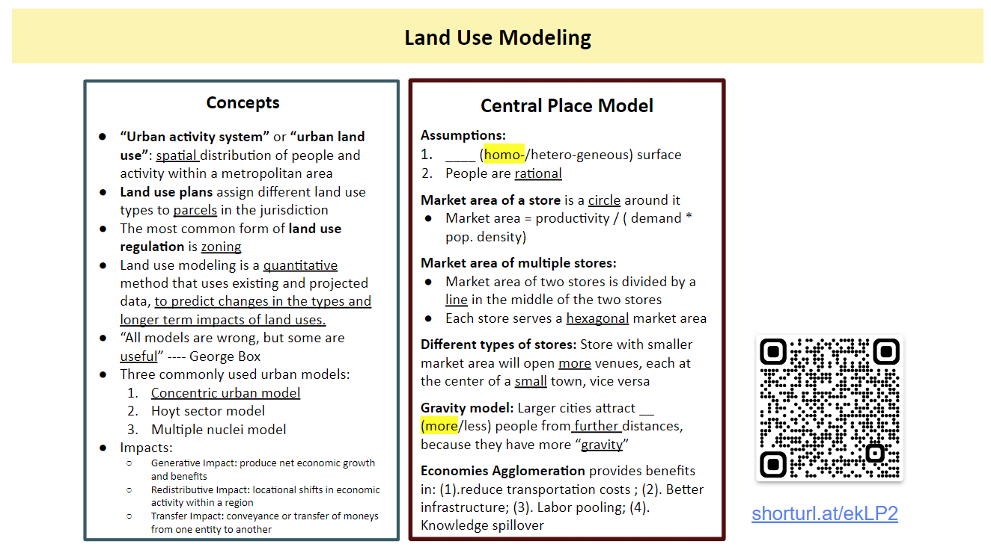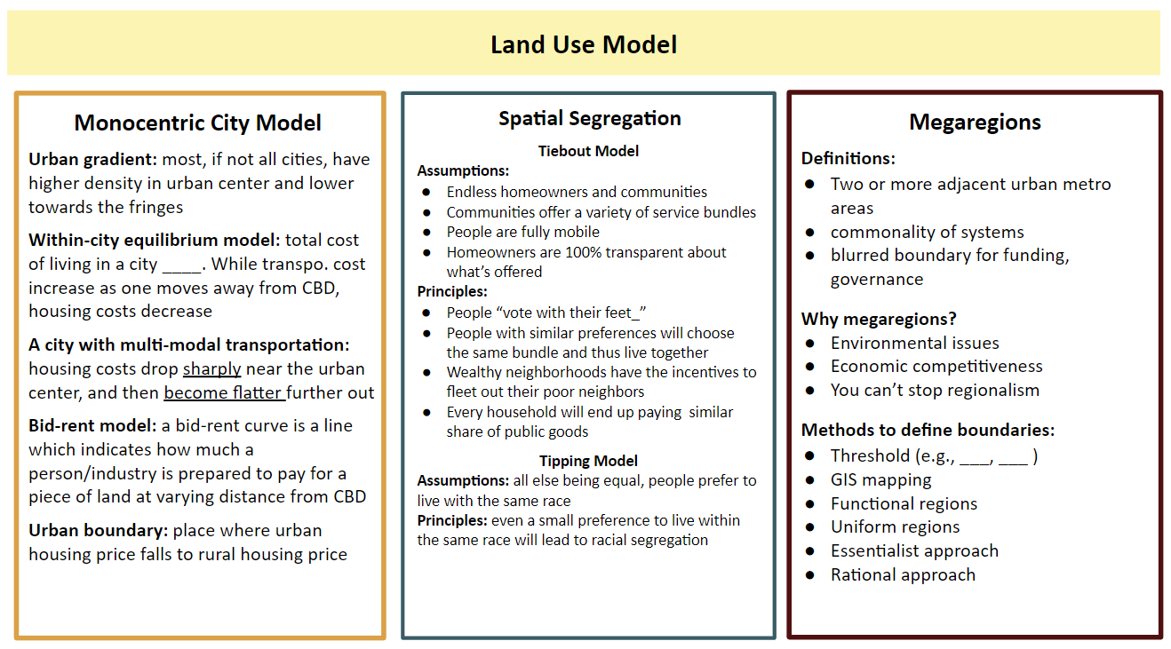
Figure 4. Example of a Two-page Summary Cheat Sheet

Possible Extensions and Substitutions

Pre-class Survey
Some instructors may find a pre-class survey necessary to understand their students' prior knowledge. Since this lesson is designed for students not in economics to learn some basic principles for their application, the level of prior knowledge is hard to anticipate. This survey can be combined with the pre-course survey for simplicity. Two questions are likely relevant:
- What is your level of prior knowledge?
- What is your goal/level of interest in learning relevant knowledge?

Online Quiz
When the instructor wants to cut down the time for in-class discussion, or in any situation the instructor or the students try to avoid the discussion, an online quiz can be used as a formative assessment method to understand students learning. Depending on the availability of technologies, the ideal quiz will be 3-5 questions by the end of each pre-recorded lecture video. If the end-of-video quiz is not available, the quiz can either be online or in-person through Canvas. The quiz questions should align with the context of the course. Figure 5 shows some example questions in the context of urban transportation planning.
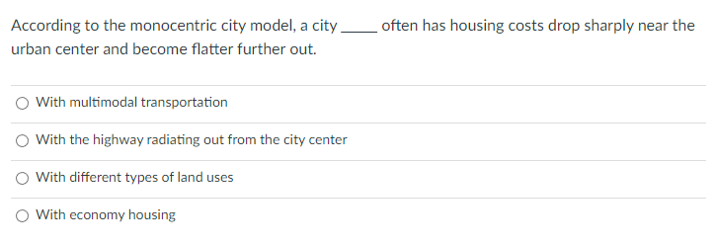
(a)
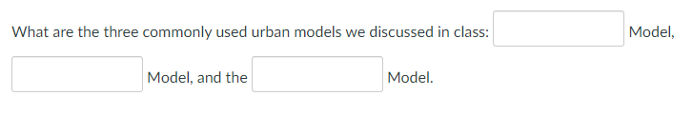
(b)
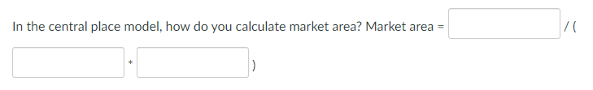
(c)
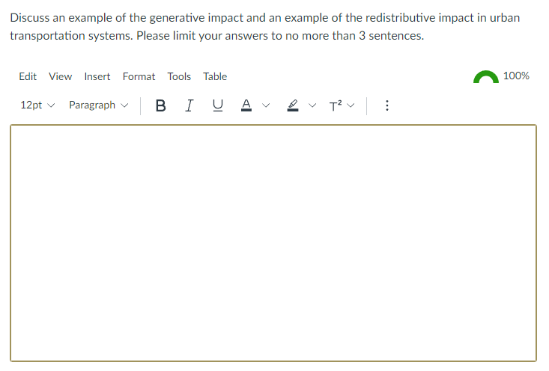
(d)
Figure 5. Example Canvas quiz questions

Instructions for Other Use Cases
If only some of the aforementioned topics are within the scope of the class, instructors can easily modify the course contents to fit individual needs. The pre-recorded lecture videos are prepared in separate files, each for a topic. The instructor can provide the contents they find appropriate for the students. The same is true for the Jigsaw activity worksheet.
On the other hand, if students need more instruction, the instructor can use one and a half or two lectures to introduce the material. When the tool developer taught this lesson, all materials were incorporated into two lessons.
If the class has little prior knowledge of the subject topic, some economic review materials (link) within the context of urban transportation planning may be helpful. Like the land use videos, these videos are also chunked into units for better flexibility, and the examples used are all relevant to the subject.
If the instructor does not plan to use 3 hours of the student's time and would like to trim the session into a normal class time (1.5 hours), the original presentation file that was used to make the videos are also available for an in-person or online lecture (link). Instead of asking students for 1.5 hours of pre-lecture preparation, instructors can change the class into a more traditional lecture format, use the slides for a 45-60 minutes presentation, and use the Jigsaw discussion cases as prompts for short in-class discussions.

Resources for Further Reading
Alonso, W. (2013). Location and land use. In Location and land use. Harvard university press.
Becker, C. (2020, January 14). Market Areas, Central Place Theory, and Urban Economic Growth [lecture]. Urban Economics, Duke University, Durham, NC, United States.
Becker, C. (2020, January 24). Monocentric City Model [lecture]. Urban Economics, Duke University, Durham, NC, United States.
Becker, C. (2020, February 7). Tiebout Sorting [lecture]. Urban Economics, Duke University, Durham, NC, United States.
Brueckner, J. (2019, March 5). The Economics of Urban Sprawl [lecture]. Public Lecture at the Higher School of Economics, Moscow, Russia.
Christaller, W. (1933). Die zentralen Orte in Suddeutschland: Eine okonomisch-geographische Untersuchung uber die Gesetzmassigkeit der Verbreitung und Entwicklung der Siedlungen mit stadtischen Funktionen. Jena.
Glaeser E. [CitiesX]. (2018, February 1). The Within-City Equilibrium Model [Video]. YouTube. https://www.youtube.com/watch?v=QrwgRehzh-I&list=PLswroYMOEWFYdAtnmcM3HLiiGvy9PFTEW&index=12&ab_channel=CitiesX
Glaeser E. [CitiesX]. (2018, February 1). Race and Tipping Models [Video]. YouTube. https://www.youtube.com/watch?v=4c9JQbySRxg&list=PLswroYMOEWFYdAtnmcM3HLiiGvy9PFTEW&index=14&ab_channel=CitiesX
Mills, E. S. (1967). An aggregative model of resource allocation in a metropolitan area. The American Economic Review, 57(2), 197-210.
Mills, E. S. (1972). Studies in the Structure of the Urban Economy.
Muth, R. F. (1969). CITIES AND HOUSING; THE SPATIAL PATTERN OF URBAN RESIDENTIAL LAND USE.
Sase J. [Video Economist]. (2014, August 20). Bid-Rent Theory [Video]. YouTube. https://www.youtube.com/watch?v=xSTWwc3J6RY&list=PLypVCORo_yNdG4zTOGGi43WFK9sbIuKaQ&index=7&ab_channel=VideoEconomist
Sase J. [Video Economist]. (2014, August 3). Agglomerative Subcenters in Monocentric Cities [Video]. YouTube. https://www.youtube.com/watch?v=9W-mPjoNkt8&ab_channel=VideoEconomist
Tiebout, C. M. (1956). A pure theory of local expenditures. Journal of political economy, 64(5), 416-424.

