Worksheet: Designing and Integrating SDG Learning Objectives for Your Course
Step 1: Revisit your existing course learning outcomes and identify relevant SDGs
Review the existing course outcomes and consider them in relation to the SDGs. Which SDG or SDGs are most relevant to your course? Will you incorporate one or multiple? Throughout the course or in a single lesson or unit?
List your current course learning objectives here:

Step 2: Identify the “big ideas” or key questions associated with the SDG(s) you have chosen and integrate, or add, learning objectives.
As a reminder, these resources provide suggested learning objectives for each SDG:
Sustainable Foundations: A Guide for Teaching the Sustainable Development Goals
Education for Sustainable Development Goals: Learning Objectives
Hint: Some of the learning objectives in these resources align with the criteria for strong learning objectives presented in this workshop—others are formatted differently. As you review these resources, consider them as helpful starting points and evaluate then critically, as you would your own course design work, and re-shape if needed.
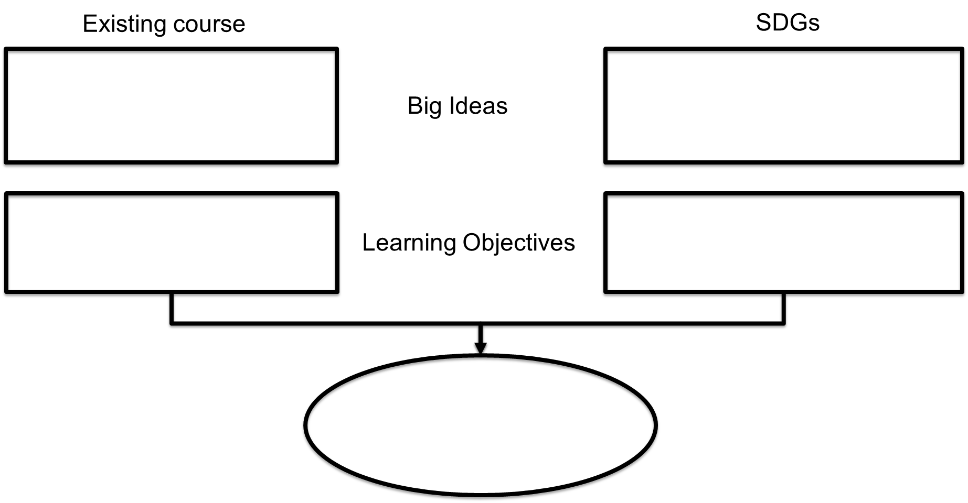

Step 3: Evaluate revised course learning objectives in relation to different kinds of learning objectives.
Which category or categories do you SDG learning objectives align with most closely? Consider whether adding another dimension would strengthen learning outcomes.
- Cognitive learning objectives
- Socio-emotional learning objectives
- Behavioral learning objectives
Step 4: List your revised set of course learning objectives here:

