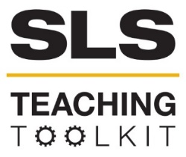 | Student Team Project:  Using a SDG Perspectives to Mitigate the Urban Heat Island (UHI) Effect in Atlanta, GA
Discipline: GT 1000, English/Communications | Type: Group Project | Time Commitment:  1-2 class periods | Category: U.N. SDGs, Equitable & Sustainable Development, Sustainability in Atlanta
OVERVIEW:
This tool incorporates the application of several UN Sustainable Development Goals as an integrated solution to mitigate the Urban Heat Island (UHI) effect in Atlanta, Georgia in a group project. Through the assignment, project teams make connections to SDG 11 (Sustainable Cities and Communities) as well as at least two additional SDGs. Students draw upon goal targets and indicators to develop an innovative design for an urban plot in a metro Atlanta neighborhood that would decrease Atlanta's UHI effect as much as possible. The location of the plot of land is identified through Google Maps and coordinates.
This tool provides guidance for instructors of GT 1000/2000 classes as well as instructors in English/Communications and perhaps additional disciplines. The “resources” section provides suggested background reading/websites/videos for instructors. The Team Project assignment includes a selection of these resources as part of the suggested research material for students.
This tool was contributed by Yelena Rivera, GT 1000 instructor. For support using the tool, please contact Rebecca Watts Hull, Assistant Director, Faculty Development for Sustainability Education Initiatives, CTL: rwattshull@gatech.edu.
INSTRUCTIONS:
Refer to the instructions provided below, modifying as appropriate, to develop a student group project assignment for use in your course.
STUDENT LEARNING OUTCOMES:
After completing this group project, students will be able to:
- Demonstrate the ability to lead and productively participate in collaborative projects.
- Apply concepts described in the UN Sustainable Development Goals to address sustainability challenges in a local context.
- Identify and describe at least one kind of social responsibility they will seek to fulfill as future professionals.

Instructions:
- Before discussing the Team Project with students, introduce them to the 17 United Nations Sustainable Development Goals.
  - Play an introductory video in class: UN Sustainable Development Goals – Overview.
  - In-class activity:
    - Break the class in groups and assign each group 1 SDG.
    - Instruct them to read about their assigned SDG targets on the UN’s website and discuss their findings.
    - One member of each group will report to the class a summary of their discussion.
  - Homework & In-Class Activity:
    - Homework: Assign each student a different SDG (some may be repeated) and instruct them to visit the UN’s website to read about their assigned SDG and its targets and prepare for the class a two-sentence summary of what they learned.
    - In-class: Break the class into groups and have them share with each other what they read, identifying commonalities and differences among the SDGs. One member of the group will report to the class a summary of their discussion.
  - On the day the assignment is introduced, begin with the “Red Alert” video. After the assignment is explained, share the SDG11 video. The first will help provide historical context and the second will further explain the focal SDG 11.
    - Red Alert - How to Meet the Sustainable Development Goals Together | SDG Moment | United Nations
    - SDG 11 | Sustainable Cities and Communities
- Explain what the Urban Heat Island (UHI) effect is. For a GT 1000/2000 class, a basic description of UHI will suffice as part of the Project presentation. The EPA Learn About Heat Islands webpage provides essential information about the subject and a list of resources with more in-depth information. This webpage can be used during class and should be included as a reference in the project description.
  - Preparatory in-class activity suggestion: Have the class read Part I of the SLS Urban Heat Islands and the Georgia Tech Climate Network tool. Divide the class into 6 groups. Have each group discuss one question for the “Questions from the Reading” list. One member of the team shares what they discussed with the rest of the class.
- If time allows, introduce ABCD (Asset-Based Community Development) through the SLS in-class exercise Exploring Asset-Based Community Development: A Tale of Two Cities.
- Choose different locations for each team. All plots/land should be inside the Atlanta perimeter. Identify areas that are most likely affected by UHI. Use the satellite view in Google Maps and take a screenshot of the selected lot/land. Provide students with the coordinates and the screenshot as a reference. Be specific about where the lot/land is located.

- Break students into teams:
  - Group size: Size the group so there are enough members to complete the task. Small groups of 3-4 allow everyone to participate, making scheduling meetings and assigning tasks easier.
  - Criteria: Skills and experiences - Ideally each student will be of a different major, thus bringing a different set of skills and interests to the team. The instructor should explain to the class that this method was used to create each team.
  - Gender: Mixed-gender teams provide an opportunity to learn about gender equality. Some research has shown (Smith-Lovin & Brody, 1989) that in adult conversation, as the number of females in the group rises, the number of male interruptions decrease.
- All teams will work with SDG 11: Sustainable Cities and Communities. In addition, each team will be assigned two additional SDGs that are unique to them. By working with different combinations of SDGs, the students will be able to learn that the goals that at first glance seem to not be related to each other are in fact all connected.
Resources:
A. SDG Related
- Sustainable Development Goals Explained with 3 Useful Tips | Environment SDG Sustainability (Video with a business focus)
- Creating Sustainable Cities (Going Green)
- Achieving the SDGs in Cities and Regions
B. Urban Heat Islands
- How Landscape Architecture Mitigates the Urban Heat Island Effect (By Jolma Architects, September 12, 2018)
- Urban Heat Islands 101 (Hannah Druckenmiller, Resources Magazine, March 14, 2023)
- Recent challenges in modeling of urban heat island. (Parham A. Mirzaei, Sustainable Cities and Society, Volume 19, December 2015, Pages 200-206)
- Cooling urban heat islands with sustainable landscapes. (E. Gregory McPherson, 1994 - In: Platt, Rutherford H.; Rowntree, Rowan A.; Muick, Pamela C.; eds. The ecological city: preserving and restoring urban biodiversity. Amherst, MA: University of Massachusetts Press: 151-171)
- Learn About Heat Islands (EPA)
- Heat Islands and Equity (EPA)
- Masterclass: Understanding, Modeling, and Mitigating Urban Heat Islands (Global Health Information Network)
- About Urban Heat Islands (NIHHIS)
C. Leadership and Sustainability (TED Talks)
- Great leadership is a network, not a hierarchy, Gitte Frederiksen, TED@BCG
- Greening the ghetto, Majora Carter, TED2006
- Step up to sustainable leadership, Karin Ekberg, TEDxErasmusUniversityRotterdam
- The crisis of leadership -- and a new way forward, Halla Tómasdóttir and Bryn Freedman, TED Salon: U.S. Air Force
D. Urban Planning
- United Nations AURA guide
- A Rebecchi, S Capolongo, Healthy Design and Urban Planning Strategies framing the SDG 11 Sustainable Cities and Communities, European Journal of Public Health, Volume 31, Issue Supplement_3, October 2021, ckab164.733,
E. Climate and Project-Related Information about Atlanta and Georgia
- City of Atlanta: Trees Reports and Data
  - Downtown Tree Inventory
- Drawdown GA
- Spatial Analyses of Social Vulnerability and Heat-Related Health Outcomes in Georgia: One Element in the Validation of CDC's Social Vulnerability Index
- UrbanHeatATL: Mapping Atlanta’s Heat Islands with Community Science (Project might not be active.)
  - As heat risk grows, researchers hunt for Atlanta’s hotspots (AJC, June 17, 2022)
- Atlanta’s Urban Heat Island (NASA)
- What Climate Change Means to Georgia (EPA, August 2016)
- Hotlanta’ is even more sweltering in these neighborhoods due to a racist 20th-century policy (CNN, October 2, 2021)
F. Related SLS Toolkits
- An Introduction to Climate Resilience
- Exploring Asset-Based Community Development: A Tale of Two Cities
- Introduction to Equitable and Sustainable Development
- Introduction to SLS & Sustainable Communities
- SLS Case Study: The 1995 Chicago Heat Wave
- SLS Resource List: U.N. Sustainable Development Goals
- Sustainable Cities and Communities: SDG 11
- Urban Heat Islands and the Georgia Tech Climate Network

The Team Project:
Purpose
With this assignment, you will develop your skills to lead and productively participate in collaborative projects while learning how to work with the UN SDGs in a real-world scenario.
You will also practice the following skills that are essential to your success in school and your professional life:
- Researching and gathering information from appropriate online resources.
- Preparing effective visual aids that complement your presentation.
- Presenting information clearly and effectively.
Introduction
The Urban Heat Island (UHI) effect describes why we experience higher temperatures in urban areas compared to surrounding and rural areas. For this project, you will develop a plan for an urban piece of land/plot in a neighborhood inside the Atlanta perimeter that would decrease that neighborhood’s UHI effect as much as possible.
We’re using Google Maps to identify your assigned location. The lots can look different in real life. For this project, if there are structures in your location, assume they could be demolished to allow for your design.
Each team’s design plan must incorporate ideas represented in the UN's SDG 11: Make cities and human settlements inclusive, safe, resilient and sustainable, as well as two additional assigned SDGs that differ from the ones that other teams will be assigned. Each team will choose one target for each of the assigned three SDGs as their primary reference. Choosing a target will help the teams to better focus their projects and to find connections between the three SDGs.
Team 1 (This is an example of how the lot/land assignment would look like.):
- Plot: West Midtown (33.7818545,-84.4105414,151). The building will be demolished.
- The whole area marked in purple will be where your design would be implemented.
- SDG 11: Make cities and human settlements inclusive, safe, resilient and sustainable, SDG 1: Zero Poverty; SDG 4: Quality Education
- Choose one target of focus for each one of your three SDGs.
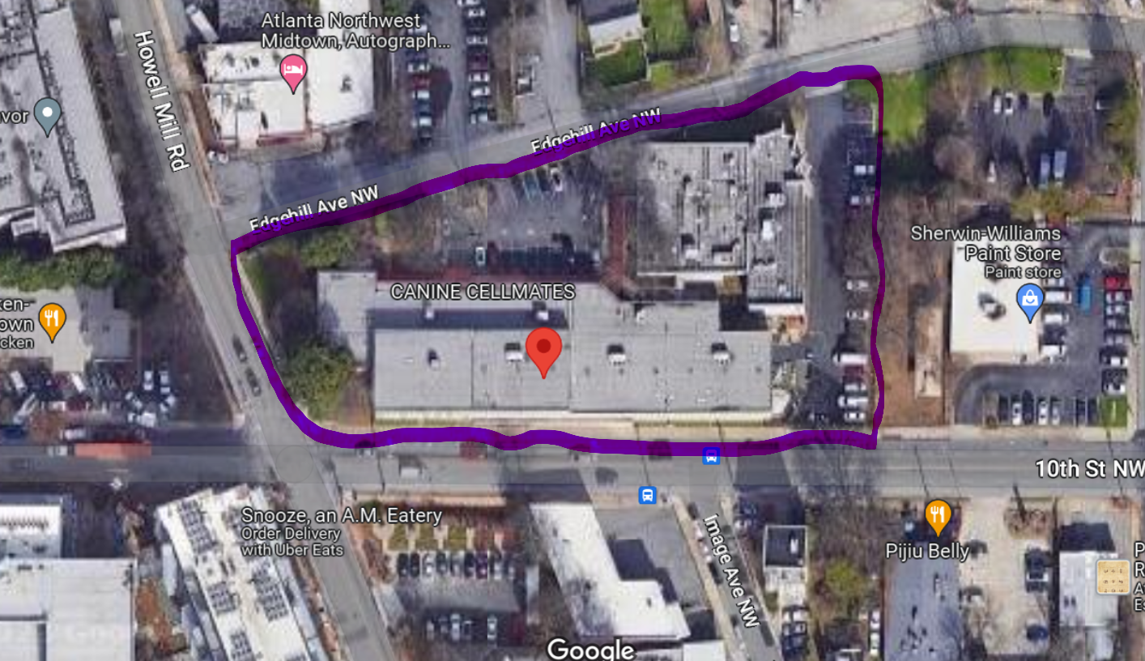
Project description:
Imagine that the City of Atlanta gave your team a piece of land/plot and requested that you design a new way to use this space to decrease Atlanta’s UHI effect as much as possible. The City has specified that the project:
- Will not be an arboretum, a garden, or a park, although they expect that tree planting be part of the design.
- The lot/land design must serve the needs of its surrounding community.
- Since land is highly valuable and scarce in the Atlanta urban area, the design must be for a multi-use space.
- The design must align with Atlanta's sustainability goals, as described by the SDGs guiding your project.
Please note:
Each team has been assigned land/plots in different locations around the city of Atlanta. When thinking about the design, take into consideration the location of your lot since your project/design will directly impact its inhabitants. Use Google Maps or visit your area to learn more about the community. You will also find valuable information on the City of Atlanta website.
Look for:
- What services and amenities are available in the community?
- Demographic information such as gender, race, education level, income, and occupation.
Before making your design decisions you will research how different factors, including vegetation and city design affect Atlanta's UHI effects. You will also research solutions on how to lower UHI effects in an urban setting.
Some reliable resources about Atlanta and Georgia are:
- City of Atlanta: Trees Reports and Data
  - Downtown Tree Inventory
- Drawdown GA
- Spatial Analyses of Social Vulnerability and Heat-Related Health Outcomes in Georgia: One Element in the Validation of CDC's Social Vulnerability Index
- UrbanHeatATL: Mapping Atlanta’s Heat Islands with Community Science (Project might not be active.)
  - As heat risk grows, researchers hunt for Atlanta’s hotspots (AJC, June 17, 2022)
- Atlanta’s Urban Heat Island (NASA)
- What Climate Change Means to Georgia (EPA)
- Hotlanta’ is even more sweltering in these neighborhoods due to a racist 20th-century policy (CNN, October 2, 2021)
Some resources about Urban Heat Islands (UHIs)
- Learn About Heat Islands (EPA)
- Heat Islands and Equity (EPA)
- Masterclass: Understanding, Modeling, and Mitigating Urban Heat Islands
- About Urban Heat Islands (NIHHIS)
You may check the GT online library for more resources.
Project Content MUST include:
- A description of the area and the community where your lot/land is located.
- Project design:
  - Elements of the design, including materials (what the "things" are made of)
  - UHI decrease (estimated – doesn’t need to be accurate)
  - Benefits for the community, surrounding area, and the City of Atlanta
  - No need to include a budget, but please think of a project that could be financially viable
- How the project helps meet the targets you selected for the 3 SDG Goals you were assigned.
Oral Presentation format:
- Your audience will be the City of Atlanta, your classmates, your instructor, and the Team Leader will represent the City during your presentation.
- Your oral presentation should incorporate slides (PowerPoint or alternative). Remember to include only the most essential text and engaging visuals.
- You must include a visual for your project design. This visual can be a collage of photos, a simple line drawing, or complex artwork, depending on your team members’ skillsets What is most important is that the images convey your project effectively.
- All team members should actively participate.
- Presentations should be 7-10 minutes in length.
- You will submit your slide deck in Canvas with notes/comments. These comments are the information that you will share during your oral presentation. The note/comments can be on the slide deck or as an attached document.
- Please appropriately credit or cite ALL your sources, including graphics, videos, photos, etc.
  - Place the photo/image/graphic credit at the bottom of the slide it’s located. If more than one photo/image/graphic is on the slide, and each one has a different “author”, place the credit underneath each one.
    - The format should be something like this: “Photo by [artist name with their website hyperlinked]” or “Image by [artist name] via [website hyperlinked].” For example, with this image from Flickr Creative Commons, should be credited as “Image by Shawn Arron via Flickr.”
  - Citing Text – Use APA format:
    - You can cite references within the text of your presentation slide using the same APA format for in-text citations (Author, Date) as in a written essay. Remember to cite sources for direct quotations, paraphrased materials, and sources of facts (such as market share data in the example slide).
    - At the end of your presentation add a Reference List slide. The full reference will vary depending on the source:
      - National Geographic (2018) Black holes 101. Available at: https://www.youtube.com/watch?v=kOEDG3j1bjs (Accessed: 24 May 2019).
      - Vartan, S. (2018, January 30). Why vacations matter for your health. CNN. https://www.cnn.com/travel/article/why-vacations-matter/index.html
      - Baker, A. (2014, May 7). Connecticut students show gains in national tests. New York Times. http://www.nytimes.com/2014/05/08/nyregion/national-assessment-of-educational-progress-results-in-Connecticut-and-New-Jersey.html

