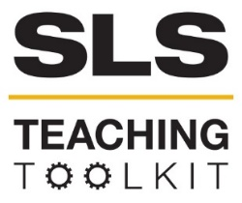 | Three Rubrics
Discipline: All | Type: Take-home assignment; In class exercise | Time Commitment: 15-30 mins | Category: Assessment
OVERVIEW:
This tool is designed to introduce instructors to a variety of rubrics. Rubrics are designed to assess student work. However, there are many types of rubrics, each of which is useful for different assignments and goals of assessment. It’s important to consider the assignment that you are assessing as well as what type of learning you are assessing when choosing the appropriate rubric type.
This tool was contributed by Carol Thurman and Owen Cantrell.
INSTRUCTIONS:
- Determine the type of rubric that may be best for your assignment (checklist, analytic, holistic).
- Review the following rubrics to find an example that may be useful for your assignment.
- Adapt the rubric to fit the type of assignment and goal of assessment for your assignment.
SLS STUDENT LEARNING OUTCOMES & ASSESSMENT:
The Serve-Learn-Sustain toolkit teaching tools are designed to assist you in gauging student progress toward achieving not only SLS student learning outcomes (SLOs), but the unique learning outcomes for your own courses. Reflection, concept maps, rubrics, and other assessment methods are shown to improve student learning. For resources on how to assess your students’ work, please review our Assessment Tools.
Want Help?
Serve-Learn-Sustain is the contact for this tool. You can reach us at serve-learn-sustain@gatech.edu

Three Rubrics Tool
Types of Rubrics Introduction
In this tool, we’ve included three types of rubrics (checklist, holistic, analytic). Each rubric is used for different types of assessment and has specific goals in mind. The checklist rubric is best for assignments in which completion of requirements is the primary goal; however, checklist rubrics are not useful for assessing the quality of student work. The holistic rubric is used to identify components of student work that are linked to the learning outcome of the assignment (or of the course); these rubrics are most useful for assessing overall quality of student work, but they are not as detailed as analytic rubrics. Finally, analytic rubrics are used to assess multiple traits of student work and can be particularly useful for identifying areas where students need to improve; however, they can often be time-consuming.
Checklist Rubric
Checklist rubrics can be used to record a list of student requirements for specific
assignments or projects. In general, checklist rubrics do not assess the quality of the work, but rather its completion. Often, the checklist rubric lists items in the order of occurrence alongside a checkbox to indicate that the student has completed the work required.

Instructors may want to use a checklist rubric when they are focused on completion of assignment components, but not as concerned with the quality of student work. While these rubrics do not assist instructors in determining student learning as it relates to learning outcomes, or specific student learning challenges, they are relatively easy to use for certain types of assignments.

Below is an example of a checklist rubric created by the University of Idaho.
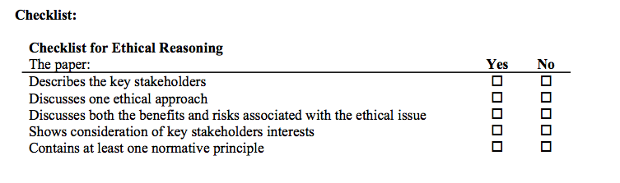
Source: “Appendix A: Rubric Tool Box”

Holistic Rubric
Holistic rubrics assess the overall quality of student work as it relates to specific learning outcomes. Instructors may want to use a holistic rubric when they have specific learning outcomes in mind and want to assess students on their current level of performance as it relates to those learning outcomes. While these rubrics help instructors determine student learning as it relates to learning outcomes, holistic rubrics are not as specific in determining individual student struggles and areas where students need improvement.

If you are developing a holistic rubric for your course, it’s important to first determine which aspects of your assignment relate to specific learning outcomes. Then, you need to determine the levels of performance required to classify student work. A holistic rubric allows you to detail a standard level or performance, as well as levels that are below or exceed this standard.

Below is an example of a holistic rubric created by the University of Idaho.

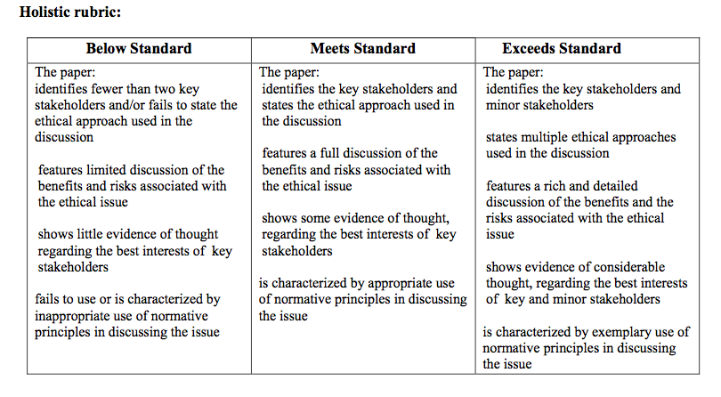Source: “Appendix A: Rubric Tool Box”

Analytic Rubric
Analytic rubrics evaluate multiple traits of student work. This allows the instructor to develop additional instruction based on trends of student performance on specific traits in an assignment. Instructors may want to use an analytic rubric when they want to track individual student learning or determine which instruction requires further attention or development. While these rubrics help instructors determine specific student challenges, their assessment can often be time-consuming.
If you are developing an analytic rubric for your course, it’s important to first identify what knowledge, skills, or abilities you plan to measure in the assignment. Then, you need to determine the levels of performance required to classify student work. In an analytic rubric, students should meet the full requirements of each level of performance, so using specific descriptors for each level is important.

Below is an example of an analytic rubric created by the University of Idaho.

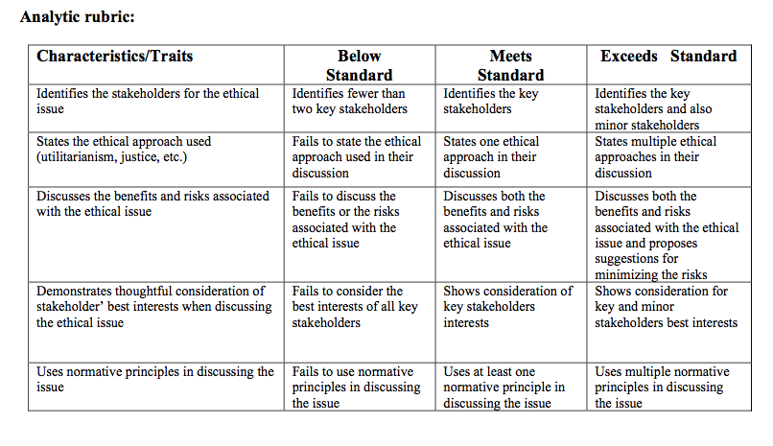 Source: “Appendix A: Rubric Tool Box”
Works Cited
“Appendix A: Rubric Tool Box,” Idaho University, https://www.uidaho.edu/~/media/UIdaho-Responsive/Files/provost/IEA/Assessment/Assessment%20Resources/rubrics/rubric_tool_box.ashx.
SLS Student Learning Outcomes
- Identify relationships among ecological, social, and economic systems.
- Demonstrate skills needed to work effectively in different types of communities.
- Evaluate how decisions impact the sustainability of communities.
- Describe how to use their discipline to make communities more sustainable.*
* Note: SLO 4 is intended to be used by upper division, project-based courses such as Capstone.

