 | Rodent Control
 | Time Commitment: 10 mins-4 hrs | Type: Take-home assignment, project | Big Ideas: Technology for Social Good; Civic Design; Prototyping; Environmental Justice & Citizen Science
OVERVIEW:
This is a collection of assignments around the problem of rodent infestation in cities, which has become a pressing problem following the mild winters in 2015-16. The assignments are designed to 1) develop mapping and data analysis skills, 2) give meaningful ideas for application prototyping, and 3) foster thinking about community engagement. This is based on an up-to-date (2017) dataset of rat sightings in New York City and an on-going collaboration between Georgia Tech and the community of English Avenue.
This tool was contributed by Dr. Ellen Zegura and Phan Anh Nguyen.
INSTRUCTIONS:
- Read the brief motivation of the problem.
- Review the data sets (by looking at their size, columns and records / shape files) and select a set of them to be the focus of data exploration.
- Based on the time commitment and effort the students are expected to make, compile a list of questions selected from phase 1-4, where 1 represents a small-time commitment, and 4 represents a large time commitment.
- Ask students to complete the assignment.
SLS STUDENT LEARNING OUTCOMES & ASSESSMENT:
The Serve-Learn-Sustain toolkit teaching tools are designed to help students achieve not only SLS student learning outcomes (SLOs), but the unique learning outcomes for your own courses. Reflection, concept maps, rubrics, and other assessment methods are shown to improve student learning. For resources on how to assess your students’ work, please review our Assessment Tools at http://serve-learn-sustain.gatech.edu/tool-category/assessment.
This tool achieves SLOs 2 & 4. See the end of this tool for further details.
Want Help?
Ellen Zegura is the contact for this tool. You can reach her at ellen.zegura@gatech.edu

Rodent Control

Instructions
- Read the brief motivation of the problem.
- Review the data sets: examine the records / shape files
  - Data Set A – Rat Sightings in New York City
  - Data Set B – Open Sewer Atlas NYC, Interceptors (sewer lines)
  - Data Set C – Public Recycling Bins
- Complete the assignments based on the data

Motivation
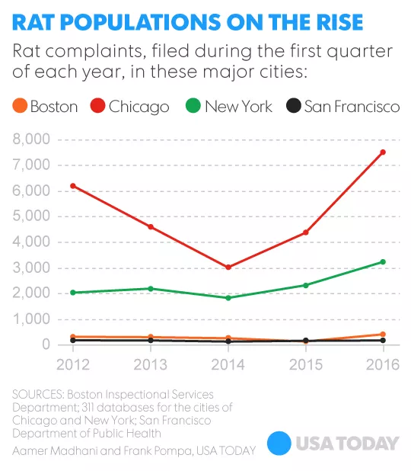
Several big U.S. cities saw a surge in rodent complaints beginning in 2015 [1]. The Department of Streets and Sanitation in Chicago blames the increase on the mild winters [2], which have been breaking the warmest temperature records [3, 4], especially in the eastern half of the U.S.
Why are the complaints important? What threats do rodents pose to people? Rodents spread over 35 diseases that can be contracted directly (for example, through rodent bite), or indirectly, (through ticks and fleas) [5]. They also cause serious damage to private and civic properties by gnawing on structures such as electrical lines and plumbing, and by chewing away doors, walls and furniture. They spoil community gardens and contaminate food supplies.
What does this have to do with Atlanta and Georgia Tech? Community leaders in English Avenue are partnering with Georgia Tech to get rid of rodents in their neighborhood. To succeed, two preconditions have to be satisfied, 1) an effective extermination method must be implemented, and 2) unfavorable conditions to the rodents must be maintained within the neighborhood. The latter involves the residents gaining an understanding of the severity of this problem, and of the living conditions of the rodents, such as their food sources and nesting sites.

The following questions and assignments explore general trends of rodent populations in cities (specifically in New York City, where detailed rat sighting data is available), and search for data-driven methods to solve rodent infestation.

Phase 1 (5-10 minutes, simple data set queries)

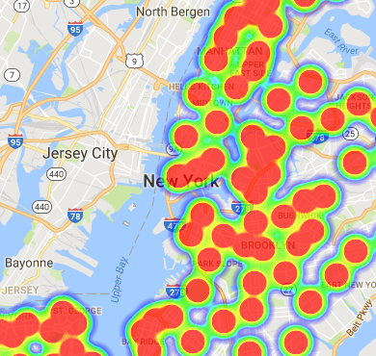
Review Data Set A and answer the following questions.
Heatmap of Rat Sightings
- How many rodent sightings were reported annually for the past 5 years? Are there observable patterns?
- What are the most heavily infested areas (by zip code and by street name)?
- What type of location (e.g. 3+ Family Apt. Building / Commercial Building / Hospital / etc.) had the most sightings?
- What time of the day are the sightings most frequently reported?

Phase 2 (1-2 hours, intermediate data analysis)

Analyze Data Sets A and respond to the following prompts.
- Based on the rodent sightings in 2010-2016, predict the count and the location of the rodent sightings in 2017.
- Identify the probable locations of rodent infestations (streets, buildings) that are also independent of each other. Is this possible, knowing that the sewer system may be a hidden channel for rodent movement?
- Identify probable routes on which the rats are travelling.
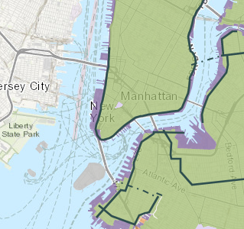
Phase 3 (3-4 hours, advanced data analysis with geospatial data)
Major Sewer Lines

Review Data Sets A-C and answer the following questions.
- Do public recycling bins attract rodents?
- Do rats appear to travel along major sewer lines?

Phase 4 (extensive design and implementation)
- Design a step by step action plan to clear a specific rodent infestation location. Also consider observing where the rats relocate.
- For each step, think about whether software / application / sensor technology could make the action more efficient / organized.
- List advantages and disadvantages of developing a software prototype.
- Design (and implement) an application / gadget that assists large scale rodent control.
An example description of a procedure to clear a certain area from rodents.
Procedure steps
- Engage local residents to communicate the importance and the severity of the problem.
- Collect rodent sightings (pictures and short reports) to identify the type of rodents in the area and to foster an initial understanding of the severity of the infestation.
- For each home in the neighborhood, teach the residents how to
  - Clean up food sources and nesting sites.
  - Seal holes inside and outside the home to prevent entry by rodents.
  - Trap rodents around the home to reduce the rodent population.
- Call a pest control expert to apply rodenticides in the appropriate way.
- Track the effectiveness of the collective method.

Resources for Further Reading
1. Madhani, Aamer. “Rats! Several big U.S. cities seeing surge in rodent complaints,” USA Today, last edited Apr 23, 2016, https://www.usatoday.com/story/news/2016/04/21/rats-several-big-us-cities-seeing-surge-rodent-complaints/83328068/
2. Holmes, Evelyn. “Chicago rat complaints on the rise after mild winter,” ABC7 Chicago, last edited May 09, 2017. http://abc7chicago.com/news/chicago-rat-complaints-on-the-rise-after-mild-winter/1973348/
3. Samenow, Jason. “America’s year without a winter: The 2015-2016 season was the warmest on record,” The Washington Post, last edited Mar 8, 2016, https://www.washingtonpost.com/news/capital-weather-gang/wp/2016/03/08/americas-year-without-a-winter-the-2015-2016-season-was-the-warmest-on-record/?utm_term=.b851a196e2d9
4. Donegan, Brian. “Where Winter 2016-17 Ranked as One of the Warmest, Coldest, Wettest or Driest on Record,” The Weather Channel, last edited Mar 1 2017, https://weather.com/news/climate/news/winter-2016-2017-warmest-coldest-wettest-driest-records
5. “Rodents,” Centers for Disease Control and Prevention, last edited Jan 20, 2017, https://www.cdc.gov/rodents/

SLS Student Learning Outcomes

Goal 1: Develop Skills & Knowledge
- Identify relationships among ecological, social, and economic systems
- Describe how actions affect community sustainability
- Work effectively in different communities
- Analyze the impact of decisions on community sustainability
Goal 2: Connect to Professional Practice
- Relate discipline to community sustainability
Goal 3: Work in Diverse Contexts
- Create and evaluate approaches to addressing community sustainability
- Communicate with the public about sustainable communities
Goal 4: Build Long-Lasting Values and Beliefs
- Manifest personal values and beliefs demonstrating responsible community membership

