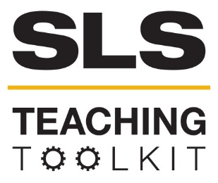 | Responsible and Sustainable Creativity: Working with the Georgia Tech Invention Studio
 | Time Commitment: 45-60 mins | Type: Take-home assignment/project; in-class exercise | Big Ideas: Problem-Based Learning; Long-Term Visioning
OVERVIEW:
This tool is developed from ideas used by Yelena Rivera-Vale and Kristina Chatfield in their GT 1000 courses. Students are invited to tour the Georgia Tech Invention Studio and to then consider how the projects they would like to create in the Studio take responsible and sustainable design practices into account.
INSTRUCTIONS:
- Review the instructions for students and decide whether students will take the tour on their own, or if you will schedule a class field trip to the Studio. Contact the Invention Studio.
- Decide whether you will be assigning the optional writing task (see the optional task portion of the instructions for students).
- Arrange students in small groups, which will tour the Invention Studio together.
- Invite students, after their tour, to brainstorm what types of projects they would like to create.
- Ask students to work with their small groups to create their own definition of sustainability.
- Small groups should then discuss specific ideas regarding responsible and sustainable design choices, including a consideration of key stakeholders. Time for this portion should be divided in half—students discuss for the first half and then a representative from each group reports to the class.
Optional task: ask small groups to choose an additional reading and create a short presentation for the entire class. The presentation portion is easily adaptable—you’re welcome to choose a traditional group presentation mode with or without visual aids, a podcast, video, or other forms of your choice.
SLS STUDENT LEARNING OUTCOMES & ASSESSMENT:
The Serve-Learn-Sustain toolkit teaching tools are designed to help students achieve not only SLS student learning outcomes (SLOs), but the unique learning outcomes for your own courses. Reflection, concept maps, rubrics, and other assessment methods are shown to improve student learning. For resources on how to assess your students’ work, please review our Assessment Tools at http://serve-learn-sustain.gatech.edu/tool-category/assessment.
This tool achieves SLOs 3 &5. It also achieves GT1000 SLOS 2, 5 & 6. See the end of this tool for details.
Want Help?
Kris Chatfield is the contact for this tool. You can reach her at kchatfield30@gatech.edu kkdljfjfdsnjdfshjdkfskristina.chatfield@gatech.edu

Responsible and Sustainable Creativity: Working with the Georgia Tech Invention Studio
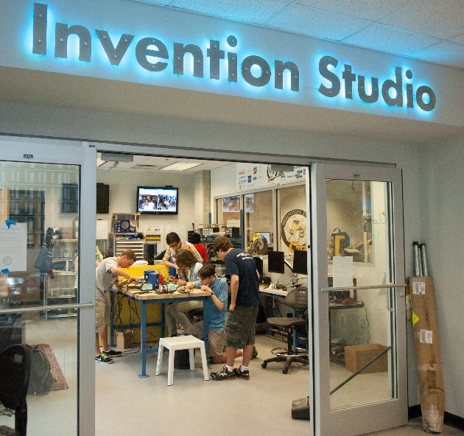
- FIRST STEP: Tour the Georgia Tech Invention Studio
  - The Invention Studio is open to anyone associated with Georgia Tech and can help you with 3D printing, woodwork, and metal projects, among others
  - Individuals may tour Monday-Friday, 9 AM-6 PM
  - Group tours are available. Visit http://inventionstudio.gatech.edu/tours/ to schedule.
  - The Invention Studio is located on the 2nd floor of the MRDC.
  - Plan on touring the Invention Studio together with your small group.
- SECOND STEP: Brainstorm!
  - Now that you know what the Georgia Tech Invention Center can help you develop, create a list of projects that you might like to develop using these facilities.
- THIRD STEP: With your small group, review the definitions of sustainability on the Serve-Learn-Sustain website (http://serve-learn-sustain.gatech.edu/).
  - Now, write a short definition, using your own words and ideas, to describe what sustainability means to you and your fellow team members.
- FOURTH STEP: Go back to your own project and have a discussion with your team.
  - WHY did you decide to create this particular project?
  - WHAT sorts of waste will this project potentially create?
  - WHO are the stakeholders that will be most directly impacted by your creation? (http://www.businessdictionary.com/definition/stakeholder.html)
  - Using your definition of sustainability, determine how this project will impact society, the environment, and/or the economy.
- OPTIONAL TASK
  - Read one of the recommended readings listed at the end of this document, then prepare a short report (approximately 500 words or less) to share with your peers on ways that business executives, artists, and/or inventors are thinking about corporate social responsibility and/or sustainable design.
  - Your report should include identification information including the title of the reading and the author’s name.
  - You may consider different ways to prepare this report: presentation (with or without accompanying visuals or handouts), summary (printed or uploaded to class website), or a brief video.

ADDITIONAL RESOURCES

Corporate Social Responsibility
Archie B. Carroll, Corporate Social Responsibility: The Centerpiece of competing and complementary frameworks (Organizational Dynamics 44, 87-96, 2015).
Olga Hawn and Ioannis Ionnanu. Mind the Gap: The Interplay Between External and Internal Actions In the Case of Social Responsibility (Strategic Management 37.16. 2569-2588, 2016).
Christopher R. Plouffe, Willy Bolander, Joseph A. Cote and Bryan Hochstein, Does the Customer Matter Most? Exploring Strategic Frontline Employees’ Influence of Customers, the Internal Business Team, and External Business Partners (Journal of Marketing 80.1.106-123, 2016).
Sustainable Design
Paul T. Anastas and Julie B. Zimmerman, Design Through The 12 Principles of Green Engineering (Environmental Science & Technology 37.5. 94A-101A, 2003).
Carmen Cucuzzella, Creativity, Sustainable Design, and Risk Management (Journal of Cleaner Production 135. 1548-1558, 2016).
Additional Facilitator Resources
“An Introduction to Corporate Social Responsibility” Huamin Research Center, School of Social Work/Rutgers University China Philanthropy Research Institute, Beijing Normal University, last edited 2015, https://pdfs.semanticscholar.org/d30b/ece388f19570d2a245b26253ce03eb2ff158.pdf
SLS Student Learning Outcomes
Goal 1: Develop Skills & Knowledge
- Identify relationships among ecological, social, and economic systems
- Describe how actions affect community sustainability
- Work effectively in different communities
- Analyze the impact of decisions on community sustainability
Goal 2: Connect to Professional Practice
- Relate discipline to community sustainability
Goal 3: Work in Diverse Contexts
- Create and evaluate approaches to addressing community sustainability
- Communicate with the public about sustainable communities
Goal 4: Build Long-Lasting Values and Beliefs
- Manifest personal values and beliefs demonstrating responsible community membership
GT1000 Curriculum and Learning Outcomes
University Culture
- Manage the university environment in ways that support academic and personal success and involvement at Georgia Tech.
- Develop a sense for what it means to learn at Georgia Tech and create a list of resources to support that learning process.

Academic Success and Time Management
- Create a time management plan and begin the process of implementing effective time management skills.
- Develop a personal study strategy based on strengths identified in a self-regulated learning survey.
Communication and Relational Skills
- Write reflectively on topics related to college major and first year college experience.
- Participate as an effective member of a team to produce and deliver a high-quality, professional presentation on a topic of value to the class.
Major/Career Research
- Describe the required skills, daily activities, current and future state (growth potential), and salary potential of the major/career selected.
Career Development Skills
- Prepare a resume applicable to internships, co-ops, study abroad programs or leadership positions (as appropriate).
Leadership/Involvement at Tech
- Identify organizations and activities for possible involvement that reflect personal, academic, and career goals and interests.

