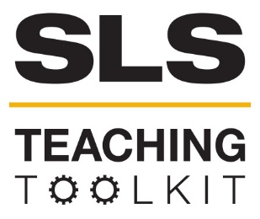 | Cross-Cultural Communication
 | Time Commitment: 30 mins | Type: Discussion, in-class exercise | Big Ideas: Shared Values; Collaborative Problem Solving
OVERVIEW:
This activity adapted from D.M. Stringer and P.A. Cassidy’s 52 Activities for Improving Cross-Cultural Communication, introduces students to three primary patterns of communication pacing. These patterns can vary in different cultural groups, and learning how different people use different styles will shed light on how students perceive each other.
This tool was contributed by Susannah McFaul.
INSTRUCTIONS:
- Read “Pacing” from D.M. Stringer and P.A. Cassidy’s 52 Activities for Improving Cross-Cultural Communication. You can access this pdf on the tool landing page.
- Print and cut-out the “Pacing Cards” included in this tool.
- Present the attached PowerPoint to your students. You can access this ppt on the tool landing page.
- Present the PowerPoint to your students as an introduction to pacing patterns.
- Place participants in groups of 3. Assign each person in each triad a different pacing card to indicate which pacing pattern they should adopt.
- Have the students engage in a 5-min conversation, on any relevant topic, where each person adopts the pacing pattern indicated on their card.
- After 5 minutes, debrief with the discussion questions on slide 5.
- Conclude with slide 6.
SLS STUDENT LEARNING OUTCOMES & ASSESSMENT:
The Serve-Learn-Sustain toolkit teaching tools are designed to help students achieve not only SLS student learning outcomes (SLOs), but the unique learning outcomes for your own courses. Reflection, concept maps, rubrics, and other assessment methods are shown to improve student learning. For resources on how to assess your students’ work, please review our Assessment Tools at http://serve-learn-sustain.gatech.edu/tool-category/assessment.
This tool achieves SLOs 1-9. See the end of this tool for further details.
Want Help?
Susannah McFaul is the contact for this tool. You can reach her at susannah.mcfaul@gatech.edu

Cross-Cultural Communication: Pacing Cards

TURN-TAKING  When someone is speaking to you, wait until he or she finishes, and then begin speaking.  “It wouldn’t be polite to interrupt while you’re speaking.” | TURN-TAKING  When someone is speaking to you, wait until he or she finishes, and then begin speaking.  “It wouldn’t be polite to interrupt while you’re speaking.”
TURN-TAKING  When someone is speaking to you, wait until he or she finishes, and then begin speaking.  “It wouldn’t be polite to interrupt while you’re speaking.” | TURN-TAKING  When someone is speaking to you, wait until he or she finishes, and then begin speaking.  “It wouldn’t be polite to interrupt while you’re speaking.”
TURN-TAKING  When someone is speaking to you, wait until he or she finishes, and then begin speaking.  “It wouldn’t be polite to interrupt while you’re speaking.” | TURN-TAKING  When someone is speaking to you, wait until he or she finishes, and then begin speaking.  “It wouldn’t be polite to interrupt while you’re speaking.”
Pausing  Listen closely when someone is speaking to you. When he or she finishes speaking, reflect silently on the topic for 15 seconds before responding.  “How can I start to respond when I haven’t had time to think about what you said?” | Pausing  Listen closely when someone is speaking to you. When he or she finishes speaking, reflect silently on the topic for 15 seconds before responding.  “How can I start to respond when I haven’t had time to think about what you said?”
Pausing  Listen closely when someone is speaking to you. When he or she finishes speaking, reflect silently on the topic for 15 seconds before responding.  “How can I start to respond when I haven’t had time to think about what you said?” | Pausing  Listen closely when someone is speaking to you. When he or she finishes speaking, reflect silently on the topic for 15 seconds before responding.  “How can I start to respond when I haven’t had time to think about what you said?”

Overlapping  When someone is speaking with you, jump into the middle of the sentence to add your own thoughts or show enthusiasm. Do not wait until they have finished speaking.  “How can I resist making the conversation more interesting by enriching it with my information? -I have to say something!” | Overlapping  When someone is speaking with you, jump into the middle of the sentence to add your own thoughts or show enthusiasm. Do not wait until they have finished speaking.  “How can I resist making the conversation more interesting by enriching it with my information? -I have to say something!”
Overlapping  When someone is speaking with you, jump into the middle of the sentence to add your own thoughts or show enthusiasm. Do not wait until they have finished speaking.  “How can I resist making the conversation more interesting by enriching it with my information? -I have to say something!” | Overlapping  When someone is speaking with you, jump into the middle of the sentence to add your own thoughts or show enthusiasm. Do not wait until they have finished speaking.  “How can I resist making the conversation more interesting by enriching it with my information? -I have to say something!”
Overlapping  When someone is speaking with you, jump into the middle of the sentence to add your own thoughts or show enthusiasm. Do not wait until they have finished speaking.  “How can I resist making the conversation more interesting by enriching it with my information? -I have to say something!” | Overlapping  When someone is speaking with you, jump into the middle of the sentence to add your own thoughts or show enthusiasm. Do not wait until they have finished speaking.  “How can I resist making the conversation more interesting by enriching it with my information? -I have to say something!”

Pacing and Conversation Styles across Cultures

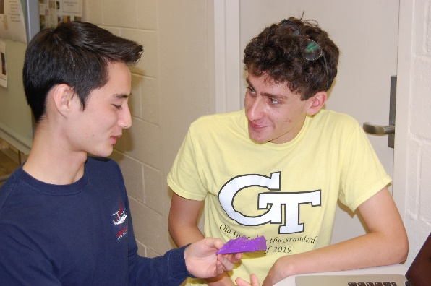
Discussion Questions:
- What happened during this activity?
  - How did you feel? What did you do? What did you learn?
- How might someone with one preferred communication style misinterpret someone using another style? Why is this a concern?
- How does this activity relate to diverse teamwork?
- What are some strategies that you could use to include those with a different style than your own?

SLS Student Learning Outcomes

Goal 1: Develop Skills & Knowledge
- Identify relationships among ecological, social, and economic systems
- Describe how actions affect community sustainability
- Work effectively in different communities
- Analyze the impact of decisions on community sustainability
Goal 2: Connect to Professional Practice
- Relate discipline to community sustainability
Goal 3: Work in Diverse Contexts
- Create and evaluate approaches to addressing community sustainability
- Communicate with the public about sustainable communities
Goal 4: Build Long-Lasting Values and Beliefs
- Manifest personal values and beliefs demonstrating responsible community membership

