 | Urban Heat Islands and the Georgia Tech Climate Network
Discipline: | Type: Take-home assignment / project | Time Commitment:  1-2 hrs | Category: Using Data; Equity, Justice & Sustainability
Big Ideas: Social and Environmental Determinants of Health; Infrastructure: Physical, Technological, Social; Environmental Justice & Citizen Science
OVERVIEW:
Extreme heat leads to more deaths in the US than all other natural disasters combined, and as global temperatures rise, so will the dangers [1]. Urban areas, such as Georgia Tech’s campus, are of primary concern because of the urban heat island effect – the phenomenon in which cities are warmer than nearby rural areas.
Georgia Tech needs your help! This tool will teach you more about the urban heat island effect. You’ll identify real-world urban heat islands on the Georgia Tech campus and propose strategies to reduce temperatures at these campus hot spots. We encourage you to send your recommendations to Georgia Tech’s Urban Climate Lab for consideration!
This tool was contributed by Kevin Lanza.
INSTRUCTIONS:
Ask students to:
- Read Part 1. Urban Heat Islands, and answer the questions from the reading, in writing to be later discussed in class.
- Read Part 2. The Urban Climate Network at Georgia Tech.
- Complete Part 3. UHI Identification on the Georgia Tech Campus.
SLS STUDENT LEARNING OUTCOMES & ASSESSMENT:
The Serve-Learn-Sustain toolkit teaching tools are designed to help students achieve not only SLS student learning outcomes (SLOs), but the unique learning outcomes for your own courses. Reflection, concept maps, rubrics, and other assessment methods are shown to improve student learning. For resources on how to assess your students’ work, please review our Assessment Tools.
This tool achieves SLOs 2 and 3. See the end of this tool for further details.
Want Help?
Kevin Lanza is the contact for this tool. You can reach him at lanza.kevin@gatech.edu

Urban Heat Islands and the Georgia Tech Climate Network

Instructions
- Read Part 1. Urban Heat Islands, and answer the questions from the reading, in writing to be later discussed in class.
- Read Part 2. The Urban Climate Network at Georgia Tech.
- Complete Part 3. UHI Identification on the Georgia Tech Campus.

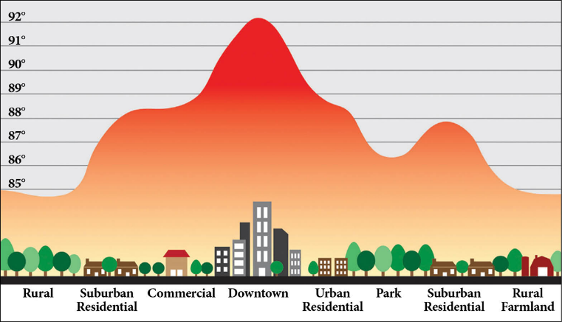
Part I. Urban Heat Islands
Land Use
Afternoon Temperature (°F)
Figure 1. The urban heat island effect.
The Phenomenon
Since 1895, the burning of fossil fuels has increased US average temperatures by 1.3 -1.9°F, with the previous decade being the warmest ever recorded in the US [2, 3]. On top of climate change, cities are also warming due to the urban heat island (UHI) effect, a phenomenon in which cities experience annual mean air temperatures 1.8-5.4°F warmer than surrounding rural areas (Figure 1) [4].
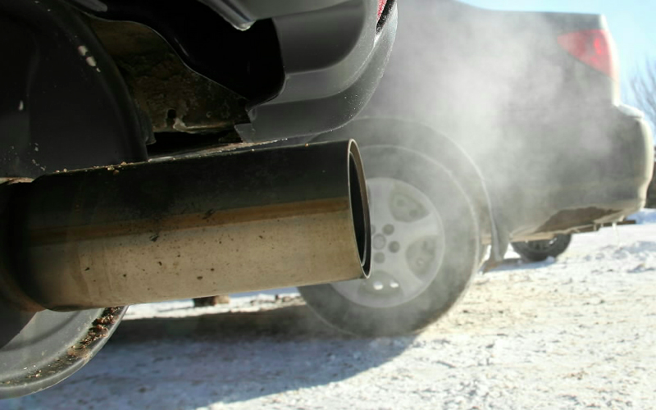
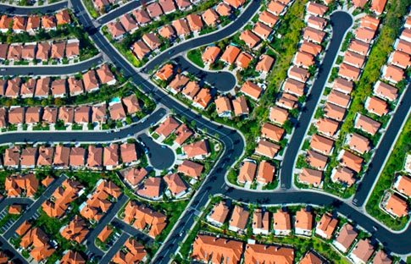
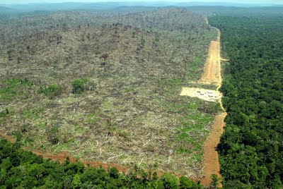
Figure 2 shows the four drivers of UHIs: 1) loss of vegetation, 2) high amounts of impervious materials, 3) waste heat, and 4) urban morphology.
loss of
vegetation
impervious
materials
waste
heat
urban
morphology
Figure 2. The drivers of the urban heat island effect.
Vegetation reduces air temperatures through shading and evapotranspiration, the process by which plants use the sun’s energy to convert water to water vapor, cooling the air.
Impervious materials are dark surfaces (e.g., buildings, roads, and parking lots) that absorb the sun’s energy and later release that energy as heat into the surrounding air.
Waste heat refers to the leftover energy produced by industrial processes, with common sources including automobiles and power plants.
Lastly, urban morphology contributes to warmer temperatures because the canyon shape of tall buildings and the narrow space between them traps heat emitted from impervious materials, as well as waste heat, near the Earth’s surface.
The Health Impact
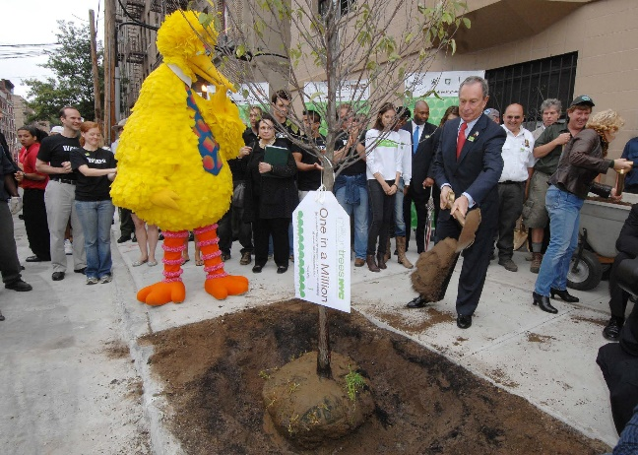
UHIs are a threat to human health. High-temperature environments can elevate an individual’s core body temperature to levels that can cause heat exhaustion, or even heat stroke. Common characteristics of heat exhaustion include nausea, muscle cramps, fatigue, and dizziness. If left untreated, heat exhaustion can progress to heat stroke, a more serious condition characterized by intense nausea, headache, dizziness, and unconsciousness. If not treated promptly, heat stroke can result in death. In the US, heat leads to more deaths than all other natural disasters combined, a surprising fact for many because heat does not cause the same physical destruction as hurricanes, earthquakes, and tornadoes. Research finds that heat disproportionately affects those who are young, elderly, low income, socially isolated, and with preexisting health conditions [5]. In 1995, a heat wave (i.e., two or more consecutive days of excessive temperatures) in Chicago resulted in 739 excess deaths. Learn more by reading our SLS Case Study: The 1995 Chicago Heat Wave.
Figure 3. Mayor Bloomberg and Big Bird planting for Million Trees NYC.
The Solutions
Fortunately, researchers have discovered several strategies to reduce temperatures in cities. These UHI adaptation strategies are tied to the four drivers of UHIs, with the most common UHI adaptation strategies being planting vegetation (i.e., trees and other vegetation) and installing cool materials. One study found suburban areas with mature trees were 4-6ºF cooler than new suburbs without trees [7]. In part to reap the cooling benefits of trees, New York City developed the Million Trees NYC initiative, in which the city planted one million trees across the five boroughs, ultimately increasing New York City’s urban forest by 20% (Figure 3) [8]. Cool materials are light-colored materials with a high albedo, that is, the materials reflect more of the sun’s energy than they absorb, resulting in a larger proportion of the sun’s energy reflected back into space, rather than being absorbed by the material and later re-emitted as heat near the Earth’s surface (Figure 4). In the Los Angeles area, researchers found that installing cool pavement and roofing reduced temperatures by 1.5ºF [9].
Figure 4. Cool pavement (right) reflects more of the sun’s energy than it absorbs, cooling the near-surface environment.
Planting vegetation and installing cool materials are more common UHI adaptation strategies than reducing waste heat emissions and changing urban morphology, as the latter two strategies require more intensive policy and development changes than the former two.
A Continuing Problem
The danger of heat to public health is projected to increase over time. Regarding global climate change, scientists have modeled different scenarios of greenhouse gas concentrations based on human emissions, and find these scenarios will increase global temperatures by 2.5-11°F by 2100 [10]. Along with increased global temperatures, climate change is expected to increase the intensity, duration, and frequency of heat waves over time [11]. Cities will experience these rising temperatures from climate change, along with higher temperatures from heat islands. Furthermore, with two-thirds of the world’s population expected to live in cities by 2050, urban heat islands will become more intense with this increased development [12]. As such, sustainable urban development requires heat management, as cities must safeguard the public from the health hazards of high temperatures.

Questions from the Reading
- In what ways, if at all, do high temperatures influence your daily activities?
- Have high temperatures ever affected your health or the health of someone you know? If so, where did this take place, what was the activity, and what was the effect on health?
- Can you think of an instance where urban heat islands might be considered beneficial?
- Which of the four UHI adaptation strategies do you think would be the easiest for a city to implement?
- Besides cooling cities, what are other ways UHI adaptation strategies may benefit cities?
- From your personal experience, can you think of any locations where UHIs may exist in Atlanta?

Part 2. The Urban Climate Network at Georgia Tech
Georgia Tech’s Urban Climate Lab has established a dense network of 24 temperature sensors, called HOBOs, to measure urban heat islands around the Georgia Tech campus (Figure 5). In addition to identifying the location of hot spots, these HOBOs measure the impact of ongoing development on local climate conditions and assess how the use of vegetation and cool materials around campus can reduce temperatures. UHIs are measured for these locations on Georgia Tech’s urban campus, by calculating the difference in temperature between any one campus HOBO and a rural reference point, that is, a HOBO in a rural area just outside of urban Atlanta.
Figure 5. HOBO attached to light pole on top of Curran St. Parking Deck, Georgia Tech.

Part 3. UHI Identification on the Georgia Tech Campus
Introduction
Georgia Tech’s Urban Climate Lab has shared temperature data for six HOBOs (i.e., one rural reference point and five throughout the Georgia Tech campus). As a form of citizen science, the lab has tasked you with describing the locations of each HOBO, calculating the intensity (i.e., strength) of the UHI, and reporting back with an explanation of the UHI intensity results. Please follow the instructions and answer the questions below.
Instructions
- Download this Excel file, titled “HOBO_Data.”
  - The sheet titled “HOBOs” includes HOBO IDs and location
  - The sheet titled “Temperature_Data” has daily mean temperature readings from each HOBO for Summer 2017 (June – August)
- Open Google Maps.
- From the “HOBO_Data” file, copy a cell with the Latitude / Longitude of one HOBO and directly paste into the Search bar in Google Maps. Click the Search icon.
- To understand the HOBO location, toggle between map view , satellite view 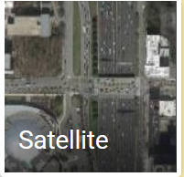, and street view in Google Maps.
- Repeat steps 3 and 4 for the remaining five HOBOs
- Calculate the average temperature from June through August for each of the six HOBOs
- For each of the five HOBOs on Georgia Tech’s campus, calculate the UHI intensity (i.e., difference in average temperature from the rural reference point)
Questions
- Describe each HOBO site. Is the HOBO located near a major road and / or surrounded by buildings? Are there any natural features nearby, such as vegetation? Do you expect the HOBO site to have high pedestrian traffic?
- List the calculated UHI intensities for the five HOBOs on Georgia Tech’s campus. Do any of the five campus sites have lower average summer temperatures than the rural reference point?
- Do any of the five campus HOBOs have similar UHI intensities? Based on your understanding of UHI drivers, give your reasoning for each calculated UHI intensity.
- Which sites, if any, do you believe are a public health concern, and why?
- Which UHI adaptation strategy, or combination of strategies, do you recommend to reduce temperatures at each campus site? Please be specific in your response. You are welcome to send your proposed UHI adaptation strategies to Kevin Lanza of the Urban Climate Lab.
Conclusion
By completing this assignment, you have learned about one of the deadliest natural disasters in the US. You have identified hot spots around the Georgia Tech campus. and strategized ways to manage heat in these dangerous areas. With projected global warming and urban population growth, cities must factor heat into their development decisions in order to safeguard public health. Our cities of the future do not have to be characterized by asphalt, tree scarcity, and car dependency; we can design communities that integrate light-colored building materials, vegetation, and alternative modes of transportation (e.g., bikes) within the urban fabric, allowing for not only cooler cities, but also more livable cities.

Resources for Further Reading
Georgia Tech Urban Climate Lab. (2017). Dallas urban heat island management study. Retrieved June 15, 2016 from https://texastrees.blob.core.windows.net/static/Texas%20Trees%20UHI%20Sudy_Final_v4_title%20change.pdf
Georgia Tech Urban Climate Lab. (2018). Urban climate lab website. Retrieved June 15, 2016 from http://www.urbanclimate.gatech.edu/
US Environmental Protection Agency. (2018). Heat island effect. Retrieved June 15, 2016 from https://www.epa.gov/heat-islands
US Environmental Protection Agency. Reducing urban heat islands: compendium of strategies – cool pavements. Retrieved June 15, 2016 from https://www.epa.gov/sites/production/files/2014-08/documents/coolpavescompendium_ch5.pdf
US Environmental Protection Agency. Reducing urban heat islands: compendium of strategies – trees and vegetation. Retrieved June 15, 2016 from https://www.epa.gov/sites/production/files/2014-06/documents/treesandvegcompendium.pdf

References
- Luber, G., McGeehin, M. (2008). Climate change and extreme heat events. American Journal of Preventive Medicine, 35(5), 429-435.
- Melillo, J. M., Richmond, T., & Yohe, G. (2014). Climate change impacts in the United States. Third National Climate Assessment.
- National Oceanic and Atmospheric Administration. (2017). Global temperature anomalies - graphing tool. Retrieved June 15, 2016 from https://www.climate.gov/maps-data/dataset/global-temperature-anomalies-graphing-tool
- Wong, E., Akbari, H., Bell, R., & Cole, D. (2011). Reducing urban heat islands: compendium of strategies. Environmental Protection Agency, retrieved June 16, 2018.
- Klinenberg, E. (2002). Heat wave: A social autopsy of disaster in Chicago. Chicago: University of Chicago Press.
- Whitman, S., Good, G., Donoghue, E. R., Benbow, N., Shou, W., & Mou, S. (1997). Mortality in Chicago attributed to the July 1995 heat wave. American Journal of Public Health, 87(9), 1515-1518.
- Wong, E., Akbari, H., Bell, R., & Cole, D. (2011). Reducing urban heat islands: compendium of strategies. Environmental Protection Agency, retrieved June, 16, 2018.
- City of New York. (2015). Million trees NYC. Retrieved June 16, 2016 from http://www.milliontreesnyc.org/html/about/about.shtml
- Wong, E., Akbari, H., Bell, R., & Cole, D. (2011). Reducing urban heat islands: compendium of strategies. Environmental Protection Agency, retrieved June, 16, 2018.
- Pachauri, R. K., Allen, M. R., Barros, V. R., Broome, J., Cramer, W., Christ, R., ... & Dubash, N. K. (2014). Climate change 2014: synthesis report. Contribution of Working Groups I, II and III to the fifth assessment report of the Intergovernmental Panel on Climate Change (p. 151). IPCC.
- Gao, Y., Fu, J., Drake, J., Liu, Y., & Lamarque, J. (2012). Projected changes of extreme weather events in the eastern United States based on a high resolution climate modeling system. Environmental Research Letters, 7(4), 044025.
- Buhaug, H., & Urdal, H. (2013). An urbanization bomb? Population growth and social disorder in cities. Global Environmental Change, 23(1), 1-10.

SLS Student Learning Outcomes
- Identify relationships among ecological, social, and economic systems.
- Demonstrate skills needed to work effectively in different types of communities.
- Evaluate how decisions impact the sustainability of communities.
- Describe how to use their discipline to make communities more sustainable.*
* Note: SLO 4 is intended to be used by upper division, project-based courses such as Capstone.

