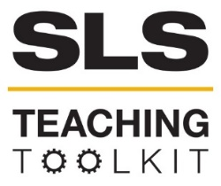 | SLS Case Study: Proctor Creek
Discipline: All | Type: Reading; Discussion; Take-home assignment; In-class exercise | Time Commitment: 30-60 mins | Category: Intro to SLS & Creating Sustainable Communities; Sustainability in Atlanta
Big Ideas: Environmental Justice & Citizen Science; Inequality, Poverty, and Sustainable Development
OVERVIEW:
Proctor Creek runs through northwest Atlanta, extending from I-20 in southwest Atlanta to the Chattahoochee River. An important piece of Atlanta’s natural environment, it also has a long history of neglect and pollution, which has negatively affected its surrounding communities. In this case study, read about this history, as well as new and ongoing development projects in West Atlanta that demand close attention to the Proctor Creek Watershed. Additionally, concepts like Environmental Justice and Citizen Science will provide a lens for thinking about issues related to the creek and how to protect its surrounding communities.
This tool was contributed by Matthew Dischinger.
INSTRUCTIONS:
- Use this case study in the way that works best for your course: assign it as a take-home reading, or as an in-class reading. Supplement the case study with sources from the Resources for Further Reading section.
- Either as a take-home assignment, or in-class discussion, answer the Discussion Questions, or craft your own.
SLS STUDENT LEARNING OUTCOMES & ASSESSMENT:
The Serve-Learn-Sustain toolkit teaching tools are designed to help students achieve not only SLS student learning outcomes (SLOs), but the unique learning outcomes for your own courses. Reflection, concept maps, rubrics, and other assessment methods are shown to improve student learning. For resources on how to assess your students’ work, please review our Assessment Tools.
This tool achieves SLOs 1-3. See the end of this tool for further details.
Want Help?
Serve-Learn-Sustain is the contact for this tool. You can reach us at serve-learn-sustain@gatech.edu.

SLS Case Study: Proctor Creek

Introduction
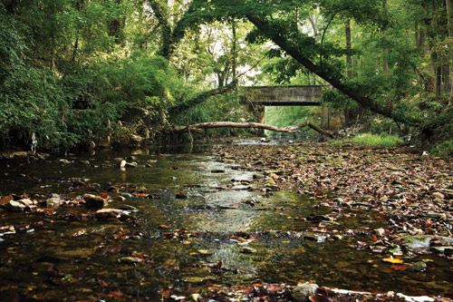
Extending from the Chattahoochee River all the way to Downtown Atlanta (also known as The Gulch), Proctor Creek is home to a diverse range of wildlife within the city of Atlanta. The creek stretches through at least 40 neighborhoods on Atlanta’s Westside, including some of the most economically depressed and often underserved areas of the city (Proctor Creek Stewardship Council). Regular stormwater flooding and sewage overflows mean that the creek suffers from erosion as well as high bacteria levels (EPA). Sewage overflows often result from problems with the city’s combined sewer system, which carries both sewage and rainwater, and its sanitary system, which struggles with stormwater seepage despite being designed for sewage only (Klepal).
Proctor Creek. Source: atlantamagazine.com
The Proctor Creek watershed, or the basin of land that drains into the creek, is already home to more than 52,000 people (Proctor Creek Stewardship Council). Because of the completion of projects like the Atlanta BeltLine as well as the continuation of development projects across Atlanta, many expect the Proctor Creek Watershed to experience continuous population growth in the coming years. One early project that has garnered attention is the Proctor Creek Greenway, which opened three-and-a-half miles of its trail on May 7, 2018 and will eventually connect with the BeltLine. Once completed, the Proctor Creek Greenway will extend from Maddox Park, where it will link to the BeltLine, to the Chattahoochee River (Miller). As these development projects get further underway, issues related to flooding and pollution will become more urgent. At present, local individuals and community organizations are leading the effort to monitor and protect the creek—as well as lobbying civic and corporate entities to ensure that these communities do not carry an unfair burden of the negative environmental effects of development. The future of Proctor Creek and its surrounding neighborhoods depends upon the continued work of these citizens as well as crucial collaborations with students, faculty, and staff at Georgia Tech, which also sits in the Proctor Creek Watershed. In short, issues surrounding Proctor Creek are relevant to all Atlantans, and particularly urgent to communities in and around Georgia Tech.
Key Takeaway: The Proctor Creek watershed faces problems related to erosion, bacteria, and the city’s sewer system. Local stakeholders are leading efforts to address these problems.
History
The issues facing Proctor Creek are not new. In the early 1900s, people residing near Proctor Creek sued a furnace company for dumping trash into the creek rather than burning it. The residents won, but trash pollution persisted (Samuel, “The Trouble”). In the 1960s, then Atlanta Mayor Ivan Allen, Jr. learned of the condition of Proctor Creek. In November of 1967, the director of Georgia’s Water Pollution Control, Robert H. Morriss, penned a letter to Allen outlining the findings of the State Water Quality Control Board’s investigation into Proctor Creek. Morriss describes the “high level of pollution” and flooding as “problems of long standing” for the residents in the Proctor Creek watershed. He notes that during a time in which the city was investing in more housing in the area, the city would need to invest in a temporary treatment facility to “prevent the overflow of untreated sanitary sewage from the separate sanitary sewer system” in the southern sections of the Proctor Creek watershed.
Pollution in Proctor Creek off Johnson Road in the 1960s. Source: Ivan Allen papers
The 1967 Water Quality Study of Proctor Creek, which accompanied Morriss’ letter, outlines the issues it faced that required dramatic, immediate action. Describing the overall state of the creek, the study judges that “the pollution load … appears to be very heavy” (Ivan Allen papers). It notes that pollution sources are commercial, industrial, and domestic, and point source issues range from “broken manhole” to more systemic sewer overflow. The letters and reports to the office of Ivan Allen paint a picture of Proctor Creek as an area afflicted with all manner of obstacles, ranging from point source pollution by individuals to foundational issues relating to the city’s treatment of human waste (Ivan Allen papers). Even in the 1960s, the issues facing Proctor Creek were already a result of long-term neglect.
Key Takeaway: Many of the issues that face Proctor Creek today are the result of longstanding neglect.
While the city attempted to address this neglect with short-term fixes over the years, problems with sewage removal and pollution have continued to plague Proctor Creek. In 2002, a neighborhood just west of downtown, Vine City, flooded with raw sewage after a hard rain overwhelmed the sewer system. The flood required boats to come rescue people who were swimming from their homes. The situation was so dire that the city took over some of the affected land, tearing down roughly 60 houses (Samuel, “The Trouble”).

Proctor Creek, Environmental Justice, & Citizen Science
One useful way to think about the issues facing Proctor Creek, and potential solutions to those issues, is through the lenses of Environmental Justice (EJ) and Citizen Science. EJ is concerned with making sure that (A) no community takes on an unfair share of environmental burdens and (B) environmental benefits are shared in an equitable way regardless of race, class, gender, or orientation. Citizen Science is a fast-growing field that can contribute to EJ work. While the city of Atlanta has carried out infrastructural projects that have alleviated the stresses on Proctor Creek, such as the billions of dollars the city spent on its sewer system after being sued in the 1990s, a renewed interest in real estate development in Northwest Atlanta has revealed longstanding issues with the creek and its unequal effects on nearby residents (Samuel, “The Trouble”). For example, flooding due to stormwater surges in the sewage system leads to human contact with water carrying e. coli and fecal coliform bacteria, and continued flooding creates stagnant water in which mosquitos carrying the Zika or West Nile viruses can breed (Samuel, “Health Problems”).
Neighborhood flooding from Proctor Creek. Source: Urban Waters
Aside from the health problems related to recurring flooding, many nearby neighborhoods deal with community disinvestment because of the living conditions along the creek. Issues like crime, blight, and abandoned houses accompany disinvestment and exacerbate environmental issues. Specific issues that lead to health concerns, such as mold, disproportionately affect many houses in these neighborhoods. One study by Emory University linked two low-lying neighborhoods near the creek, Vine City and English Avenue, to an increased occurrence of asthma-inducing mold. Of 150 houses in which samples were taken to check for mold, the researchers found mold in more than 80 percent. Of the adults who answered the doors and participated in the research at those houses, 14 percent had asthma (Samuel, “Health Problems”). This research illustrates how many areas in the Proctor Creek watershed take on an unequal share of the environmental burdens related to Atlanta’s sewer system, in particular.
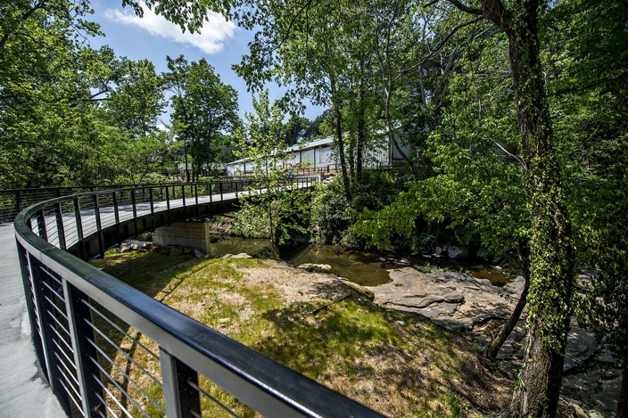
Despite these problems, the areas along Proctor Creek are the subject of renewed interest by real estate and economic developers. Already underway projects like the Proctor Creek Greenway will connect the creek to the BeltLine. In addition, the recently announced Quarry Yards project presents another type of development project that closely resembles development projects on the east side of Atlanta. This mixed-use development project will include 850 residences, a 300-room hotel, retail spaces, restaurants, and more than a half-million square feet of high-end office space in just its first phase (Trubey). Former Georgia Tech and Atlanta Braves baseball player Mark Teixeira, who is also a founder of the Emerald Corridor Foundation, is one of the public faces and partners of the real-estate development project.
Proctor Creek Greenway. Source: atlanta.curbed.com
While these projects may present opportunities for economic development that benefit the health of the communities along Proctor Creek, longtime residents are worried that they are among many signs that the area is about to experience rapid gentrification. One resident of northwest Atlanta, Bob Johnson, voiced the concern that these projects could lead to current residents being permanently displaced if they are not given a voice to contribute at the outset: “You have to involve those people in the conversation, not just in bits and pieces of it but from the beginning to the end. You have to take them seriously and not just have them as the token. No one is really against progress, we just want to be a part of it” (Samuel, “Fears of Gentrification”).
Alongside these projects, residents and stakeholders are mobilizing to help insure the protection of both Proctor Creek and its many nearby residents. Many residents are involved in the Proctor Creek Stewardship Council, “a grassroots group of stakeholders who live and work in the watershed” and “works … to identify solutions to the challenges facing the watershed and press for radical action” (Proctor Creek Stewardship Council). For example, resident Ruby Mitchell-Harrison led a citizen science effort to clean and protect Lillian Cooper Shepherd Park by lobbying the Atlanta City Council and winning grants to build playground equipment (Samuel, “Neighborhood Park”). The future of the neighborhoods affected by both environmental neglect and rapid redevelopment depends upon both these citizen science efforts and collaborations with people and resources equipped to help solve specific problems related to equitable, sustainable development in the Proctor Creek watershed.
Key Takeaway: Current issues facing residents in neighborhoods along Proctor Creek relate to environmental justice and sustainable development.

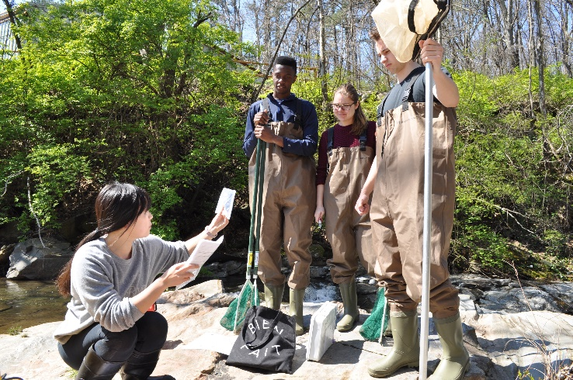
Georgia Tech’s role
Georgia Tech students monitoring Proctor Creek
Students, faculty, and staff at Georgia Tech have already carried out projects that can both inform future collaborations with Proctor Creek stakeholders and serve as an example of how community efforts to monitor and protect Proctor Creek can be strengthened through collaborations with Georgia Tech—even in only a semester of work. In the fall of 2017, for example Emily Weigel’s ecology lab used Proctor Creek to learn best practices for testing stream water health. With the data Weigel’s student’s logged, students in Matthew Dischinger’s spring 2018 first-year writing course made pamphlets that would both clearly outline these findings and help community stakeholders see how Georgia Tech’s resources could be used to monitor the stream health of Proctor Creek in the future, as government agencies like the EPA have to scale their work back due to budget cuts.
Dischinger’s students also produced maps that will help Georgia Tech students, faculty, and staff interested in working in Proctor Creek better understand the many community resources that have a longstanding interest in environmental justice and citizen science. Here are links to two examples of these maps:
Key Takeaway: Georgia Tech students have made and can continue to make a positive impact on Proctor Creek and the surrounding communities.
English 1102 Project: Proctor Creek Map 1
English 1102 Project: Proctor Creek Map 2
Taken together, these two projects will help ensure that future collaborations between community and campus stakeholders begin with a clear understanding of what Georgia Tech’s resources can add to community-driven projects and, just as importantly, what has already been accomplished.

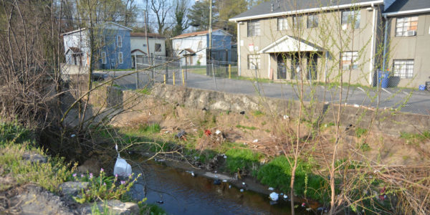
Discussion Questions
Proctor Creek. Source: wabe.org
- What are some examples related to environmental justice that you noticed while reading the Proctor Creek case study?
- Environmental Justice goes hand-in-hand with Citizen Science by allowing citizens to ensure that no community—regardless of race, class, gender, or orientation—takes on an unfair share of environmental burdens. How have residents nearby Proctor Creek demonstrated the relationship between Environmental Justice and Citizen Science? Cite examples from the Resources for Further Reading found at the end of this case study.
- Explain why you think pollution and disinvestment along Proctor Creek have persisted.
- Read about the Proctor Creek Greenway and the Quarry Yards development projects below in Resources for Further Reading. What are the fundamental goals of these projects? Are those goals at odds with Environmental Justice? Get into groups and brainstorm how we might improve these projects, and come up with a list of concrete ideas you could present in a community forum.

Resources for Further Reading

Chattahoochee Riverkeeper, https://chattahoochee.org/.

The City of Atlanta’s Office of Resilience, https://www.atlantaga.gov/government/mayor-s-office/executive-offices/office-of-resilience.

Community Improvement Association, http://tonytorrence.wixsite.com/atlantacia.

Community-Building Coalition of Northwest Atlanta, https://sites.google.com/site/ccnatlanta/.

Emerald Corridor Foundation, http://emeraldcorridor.org/.

EPA’s Urban Water’s Partnership page on Proctor Creek, https://www.epa.gov/urbanwaterspartners/urban-waters-and-proctor-creek-watershedatlanta-georgia.

Historic Westside Gardens, http://www.historicwestsidegardens.org/.
Jelks, Na’Taki Osborne O., Timothy L. L. Hawthorne, Dajun H. Dai, Christina H. Fuller, and Christine Stauber. "Mapping the Hidden Hazards: Community-led Spatial Data Collection of Street-level Environmental Stressors in a Degraded, Urban Watershed." International Journal of Environmental Research and Public Health 15, no. 4 (2018).
Klepal, Dan. “Atlanta council committee wants report on sewage spills,” Atlanta Journal-Constitution, March 15, 2016, https://www.ajc.com/news/local-govt--politics/atlanta-council-committee-wants-report-sewage-spills/Ll4UxhYyyYszsn13b2v3cI/?icmp=np_inform_variation-control.
Miller, Pamela. “Proctor Creek Greenway officially opens,” Atlanta Journal-Constitution, May 9, 2018, https://www.ajc.com/news/local/proctor-creek-greenway-officially-opens/vS8Eq8BZ4p0S5zyYXwcFKK/.

The PATH Foundation, https://pathfoundation.org/.

Proctor Creek Stewardship Council, http://www.proctorcreek.org/.
Samuel, Molly. “City Wildlife: Scientists Research Atlanta’s Proctor Creek,” WABE, September 14, 2016, https://www.wabe.org/city-wildlife-scientists-research-atlanta-s-proctor-creek/.
Samuel, Molly. “EPA Finds Toxic Chemicals in Fish in Atlanta’s Proctor Creek,” WABE, February 21, 2017, https://www.wabe.org/epa-finds-toxic-chemicals-fish-atlantas-proctor-creek/.
Samuel, Molly. “How Proctor Creek Health Problems Affect Those Living Nearby,” WABE, May 22, 2017, https://www.wabe.org/how-proctor-creek-health-problems-affect-those-living-nearby/.
Samuel, Molly. “The Trouble with Atlanta’s Proctor Creek,” WABE, July 18, 2017, https://www.wabe.org/the-trouble-with-atlantas-proctor-creek//
Samuel, Molly. “The Woman Who Revived Her Neighborhood Park, WABE, July 20, 2017, https://www.wabe.org/the-woman-who-revived-her-neighborhood-park/.
Terrell, Ross. “Proctor Creek Greenway Opening Stokes Fears of Gentrification,” WABE, May 7, 2018, https://www.wabe.org/proctor-creek-greenway-opening-stokes-fears-gentrification/.
Trubey, Scott. “Ex-Brave Teixeira unveils plans for Quarry Yards project,” Atlanta Journal-Constitution, February 28, 2018, https://www.ajc.com/business/brave-teixeira-unveils-plans-for-quarry-yards-project/J51HRGUMYLOussATfKZDvM/.
West Atlanta Watershed Alliance, http://wawa-online.org/.

SLS Student Learning Outcomes

- Identify relationships among ecological, social, and economic systems.
- Demonstrate skills needed to work effectively in different types of communities.
- Evaluate how decisions impact the sustainability of communities.
- Describe how to use their discipline to make communities more sustainable.*
* Note: SLO 4 is intended to be used by upper division, project-based courses such as Capstone.

