 | Urban Farming & Community Gardens
 | Time Commitment: 45 mins-2 hrs | Type: Take-home assignment, project | Big Ideas: Technology for Social Good; Civic Design; Prototyping; Inequality, Poverty and Sustainable Development
OVERVIEW:
Starting a community garden in an abandoned vacant lot is a good way to address blight in a neighborhood. This project builds on the dataset of Westside Atlanta property surveys and walks the students through the process of starting a community garden to selling its produce on farmers markets. It emphasizes the social aspect of community building and the importance of buying local.
INSTRUCTIONS:
- Watch the TED Talk video for inspiration.
- Read the brief motivation about local organizations in Atlanta (Aluma Farm, Food Bank) that promote urban gardening.
- Take a look at the process of starting and developing a community garden. The students could be guided through the complete process, or a specific part of the process could be selected and students could do a deep-dive into it by reflecting on what technology may be useful.
- Optional: ask students to develop and implement the most promising idea.
SLS STUDENT LEARNING OUTCOMES & ASSESSMENT
The Serve-Learn-Sustain toolkit teaching tools are designed to help students achieve not only SLS student learning outcomes (SLOs), but the unique learning outcomes for your own courses. Reflection, concept maps, rubrics, and other assessment methods are shown to improve student learning. For resources on how to assess your students’ work, please review our Assessment Tools at http://serve-learn-sustain.gatech.edu/tool-category/assessment.
This tool achieve SLOs 2 & 5. See the end of this tool for further details.
Want Help?
Ellen Zegura is the contact for this tool. You can reach her at ellen.zegura@gatech.edu

Urban Farming & Community Gardening

Instructions
- Watch the TED Talk video for inspiration.
- Read the brief motivation of urban agriculture.
- Review the data sets: examine the records / shape files
  - Data Set A - Westside Atlanta Built Environment Survey
  - Data Set B - Farmers Market Locations
- Reflect on the questions, and answer them based on personal experience as well as additional readings.

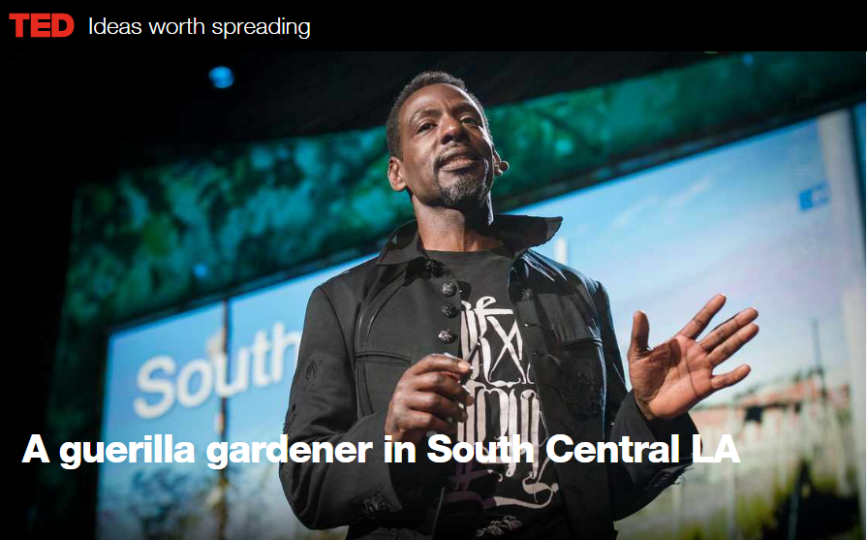
Motivation
A guerilla gardener in South Central LA
“Ron Finley grows a nourishing food culture in South Central L.A.’s food desert by planting the seeds and tools for healthy eating.”
Ted Talk –
About the Speaker
Urban agriculture and community gardening is a continuing trend in the U.S. It is a comprehensive approach to engage neighborhoods, promote economic development through food production, improve neighborhood safety through combating blight, and build bridges between generations [1].
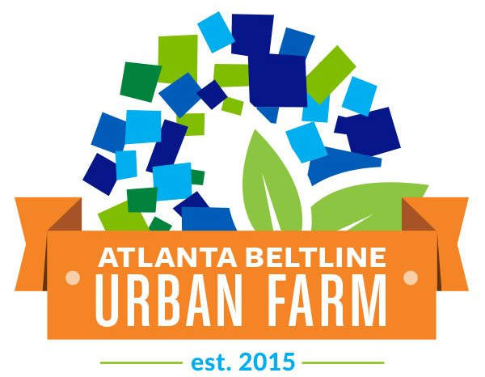
In Atlanta, the Aluma Farm at Adair Park is the BeltLine’s pilot for an urban agriculture program that supplies fresh produce to neighborhoods in southwest Atlanta, where options for groceries remain limited. Once an abandoned site of industrial manufacturing facilities, it now aspires to be the center of educational nutritional programming for the area [2].
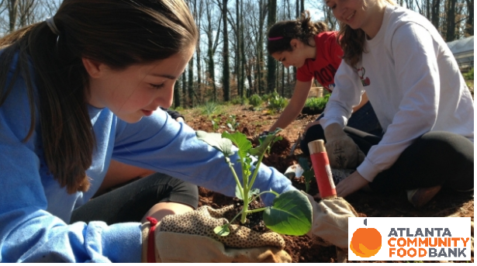
Additional urban agriculture initiatives across metro Atlanta are supported by The Atlanta Community Food Bank. Their Community Gardens project offers assistance to over 100 gardens across the city by providing expertise, seeds to tilling and tools [3]. Starting a community garden can renew local economies, creating job opportunities for residents. It also serves urban economic system by repurposing household waste and organic refuse into compost, while communities farmers can sell their surpluses at farmers markets or to nearby restaurants.
The following questions and descriptions walk the students through the process of starting a community garden to selling its produce on farmers markets.

Community Garden in the Neighborhood
Location. Like the BeltLine’s Aluma Farm, many urban agriculture projects start out in abandoned lots. Transforming vacant lots and unused parking lots into flourishing community gardens and green zones is a good way to address blight within a neighborhood. Not only does this clear unhealthy situation, but the whole neighborhood itself will be viewed in a different light, stimulating other actions for improving the community's livelihood.
New York 50 Cent's Area Before and After
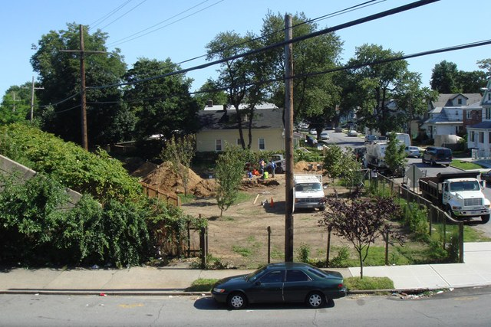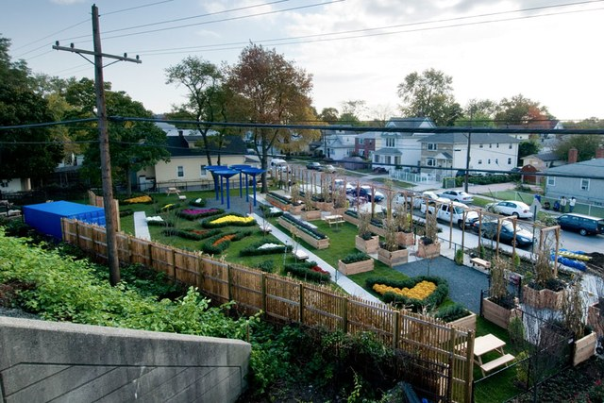
More Community Garden Before and After Photos at Agriscaping.
Take a look at the Westside Built Environment survey dataset. Map the location of the abandoned lots. A group of local residents would like to start a community garden, but they don’t know where they should begin. Supposing that they received funds for renting 3 parcels in the next 5 years, give them suggestions as to which parcels to request. What is your suggestion based on?

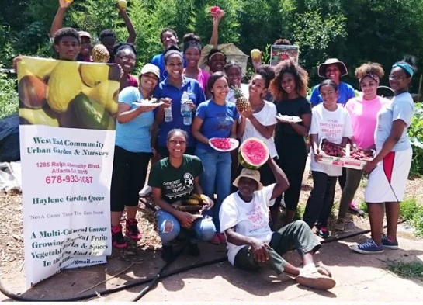
Initial tasks. Starting a community garden comes with its challenges. It brings people together from all walks of life. Some may have extensive knowledge about agriculture, some may be novices. Forming an organizing committee helps with collaboration, holding training sessions and dividing up the work effectively. [4]
West End Community Urban Garden & Nursery

Imagine you are a resident trying to establish a community garden. How would you coordinate initial tasks? These include ensuring a metered water source, testing the soil for basic fertility, contacting landowners to obtain land permissions, as well as contacting the Atlanta Community Food Bank for trainings and expertise.
Is there a technology that would help the coordination? What would make its use effective and what could undermine its usefulness?
Garden layout. Participating community members plan, design, and set-up the garden. If the garden is not divided into individual garden plots, and everyone is collectively working on the whole area, there must be some type of regular coordination. Otherwise, everyone may think someone else is doing the work (especially on really hot days) [5].
How would you track who is working on which garden plot? Or which tool was used by whom most recently?
Is there a technology that is effective for addressing these questions? Is this something that should / could be solved without modern technology
Buying local. Community members generally consume the produce they grow. However, when the garden reaches higher capacity, there ought to be surpluses. Where should the surpluses go?
Locally grown, organic, non-GMO produce are often sold at farmers markets, where shoppers enjoy the seasonal fruits and vegetables, knowing that their purchases support local economies and local family farms.
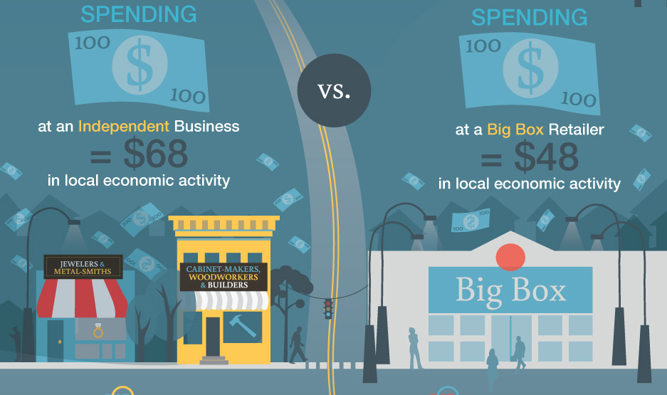
Perform an address - latitude longitude conversion on the Farmers Market Locations dataset and map the closest market locations to the community garden. Would the closest location be a good place to sell the surplus? What alternatives are there for using the produce?
Excerpt from “Why Buying Local Is Worth Every Cent”

Resources for Further Reading
[1] Terry McLean, The Urban Agriculture trend continues in 2017, Michigan State University Extension, Jan 26, 2017
[2] Welcome to the Atlanta BeltLine's First Urban Farm, Atlanta BeltLine
[3] What is the Community Gardens project, Atlanta Community Food Bank
[4] Holly Owen, Tom Matott, Alan Brent, Community Garden Toolkit, Master Gardeners of Fresno County, Fresno Metro Ministry, Fresno Community Garden Coalition
[5] Dan Charles, At The Community Garden, It's Community That's The Hard Part, National Public Radio, Mar 20, 2012
[6] Urban agriculture: what and why, RUAF Foundation

SLS Student Learning Outcomes

Goal 1: Develop Skills & Knowledge
- Identify relationships among ecological, social, and economic systems
- Describe how actions affect community sustainability
- Work effectively in different communities
- Analyze the impact of decisions on community sustainability
Goal 2: Connect to Professional Practice
- Relate discipline to community sustainability
Goal 3: Work in Diverse Contexts
- Create and evaluate approaches to addressing community sustainability
- Communicate with the public about sustainable communities
Goal 4: Build Long-Lasting Values and Beliefs
- Manifest personal values and beliefs demonstrating responsible community membership

