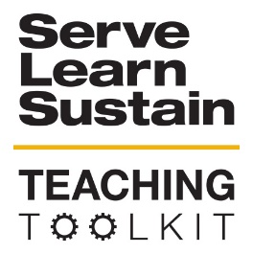 | EJ Resources
OVERVIEW:
This tool provides a series of definitions, videos, and other resources for faculty and students who wish to learn more about Environmental Justice. This is an evolving resource, so please feel free to make recommendations!
INSTRUCTIONS:
- N/A
SLS LEARNING OUTCOMES:
- Develop Skills and Knowledge
- Connect to Professional Practice
- Structure Deep Learning Experience
- Build Long-Lasting Values and Beliefs
TOOL CATEGORY
- Equity & Justice
TOOL TYPE
- Reading
AUDIENCE:
- N/A
DISCIPLINE
- All
BIG IDEAS
- Inequality, Poverty and Sustainable Development
- Equity and Climate
- Environmental Justice and Citizen Science
- Sustainable urban development
KEY WORDS
- Environmental justice
- Environmental Racism
- Equity
- Sustainability
MATERIALS
- N/A
TIME COMMITMENT
- Other

