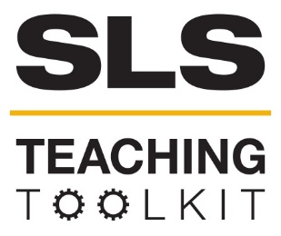 | CONCEPT MAPS
 | Time Commitment: 15-60 mins | Type: Discussion; Take-home assignment/project; In-class exercise | Big Ideas: Long-term visioning
OVERVIEW:
This tool provides an overview of concept maps, and how to use them. Concept maps (CMaps) are diagrams that represent organized knowledge. They are a useful tool for assessing student knowledge over the course of a project, module, or course. You can also utilize concept maps as a pre- and post-assessment activity to test student knowledge regarding a specific topic or skill.
This tool was contributed by Carol Thurman and Owen Cantrell.
INSTRUCTIONS:
- Read the Concept Maps Overview to understand what concept maps are and how they can be used in your course.
- Watch the Concept Mapping Tutorial and Review the Concept Mapping Introduction PowerPoint . Here is an additional Introduction to Concept Maps that you might also find useful.
- Utilize the Concept Map handouts below (How to Build a Concept Map, Activity 1, Activity 2, Activity 3,) to have students complete their own concept maps
- If you wish students to use the program CMapTools© to create their concept maps, review the CMapTools© handouts (How to Download CMapTools, How to Use CMapTools). You can also have your students do the CMap In-Class Assignment.
Use the guides and rubrics to assess student concept maps using either the analytic or traditional method.
SLS STUDENT LEARNING OUTCOMES & ASSESSMENT
The Serve-Learn-Sustain toolkit teaching tools are designed to help students achieve not only SLS student learning outcomes (SLOs), but the unique learning outcomes for your own courses. Reflection, concept maps, rubrics, and other assessment methods are shown to improve student learning. For resources on how to assess your students’ work, please review our Assessment Tools at http://serve-learn-sustain.gatech.edu/tool-category/assessment.
This tool achieve SLOs 1-2, 5. See the end of this tool for further details.
Want Help?
Carol Thurman is the contact for this tool. You can reach her at carol.thurman@gatech.edu

CONCEPT MAPS

Overview
This Concept Maps tool introduces and provides an overview of concept maps, which can be used to assess student knowledge in a specific module or assignment.
Concept maps are a useful tool for assessing student knowledge over the course of a project, module, or course. You can utilize concept maps as a pre- and post-assessment activity to test student knowledge regarding a specific topic or skill.

In the documents below, you’ll find some step-by-step instructions for introducing, explaining, implementing, and assessing concept maps as a component of your course. This PowerPoint produced by Dr. Mary Katherine Watson of The Citadel may be useful for introducing concept maps for you (and your students).

After introducing concept maps, some in-class activities are provided you may want to do when teaching students how to do concept maps for the first time.

While students can create concept maps either by hand or by using traditional word processing tools, an online resource is also available. CMapTools© is a program where students can create concept maps digitally and submit them to you. Step-by-step instructions for CMapTools© are also included.

When students complete their concept maps, there are two ways we suggest you may want to score the concept maps: traditional/structural, and analytic. We’ve provided instructions on how to score concept maps using the traditional method. Additionally, there are tools available to score concept maps automatically. Finally, if you wish to score the concept maps using the analytic method, a rubric is available.

If you want to learn more about concept maps, additional resources are also supplied. These Concept Map materials were developed by Dr. Mary Katherine Watson of The Citadel and adapted by Serve-Learn-Sustain.

How to Build a Concept Map

- Identify a focus topic you wish to map.
- Guided by this question, create a list of concepts that are pertinent to the topic using CMapTools®
- Sort through the concepts, and move to the side any that you do not fully understand or is not related to any other term.
- Using CMapTools®, arrange the remaining concepts in a way that makes sense to you. Terms you see as related should be kept fairly close together. One approach is to place general concepts near the top of the map and specific concepts at the bottom of the map. Other layouts may also be appropriate.
- Draw linkages using CMapTools® between concepts you see to be related.
- Write on each line the nature of the relation between the terms.
- Review your map and determine if there are any more concepts you can add. You may add to the map new concepts or concepts set aside in step 3. If you do add additional concepts, you should be sure to link them to other concepts and provide descriptive linkages.
- Again, review your map. Look for cross-links, which link together concepts in different areas of your map. Cross-links will help you to elaborate how concepts are interrelated.
- Finalize your map. Make sure that appropriate concepts are linked that all linkages are described.

Additional Resources for Further Reading
Barrella, E. M. and M. K. Watson (2016). Comparing the outcomes of horizontal and vertical integration of sustainability content into engineering curricula using concept maps New Developments in Engineering Education for Sustainable Development. W. L. Filho and S. Nesbit. Cham, Switzerland, Springer International Publishing.
Besterfield-Sacre, M., J. Gerchak, M. Lyons, L. J. Shuman and H. Wolfe (2004). "Scoring Concept Maps: An Integrated Rubric for Assessing Engineering Education." Journal of Engineering Education 93(2): 105-115.
Borrego, M.; Newswander, C. B.; McNair, L. D.; McGinnis, S.; Paretti, M. C., Using concept maps to assess interdisciplinary integration of green engineering knowledge. Advances in Engineering Education 2009, 1, (3), 1-26.
Cañas, A. J., G. Hill, R. Carff, N. Suri, J. Lott, G. Gomez, T. C. Eskridge and R. C. Arroyo (2004). CMap Tools: A knowledge modeling and sharing environment. Second International Conference on Concept Mapping, Pamplona, Spain.
Jablokow, K. W., J. F. DeFranco, S. S. Richmond, M. J. Piovoso and S. G. Bilén (2015). "Cognitive Style and Concept Mapping Performance." Journal of Engineering Education 104(3): 303-325.
Novak, J. D. and A.J. Cañas (2008). “The theory underlying concept maps and how to construct and use them.” Available at: <http://eprint.ihmc.us/5/2/TheoryUnderlyingConceptMaps.pdf>.

Novak, J.D. (2010). “Learning, creating, and using knowledge: Concept maps as facilitative tools in schools and corporations.” Journal of e-Learning and Knowledge Society 6(3): 21-30.
Ruiz-Primo, A. (2000). "On the use of concept maps as an assessment tool in science: What we have learned so far." Revista Electrónica de Investigación Educativa 2(1): 29-53.
White, R.; Gunstone, R., Probing Understanding. Falmer Press: Philadelphia, PA, 1992
Van Zele, E., J. Lenaerts and W. Wieme (2004). "Improving the usefulness of concept maps as a research tool for science education." International Journal of Science Education 26(9): 1043-1064.
Watson, M. K., Pelkey, J., Noyes, C. R., & Rodgers, M. O. (2015). Assessing Conceptual Knowledge Using Three Concept Map Scoring Methods. Journal of Engineering Education, 105(1), 118-146. doi:10.1002/jee.20111
Watson, M. K., Pelkey, J., Noyes, C., & Rodgers, M. (2016). Assessing impacts of a learning-cycle-based module on students’ conceptual sustainability knowledge using concept maps and surveys. Journal of Cleaner Production, 133, 544-556. doi:10.1016/j.jclepro.2016.04.063
Watson, M. K., & Barrella, E. (2017). Using Concept Maps to Explore the Impacts of a Learning-Cycle-Based Sustainability Module Implemented in Two Institutional Contexts. Journal of Professional Issues in Engineering Education and Practice, 143(2). doi:10.1061/(asce)ei.1943-5541.000030
Activity 1: Connecting SLS Outcomes & Concept Map Topics
Directions: Reflect on your SLS-associated course. Brainstorm concept map central topics related to your course that could be used to assess SLS outcomes. Use the table below to record your ideas, and the ideas reported by your peers.
SLS Outcome Category | SLS Outcome | Concept Map Central Topics
Develop skills and knowledge | Students will be able to identify relationships among ecological, social, and economic systems.
 | Students will be able to describe how their actions impact the sustainability of communities.
Connect to Professional Practice | Students will be able to describe how they can use their discipline to make communities more sustainable.

Activity 2: Engaging in a Concept Mapping Exercise
Directions: Creating a concept map can be hard! Before implementing a concept mapping assessment in your classroom, practice making a concept map on one of your central topics from Activity 1. Use the space below to brainstorm, but draw your final concept

Activity 3: Scoring Concept Maps using the Traditional (Structural) Method
Directions: One of the biggest challenges to using concept maps is extracting useable data from student submissions. Take a look at the concept map below and see if you can apply the traditional scoring method.
- Count the number of concepts (indicator of knowledge breadth). How many are there? ________________________
- Number first-level concepts, which define the hierarchies. How many hierarchies are there? ________________________
- Number each of the remaining concepts based on which hierarchy that they fall under.
- Count the number of cross-links, or connections between concepts from different hierarchies (indicator of knowledge connectedness). How many cross-links are there? ________________________
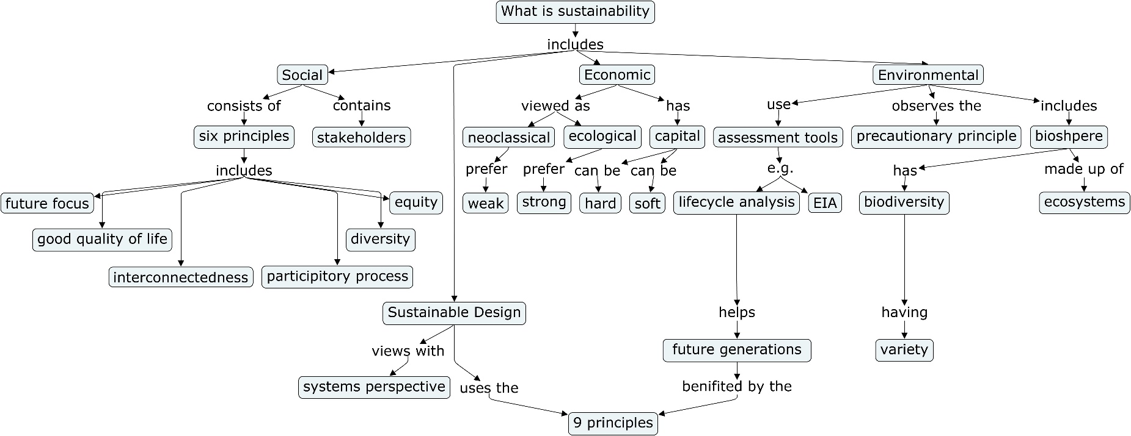
- Count the level (or number of concepts) in each hierarchy, not including the central topic. What is the highest level for this concept map (indicator or knowledge depth)? ________________________

SLS Student Learning Outcomes

Goal: Develop Skills & Knowledge
- Identify relationships among ecological, social, and economic systems
- Describe how actions affect community sustainability
- Work effectively in different communities
- Analyze the impact of decisions on community sustainability
Goal: Connect to Professional Practice
- Relate discipline to community sustainability
Goal: Work in Diverse Contexts
- Create and evaluate approaches to addressing community sustainability
- Communicate with the public about sustainable communities
Goal: Build Long-Lasting Values and Beliefs
- Manifest personal values and beliefs demonstrating responsible community membership

