Guide for Scoring Concept Maps Using the Traditional Method

Concept Maps

Concept maps (Cmaps), which are graphical tools for organizing knowledge, can be used to assess student sustainability understanding. Cmaps include several components. Construction of a Cmap is completed by enclosing concepts related to a central topic in boxes and using connecting lines, as well as linking phrases, to depict relationships between concepts. The basic unit of a Cmap is a proposition, which includes two concepts joined by a descriptive linking line. Propositions that include the Cmap topic define the map hierarchies. Cross-links, which are important for representing concept interconnectedness, are descriptive linking lines that create propositions by joining two concepts from different map hierarchies (Figure 1) (1).

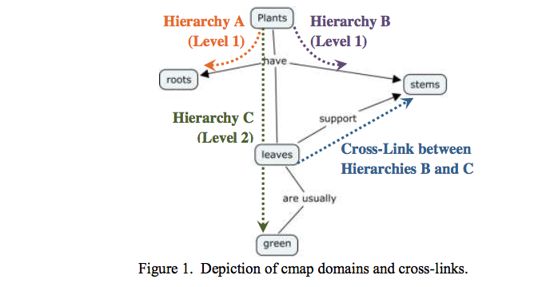

Traditional Scoring Method

Overview

In the Traditional Method, concepts, hierarchies, and cross-links are analyzed to quantify the breadth, depth, and connectedness of knowledge, respectively (Table 1). The number of concepts and cross-links are counted to obtain the breadth and connectedness scores, respectively. Both the number of hierarchies and highest level of hierarchy are used to characterize knowledge depth. Cmap scoring using the Traditional Method is intended to be quick and simple, but may become more complex as the intricacy of Cmaps increases (2).

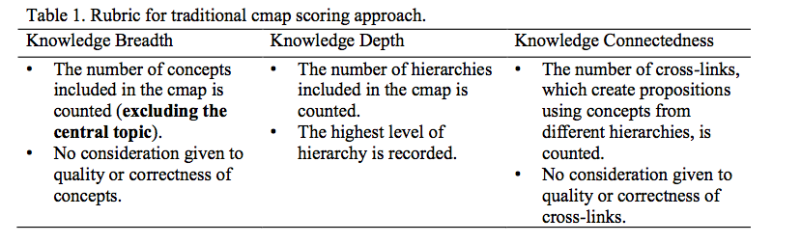

Procedure

To aid in scoring of Cmaps using the Traditional Method, the following procedure is recommended to promote consistency.

- Count the number of concepts. Remember to exclude the central topic.
- Count the number of hierarchies as the number of propositions including the central topic.
- Label each of the concepts according to which hierarchy they belong to. Due to cross-links, many concepts may belong to more than one hierarchy. However, only assign each concept to one hierarchy. By convention, arrow heads are only shown if the proposition is read up the map.
- Count the level of each hierarchy and record the highest level. If a cross-link connects two hierarchies, only count the cross-linked concept as contributing to the highest level of hierarchy.
- Count the number of cross links as propositions that include concepts from different hierarchies. Even though some ambiguity may exist in which hierarchy you assigned concepts to, this should not significantly impact the number of cross-links.
- For each Cmap, compare your number of concepts, number of hierarchies, highest level of hierarchy, and number of crosslink with other judges.
- Discuss any discrepancies with other judges to reach consensus scores.

Examples

The following examples are intended to provide insight into application of the Traditional Method for scoring Cmaps. Reviewing these examples will help will quantification of number of concepts, number of hierarchies, highest level of hierarchy, and number of cross-links.

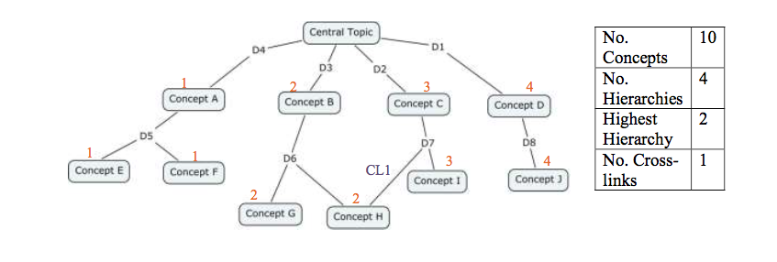
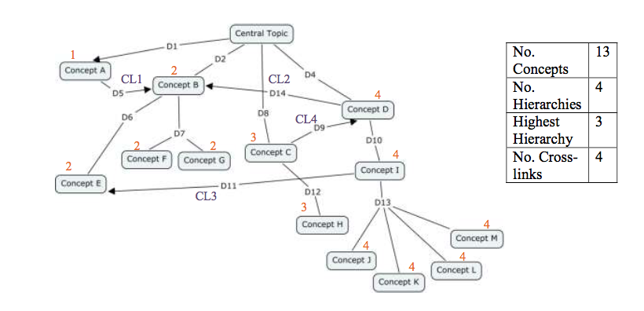

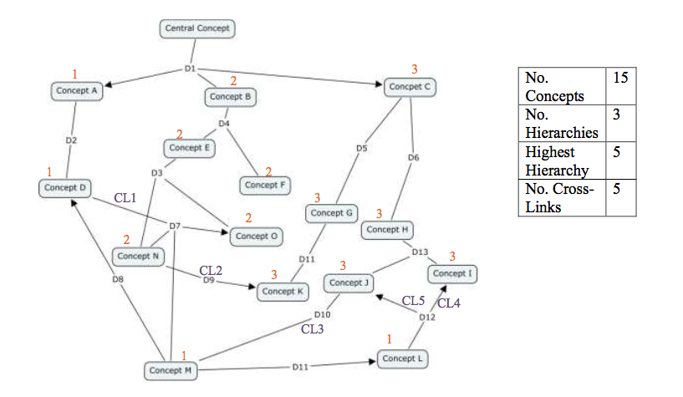

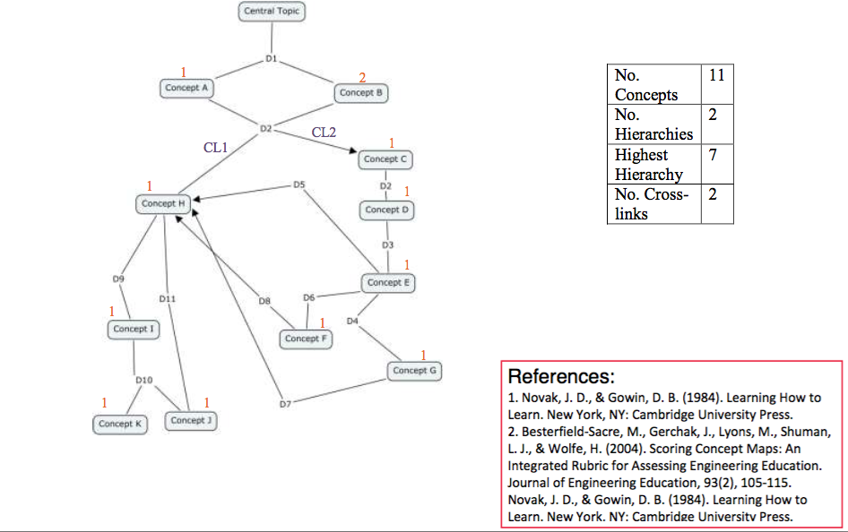
Automatic Scoring of Concept Maps:
Traditional/Structural Method

- Export concept map (created using Cmap Tools) as a. cxl file (“File” “Export”)
- Visit: https://github.com/joshpelkey/Cmap-parse
- Download: CmapParse_v1.2.zip
- Open: Campers (Application)
- Type the “root concept” that appears in the concept map (e.g., “sustainability”)
- Select the appropriate .cxl file in the “Select concept maps…” box. Note: you can select multiple .cxl files to score several concept maps at one time.
- Select a location for the results to be saved (as a .txt file).
- Press “Run.”
- Open your results!

Analytic Concept Map Scoring Rubric

Adapted for Sustainability-Focused Concept Maps
