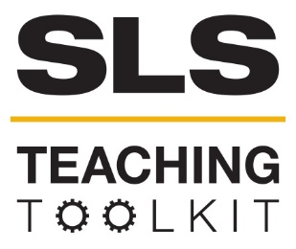 | Atlanta BeltLine Case Study
 | Time Commitment: 30-60 mins | Type: Reading; Discussion; Take-home assignment, project; In-class exercise | Big Ideas: Systems Thinking; Infrastructure: Physical, Technological, Social
OVERVIEW:
The Atlanta BeltLine is one of the most important urban renewal projects of the 21st century. In this case study, read about the ambitions, successes, and struggles of this project, now in its 12th year. Serve-Learn-Sustain interprets sustainable communities as integrated systems, wherein environmental, economic, and social factors all inform each other. As you read this case study, consider these terms as discrete factors, but also as connected.
This tool was contributed by Dr. Bethany Jacobs
INSTRUCTIONS:
- Use this case study in the way that works best for your class: assign it as a take-home reading, or as an in-class reading. Supplement the case study with sources from the Additional Readings section.
- Either as a take-home assignment, or in-class discussion, answer the Discussion Questions, or craft your own.
SLS STUDENT LEARNING OUTCOMES & ASSESSMENT
The Serve-Learn-Sustain toolkit teaching tools are designed to help students achieve not only SLS student learning outcomes (SLOs), but the unique learning outcomes for your own courses. Reflection, concept maps, rubrics, and other assessment methods are shown to improve student learning. For resources on how to assess your students’ work, please review our Assessment Tools at http://serve-learn-sustain.gatech.edu/tool-category/assessment.
This tool achieve SLOs 1-6, 8. See the end of this tool for further details.
Want Help?
Jennifer Hirsch is the contact for this tool. You can reach her at jennifer.hirsch@gatech.edu

Atlanta BeltLine Case Study

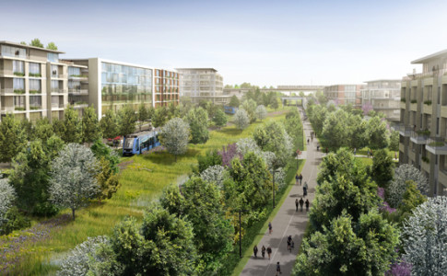
Introduction
(“Atlanta Beltline,” Atlanta.net)

In 1999, Georgia Tech student Ryan Gravel completed a master’s thesis in which he argued for transforming Atlanta’s historic rail corridor into a connected loop of parks, neighborhoods, and other amenities. Working with colleagues Mark Arnold and Sarah Edgens, Gravel soon gathered a groundswell of support from local politicians, businesses, and community leaders. Together, they broke ground on the Atlanta BeltLine, “a sustainable redevelopment project that […] will ultimately connect 45 intown neighborhoods via a 22-mile loop of multi-use trails, modern streetcar, and parks” (beltline.org). As of 2017, the BeltLine is 12 years into production, with a completion goal of 2030.
Sometimes compared to New York’s High Line (a linear park on a section of disused New York rail line), the more ambitious BeltLine represents a growing number of urban projects designed around creating sustainable cities. National reports have described it as the most “inspiring and forward-thinking” urban project currently underway (Doig), while George Washington University School of Business professor Christopher B. Leinberger argues that the BeltLine is “the most important rail-transit project that’s been proposed in the country, possibly in the world” (Fausset). Indeed, the BeltLine has received worldwide attention for its sustainable development model, making it one of the most important urban renewal projects of the early century.
Ryan Gravel
Serve-Learn Sustain interprets sustainable communities as integrated systems, wherein environmental, economic, and social factors all inform each other. As you read this case study, consider these terms as discreet factors, but also as connected. Ask yourself, how does the economy impact the environment? How does the environment affect society?

Environment
Committed to greenspace and sustainable growth, the BeltLine privileges conservation and reuse not only through its utilization of the abandoned rail line corridor, but its restoration of bridges, maintenance of historic landmarks, and recycling of old railway artifacts into public art. In addition, the BeltLine aims at 1,300 acres of public parks, a vast arboretum, and a series of urban farms, all of which contribute to environmental preservation.
Given that Ryan Gravel’s original BeltLine thesis arose from his dissatisfaction with Atlanta’s transit system, it is no surprise that the project conceives of itself as a transportation initiative. In addition to its 33-mile network of multi-use trails, the BeltLine will construct 22 miles of light rail transit looping the city, with an additional 28 miles crisscrossing town.
This commitment to public transportation in the historically traffic-plagued Atlanta has great potential for achieving environmental goals. However, Mike Dobbins, Georgia Tech faculty and former Planning Commissioner with the City, has raised questions about the likelihood of the BeltLine to improve public transportation on a significant scale. As he explains, successful transit relies on the balance between destinations and origins. In other words, the BeltLine may have excellent destinations, but if its transit system is inaccessible to the majority of Atlantans, it will go unused and thus make little environmental impact (SaportaReport). The BeltLine’s reiterated commitment to crisscrossing transit lines, and its partnership with MARTA, may mitigate this problem, something worth watching over the remainder of the project.
Key Takeaway: The BeltLine is fundamentally a transit project. Its success depends on improving public transit for all Atlantans.

Economy
(“Project Highlights,” beltline.org)
While philanthropic donations contribute to the BeltLine, its primary funding comes through tax allocation, a fact which compels community return on investment. The BeltLine has staked an interest in producing jobs, transport, and affordable housing, as well as $10-20 billion in private redevelopment. All these goals have the capacity to revitalize the economy for Atlantans of all economic backgrounds. The project anticipates 48,000 temporary construction jobs and 30,000 permanent positions. Over the past 12 years it has raised $3.7 million in private redevelopment, and currently claims an 8-to-1 return on investments (beltline.org).

But while the BeltLine holds definite economic promise, there have been various criticisms of the project’s ability to meet all of its goals. For example, of the 28,000 housing units planned along the BeltLine, only 5,600 have been allocated for Affordable Housing—a goal which the BeltLine admits it will struggle to meet. Furthermore, according to city resident Clarence Mackie, who lives near the BeltLine, “Our taxes have jumped.” The unintended consequence of BeltLine development has been that the nominally positive rise in property values also results in rising property taxes, which has led to resident displacement in a phenomenon known as gentrification (“Large Redevelopment Initiative,” Immergluck). The further division of Atlantans along economic lines can increase the wealth of certain residents, but does not ultimately serve the economic interests of the entire city. As West Side homeowner Leslie Canty observed at a June 26th, 2017 public meeting, “There needs to be more attention to the people who are already there instead of about the new developments. A lot of things they're adding to English Avenue, Vine City, and Ashview Heights are really not there for the residents. They're there for the people coming in” (Bandlamudi). Canty’s concerns are characteristic of many West Siders, who fear the shadow of gentrification will overcast any potential economic gains.
Key Takeaway: Economic gains must benefit current BeltLine residents, not push them out.

Society
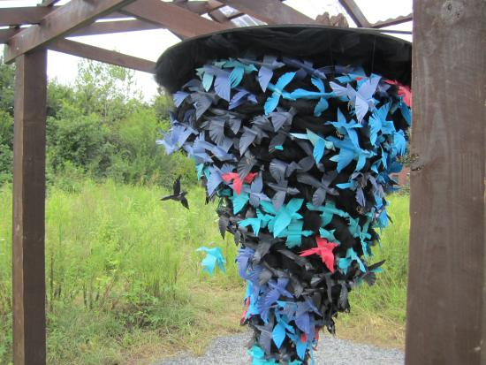
One of the great promises inherent in the Atlanta BeltLine has been its potential to improve Atlanta residents’ access to services (including outdoor recreation), and facilitate community-building by linking the city’s various districts. That promise has been articulated as including Atlantans of lower economic status, through jobs, access to affordable housing, and more reliable public transit. However, as the economic and environmental issues raised above attest, there remain questions about the BeltLine’s real-world impact vs. its ambitions. Fears of gentrification in the West Side are compounded by long-standing resentment of the East Side’s historically greater access to city resources. In that vein, critics of the Atlanta BeltLine note that the earliest stages of the project have largely benefited already prospering communities. As Mike Dobbins observes, funding for the BeltLine relies upon its demonstrable benefit to “low-wealth neighborhoods.” However, “Eleven years on, the great majority of the half-billion dollars spent has gone to upgrades and amenities concentrated in areas that were already seeing marked population growth and increased property values after the 1996 Olympics” (Dobbins, The New York Times). This problem received a glaring spotlight when Ryan Gravel resigned from the Board of the Atlanta BeltLine Partnership (ABP) in 2016 to “focus on reminding people that the Atlanta BeltLine is for everyone. Accountability to that vision has been one of our biggest challenges” (Quirk). That accountability has significant implications for equity and justice in Atlanta, where wide-spread joblessness and poverty continue to divide the city.
(“Bird Tornado,” Dorothy O'Connor and Craig Appel, on the BeltLine)
Gravel has continued to assert his faith in the ABP’s ability to serve the entire Atlanta community, and in 2017 the ABP itself reiterated that “equity must be achieved” for the BeltLine to succeed (beltline.org). In addition, Mayor Kasim Reed has announced new funding to help BeltLine residents mitigate their rising property taxes, which is key to fighting gentrification (AtlantaAgent). Given the BeltLine’s already demonstrated celebration of public art, the outdoors, and conservation, one can hope that it will face these challenges effectively, to the benefit of the entire Metro area.
Key Takeaway: The BeltLine will prove its success when West Siders share development gains with East Siders.

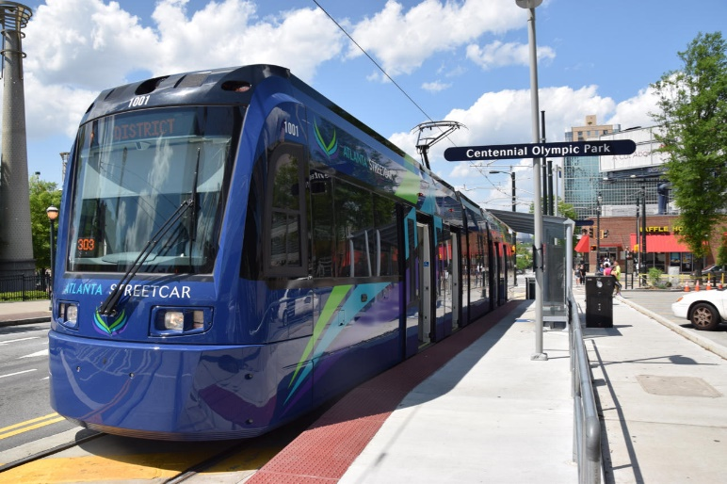
Discussion Questions
(“Atlanta Streetcar,” news.wabe.org)
- What are some of the examples of sustainability that you see at work in the BeltLine? Cite your answers from the case study itself or the Resources for Further Reading.
- The Environment, Economy, and Society are interlocking systems. What BeltLine issue demonstrate this interconnectedness? Cite your answers from the case study itself or the Resources for Further Reading.
- Explain why you think the BeltLine, a well-intentioned project backed by many committed citizens, is struggling to achieve some of its goals.
- In “Transit Planning 101 for the City of Atlanta: It’s not too late,” Mike Dobbins brings his city planning expertise to bear in describing how the BeltLine’s streetcar fails to achieve major transit gains for the Atlanta community. What other fields of expertise do you think are necessary for tackling BeltLine problems?
- The ABP continues to assert its desire for community involvement in and feedback on the BeltLine. Many people hesitate to engage in their communities because they aren’t certain what they bring to the table. Consider the specific skill sets you have been developing this semester, and then imagine you’re at a community planning meeting. How might you contribute to a conversation about improving the BeltLine?

Resources for Further Reading
Partnership for Southern Equity
Metro Atlanta Equity Atlas
The Atlanta BeltLine Official Website
The Atlanta BeltLine Community Benefits Agreement & Resolution and Principles
“Developing Sustainable Improvements for Our Future.”
Arieff, Allison. “What Happened to the Great Urban Design Projects?” (The New York Times, 2016)
Bandlamudi, Adhiti. “BeltLine’s West Side Brings Concerns about Gentrification,” (Wabe, 2017).
Chambers, Dustin. “Atlanta’s BeltLine: An Ambitious Plan to Bring a City Together” (The New York Times, 2016).
Dobbins, Mike. “Left Behind in Atlanta” (The New York Times, 2016).
Dobbins, Mike. “Transit Planning 101 for the City of Atlanta: It’s not too late” (SaportaReport, 2016).
Doig, Will. “The bold urban future starts now” (Salon, 2011).
Doig, Will. “How should we design the cities of our dreams?” (Salon, 2011).
Fausset, Richard. “A Glorified Sidewalk, and the Path to Transform Atlanta” (The New York Times, 2016).
Florida, Richard. “Building Infrastructure for More Inclusive Communities” (CityLab, 2016).
Gravel, Ryan. “Our Beltline” (ryangravel, 2016).
Immergluck, Dan. “The Beltline and Rising Home Prices: Residential Appreciation Near the Beltline Tax Allocation District and Policy Recommendations to Minimize Displacement” (2007).
Immergluck, Dan. “Large Redevelopment Initiatives, Housing Values and Gentrification: The Case of the Atlanta BeltLine.” Urban Studies, 46.8, July 2009, pp. 1723-1745.
Quirk, Vanessa. “Citing Equity Issues, Founder of Atlanta BeltLine Leaves Board” (Metropolis, 2016).
“Editorial: The Atlanta Beltline: A train off its tracks” (The Signal, 2016).

SLS Student Learning Outcomes

Goal: Develop Skills & Knowledge
- Identify relationships among ecological, social, and economic systems
- Describe how actions affect community sustainability
- Work effectively in different communities
- Analyze the impact of decisions on community sustainability
Goal: Connect to Professional Practice
- Relate discipline to community sustainability
Goal: Work in Diverse Contexts
- Create and evaluate approaches to addressing community sustainability
- Communicate with the public about sustainable communities
Goal: Build Long-Lasting Values and Beliefs
- Manifest personal values and beliefs demonstrating responsible community membership

