PRE-CP2233 CONCEPT MAPPING ASSIGNMENT

Overview
In class, we watched a training video on concept maps and walked through how to download and use CmapTools -- these materials can be found in the file “Concept Map Instructions” on T-Square. Before next class (Thursday, 1/11), you will complete a concept mapping exercise to benchmark your knowledge about urban sustainable development. You should take no more than 30-40 minutes to finish this assignment. Note that assignment completion factors into your participation grade. Please upload your concept map to the “Pre-CP2233 Concept Map” assignment on T-Square before 9:30am on Thursday, January 11th. Email Kevin Lanza at lanza.kevin@gatech.edu with any questions. Good luck!

Learning Objectives
- Construct concept map using CmapTools.

- Summarize your knowledge of Sustainable Urban Development prior to CP2233.

Concept Mapping Activity
Use the following guidelines to create your Sustainable Urban Development concept map:

Focus Question:
Create a concept map on the focus question: “What is sustainable urban development?”

What to Include:
- Prior knowledge from other courses
- Work experience, internships, service activities, etc.
- Magazines, newspapers, and other reliable media sources
- Many other possibilities…

How to Create Your Concept Map:
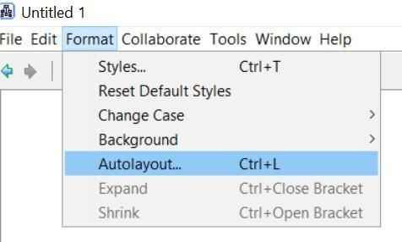
- Use CmapTools to create your concept map.
- The central topic should be: Sustainable Urban Development.

- Include as many concepts as you can think of that are relevant to the central topic.

- Show as many connections as you can between concepts. Remember,
each connection should include a meaningful linking phrase.

CmapTools Reminders:
- Double click on the workspace to create concepts.

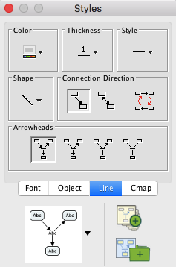
- Single click on a concept and click on the arrow above to connect concepts.
- You may use the “autoformat” option:

Format → Autolayout → Keep default settings→Generate New Layout

- You may find it useful to use the “always show arrow heads” option:

Select entire cmap → go to Styles window→ Format style → Click “Line” tab
→ Click the left-most option under arrowheads.

How to Submit Your Concept Map
- Save your concept map as: lastname_firstname_pre
- Your concept map will be saved under: Documents → My Cmaps
- Upload your concept map onto T-Square. Please submit the .cmap file

