**INSTRUCTIONS FOR**

**CONCEPT MAPPING ASSESSMENT**

***Tutorial:***

<https://www.dropbox.com/s/h3tbdp71dwzw8ut/cmapvid720.mp4?dl=0>

*Materials developed/provided by:*

**Mary Katherine Watson, PhD**

Assistant Professor

Civil and Environmental Engineering

212 LeTellier Hall

(O) 843.953.7686



**How to Download CmapTools**

* 1. Go to the Florida Institute for Human and Machine Cognition website: http://cmap.ihmc.us/



* 1. Click on “Downloads” and then “Download CmapTools”

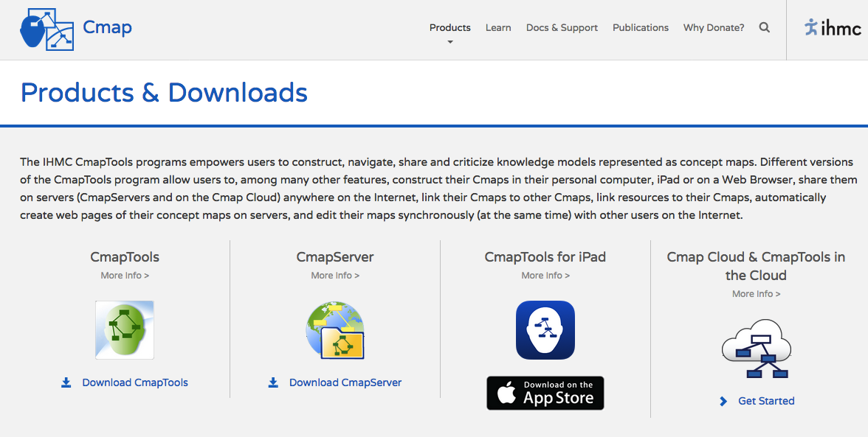

* 1. Scroll down and fill out the form. Provide required information: your Georgia Tech email address, first name, last name, organization type (i.e., higher education), country, and target operating system.

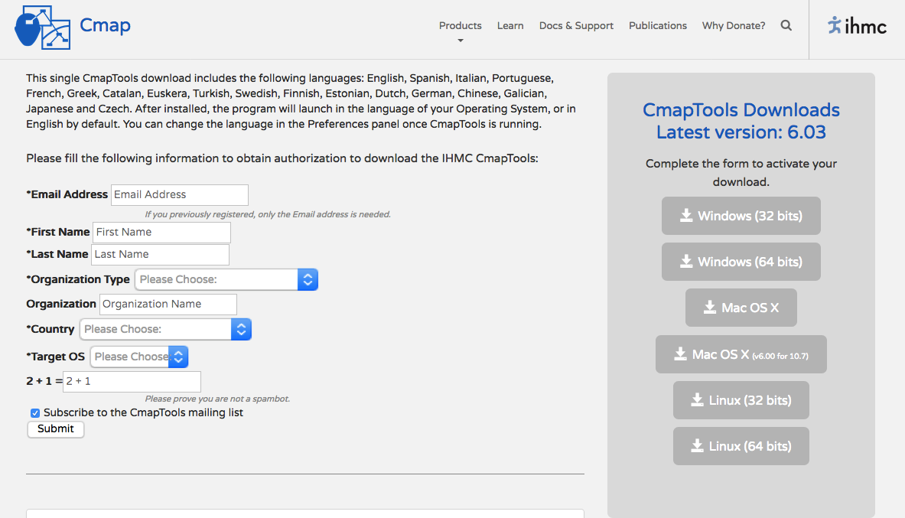

* 1. Select the appropriate download application for your computer. The IHMC Cmap “Windows (64 bits)” or “Mac OS X” downloads are appropriate for most personal computers. You do not need to make a donation to download CmapTools.

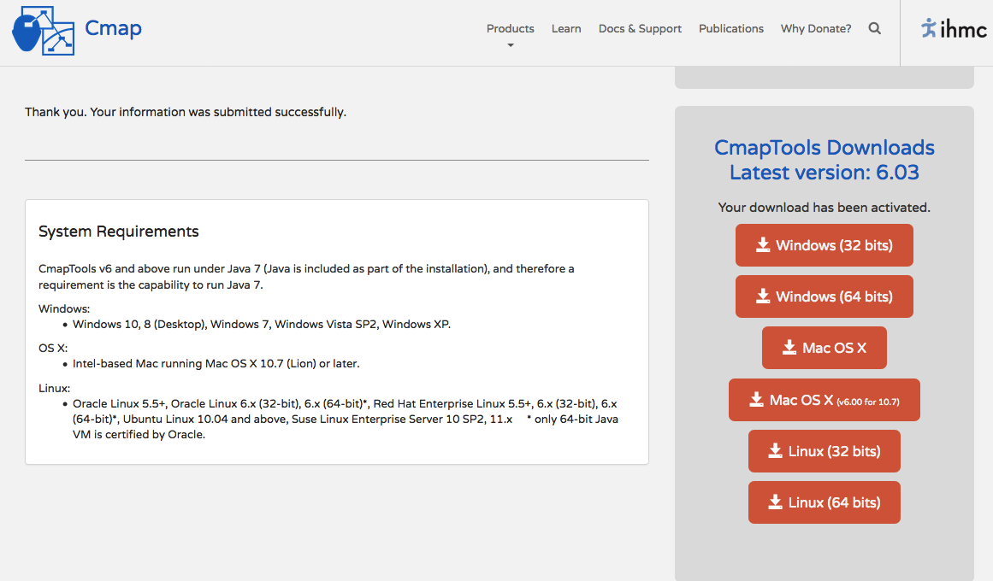

* 1. A box entitled “Opening Win64CmapTools_v6.03_10-04-17.exe“ or “Opening MacOSXCmapTools_v6.03_10-04-17.zip” (depending on operating system) should appear. Click on “Save File.”

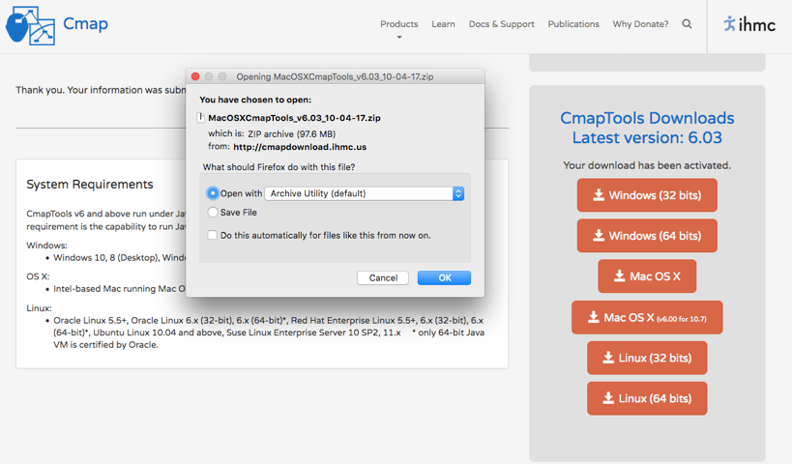

* 1. If you have a Windows operating system, open the executable CmapTools file from your Downloads folder or other specified directory, and then click “Run.” If you have a Mac operating system, double-click the zip file from your Downloads folder or other specified directory, and then open the newly created CmapTools_v6.03_10-04-17 application.
  2. The download of the CmapTools installation program will begin.
  3. A dialogue box entitled “IHMC CmapTools v6.03” should appear. You should start on the “Introduction” tab. Click “Next.”

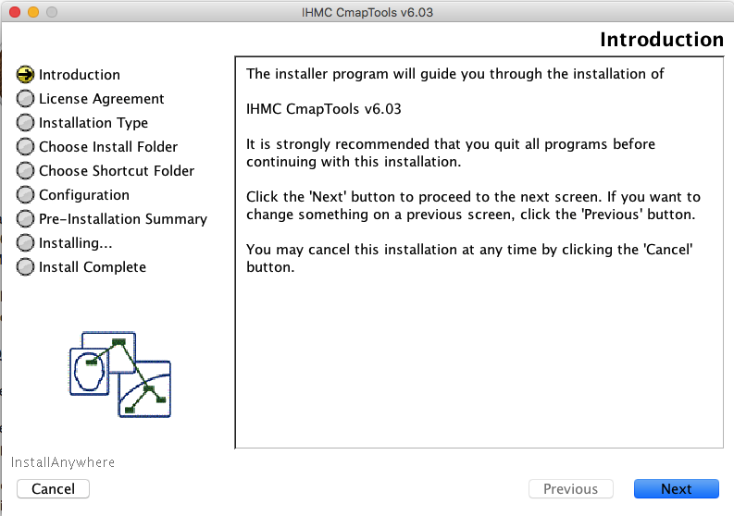

* 1. You should now be on the “License Agreement” tab. Click “I accept the terms of the License Agreement” and then click “Next.”

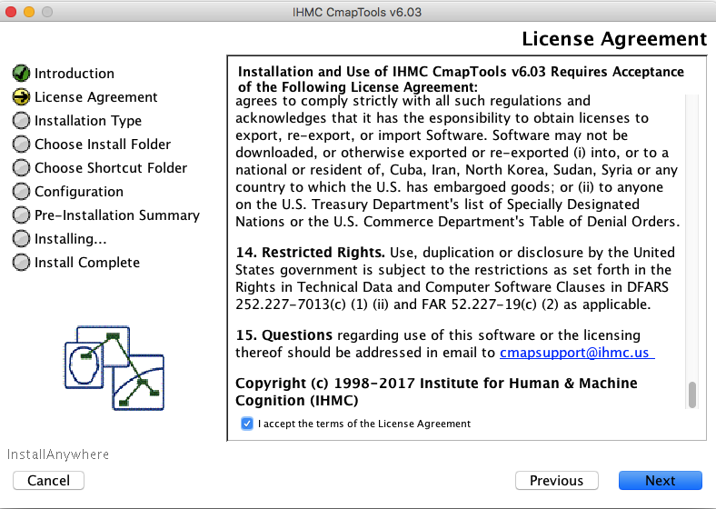

* 1. You should now be on the “Installation Type” tab. Click on “Typical Configuration” and then click on “Next.”

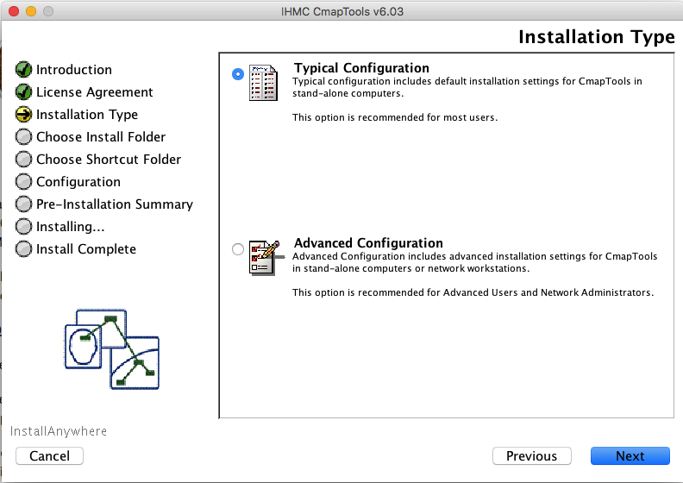

* 1. The installation software should automatically complete the “Choose Install Folder,” “Choose Shortcut Folder,” and “Configuration” stages and should now be on the “Pre-Installation Summary” tab. Click “Install.”

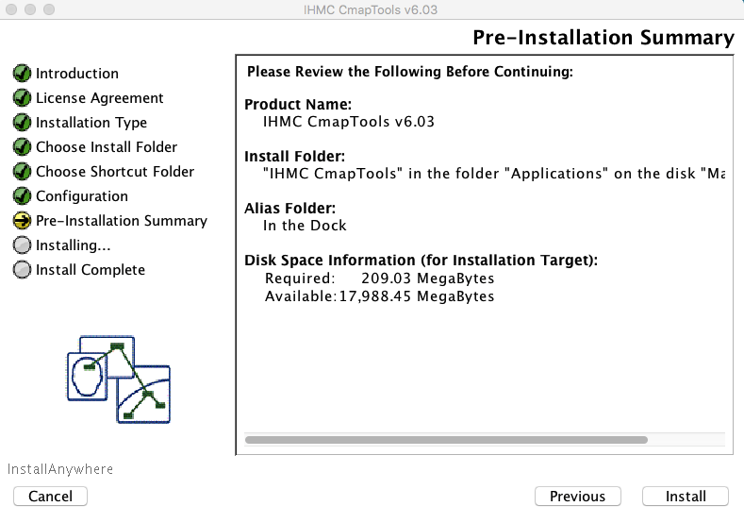

* 1. Installation of CmapTools should begin.

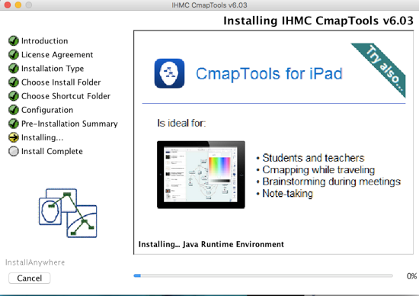

* 1. Once the installation is complete, click “Next” and then “Done.”

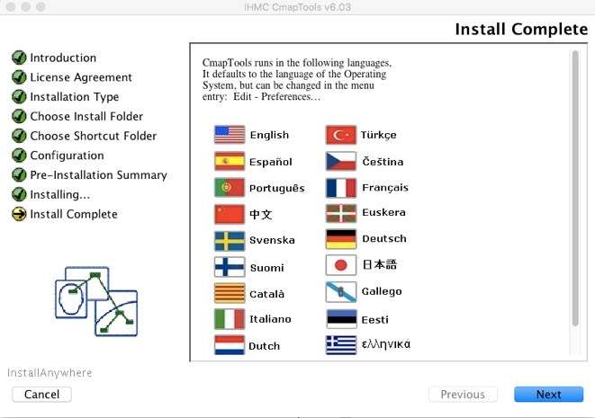 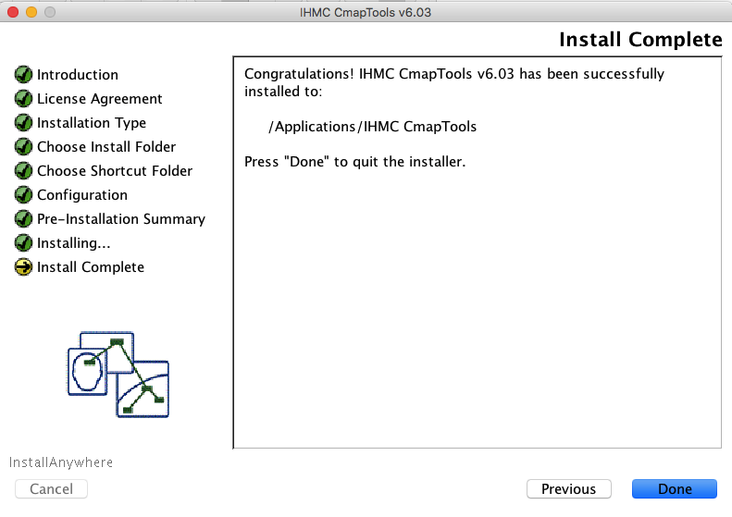

* 1. CmapTools is now installed on your computer.

**How to Use CmapTools**

1. Open CmapTools. Two windows should appear: “Views” and “Untitled 1.” Close the “Views” window.

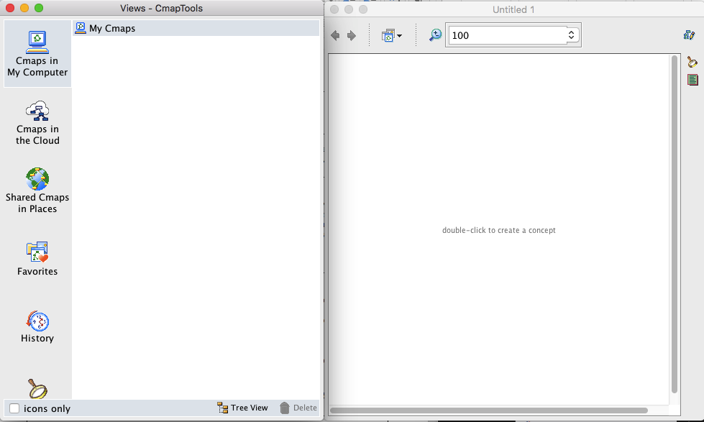

1. On the CmapTools top toolbar, select “File” and then “Save Cmap As.” On the “Save Cmap As” dialogue box, provide a file “Name” and the “Focus Question” that your concept map will address. For this demonstration, the file name is “Example” and the focus question is “Describe how birds fly.”

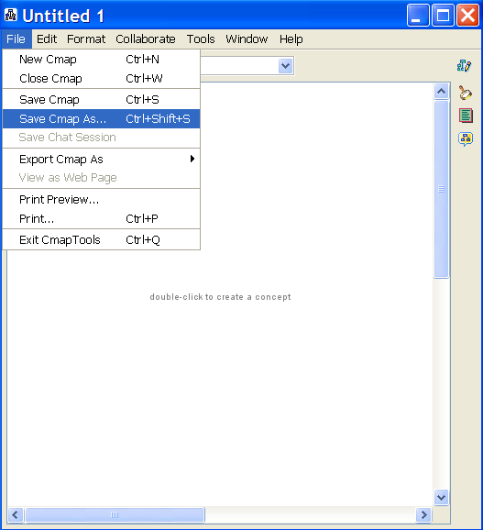 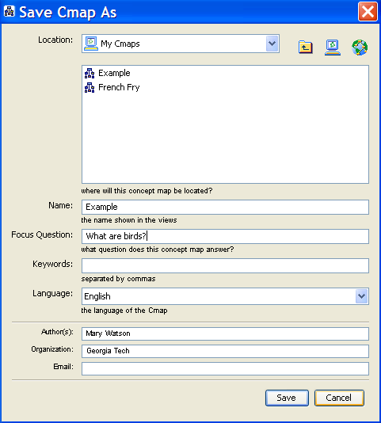

1. Double-click on the modeling space to create concepts. While a newly created concept box is highlighted, start typing to replace the label of “????” with the label of your concept using keywords or phrases.

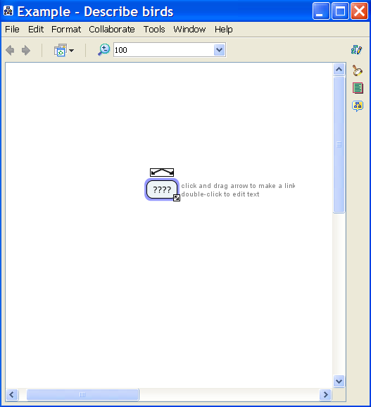 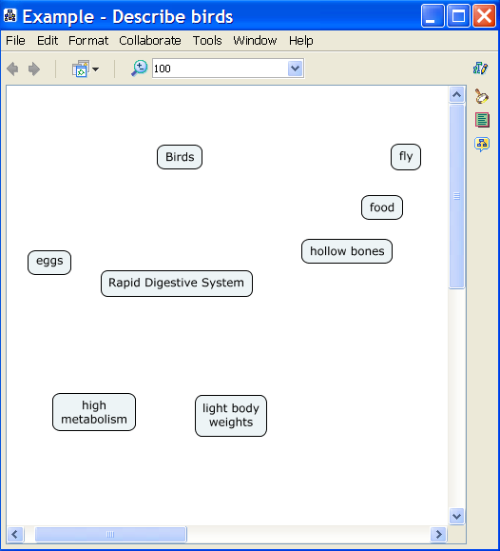

1. Link concepts together to form propositions. Click on the first concept in the proposition. Click on the arrows symbol on top of the first concept. Click on the second concept in the proposition. An arrow should now be linking concepts 1 and 2. Repeat for all propositions. NOTE: Concept maps are generally read from top to bottom. By default, CmapTools does not display arrow heads for propositions read top to bottom.

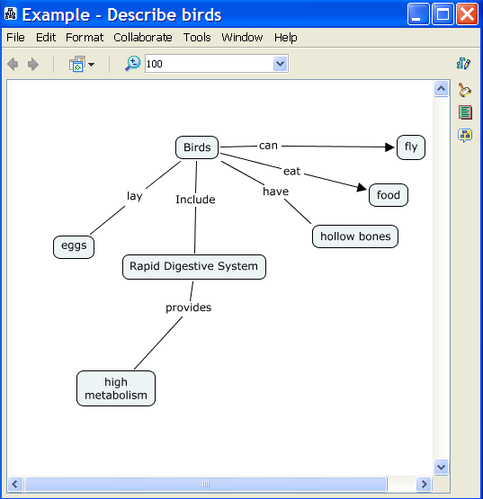

1. You may need to make branching linking lines. This is done by clicking on the description of the linking line (“provides” in the example below). Next click on the arrows symbol above the description. Click on the concept you wish to link (“light body weight” in the example below). You should now have three concepts linked together. You may repeat this process to link more than three concepts.

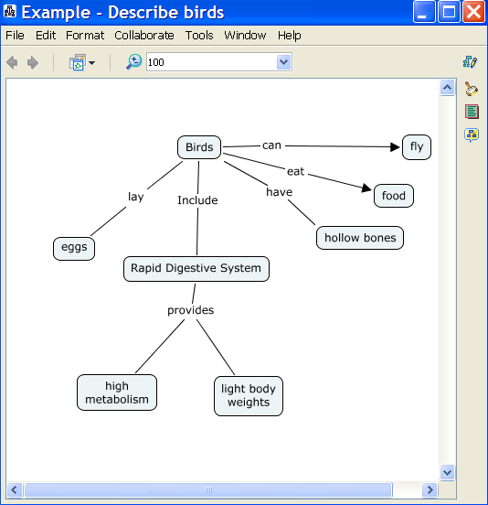

1. There are many other functions you can use in CmapTools. For instance if you select a concept or linking line, you can edit several of its features by using the “Styles” window. Advanced functions may facilitate but are not typically required for Cmap development.

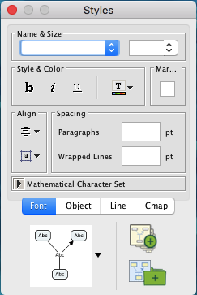

1. For additional help with CmapTools, use the help menu. Click on “Help” on the CmapTools top toolbar. Next, click on “CmapTools Help.”

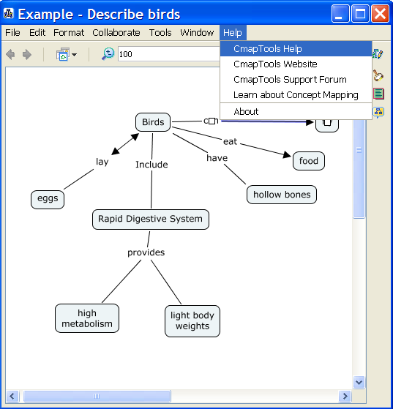

1. A CmapTools Help webpage should open. Select the topic that aligns most closely with your question.

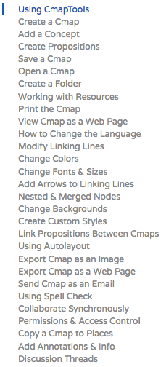

**How to Build a Concept Map**

1. Identify a focus topic you wish to map.
2. Guided by this question, create a list of concepts that are pertinent to the topic using CmapTools®.
3. Sort through the concepts, and move to the side any that you do not fully understand or is not related to any other term.
4. Using CmapTools®, arrange the remaining concepts in a way that makes sense to you. Terms you see as related should be kept fairly close together. One approach is to place general concepts near the top of the map and specific concepts at the bottom of the map. Other layouts may also be appropriate.
5. Draw linkages using CmapTools® between concepts you see to be related.
6. Write on each line the nature of the relation between the terms.
7. Review your map and determine if there are any more concepts you can add. You may add to the map new concepts or concepts set aside in step 3. If you do add additional concepts, you should be sure to link them to other concepts and provide descriptive linkages.
8. Again review your map. Look for cross-links, which link together concepts in different areas of your map. Cross-links will help you to elaborate how concepts are interrelated.
9. Finalize your map. Make sure that appropriate concepts are linked and that all linkages are described.

**References**

Borrego, M.; Newswander, C. B.; McNair, L. D.; McGinnis, S.; Paretti, M. C., Using concept maps to assess interdisciplinary integration of green engineering knowledge. *Advances in Engineering Education* **2009,** *1*, (3), 1-26.

White, R.; Gunstone, R., *Probing Understanding*. Falmer Press: Philadelphia, PA, 1992.