Empowering Students to Become Change Agents
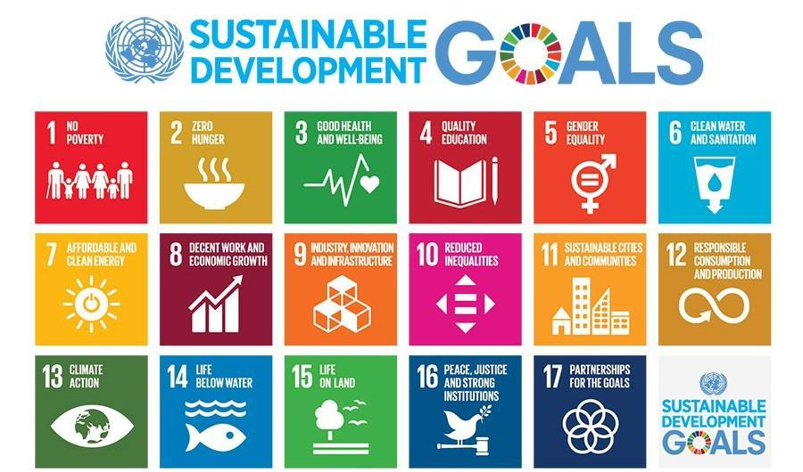

Advancing sustainability, whether in one’s dorm, on a college campus, in a community, or at national and global scales, means enabling change, and educating change agents. Many sustainability competencies and the recent National Academies report “Strengthening Sustainability Programs and Curricula at the Undergraduate and Graduate Levels” agree that sustainability education should support the ability of students to design and lead change in multiple spheres—organizations, communities, states, and internationally. How can we incorporate this key element of Education for Sustainable Development (ESD) into our teaching? This resource provides a few suggestions to help get you started; you may also contact SLS for one-on-one support.

Resources on Social Change
Organizational Change: Most students will eventually work for organizations of some kind, be they universities, corporations, nonprofit organizations, or government agencies. They will likely have opportunities at their workplaces to drive change from inside the organization. Here are a few ideas for supporting their ability to be change-makers from within:
- Provide information about organizations and governance structures on campus that are open to students–especially ones that are not limited to students only. Getting involved in decision-making on campus provides rich opportunities for learning negotiation skills.
- Share and discuss a case study of organizational change appropriate for your course. SLS has several case studies available in the Teaching Toolkit; contact us for assistance finding additional examples.
- One framework for within-organization change-making that has been applied in academia and in corporate settings is the “Tempered Radical” perspective. Share and discuss this relatively brief article on Tempered Radicals with your students.
Social Change: A “deep dive” into theories of change and social movements often is beyond the scope of what most instructors are able to incorporate into their SDG teaching. How can you help students find additional resources?
- Review and share the Social Change Toolkit 2.0 (Iowa and Minnesota Campus Compact) to introduce students to the many ways people can act to advance social change.
- Help students understand that diverse roles support social change and to see themselves as change-makers with this Social Movement Descriptor resource.
- Help interested students find appropriate electives to learn more. Share the SLS Affiliated Courses page which includes electives with connections to social change.
- Share information about the Sustainable Cities and Social Justice minors and Innovating for Social Impact certificate program at Georgia Tech.
- These additional resources from SLS may also be helpful:
  - Reflection of Protest and Social Movements
  - Anti-Racism Resource List
  - Case Studies on Sustainable Communities
SLS Presentations
SLS worked with a group of young change-makers to present a 2021 AASHE webinar: How Can Sustainability Education More Effectively Equip Students to Become Change Agents? A video of that presentation is available through AASHE’s archived webinars and videos, here. You will need to create an AASHE account to access the recording, which all Georgia Tech students, staff, and faculty may do free of charge. Create a new account here.
You may also find these conference presentation slides helpful.
Incorporating Service-Learning and Community Engagement (SLCE)
Experiential learning and, specifically, service-learning, is a powerful way to extend classroom discussions and examples of social action into the “real world.” Students who learn alongside change-makers have the opportunity to experience first-hand a variety of strategies and challenges involved in working for change. In addition, as the 2020 National Academies of Science report Strengthening Sustainability Programs and Curricula at the Undergraduate and Graduate Levels notes, service-learning also can deepen student understanding of the complex issues organizations are working to address. SLS can help you identify appropriate community-based partners and design service-learning opportunities for your students. Contact Ruthie Yow or Rebecca Watts Hull, Service Learning and Partnership Specialists, to talk through “SLCE” opportunities.
SLCE Teaching Tools:
Community Engagement and Reflection Tool
Exploring Asset-Based Community Development: The Parkway Community

