Resources for SDG Course (Re)Design: What Are the SDGs?

The United Nations (U.N.) Sustainable Development Goals (SDGs) are a set of 17 broad and interconnected goals that address the global challenges humanity faces. They were developed as part of the 2030 Agenda for Sustainable Development, adopted by all U.N. member states in 2015. The SDGs are comprehensive and visionary, including ending poverty and hunger, reducing inequality, and strengthening the health of human communities and ecosystems globally.

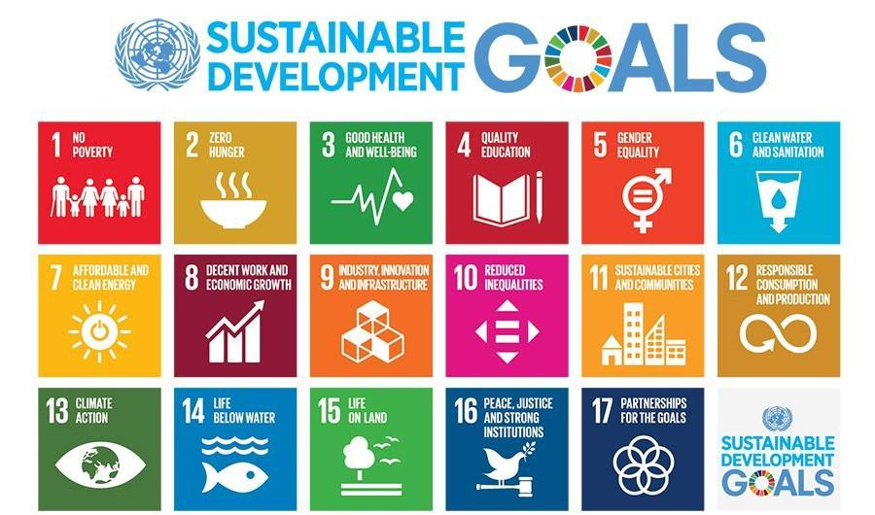

Read more about the history of the SDGs here.

Review detailed information about each of the Goals, including targets, and find related initiatives and resources here. This page also includes a roughly 30 minute video that introduces the SDGs in the context of the COVID-19 pandemic and growing collective action in response.

