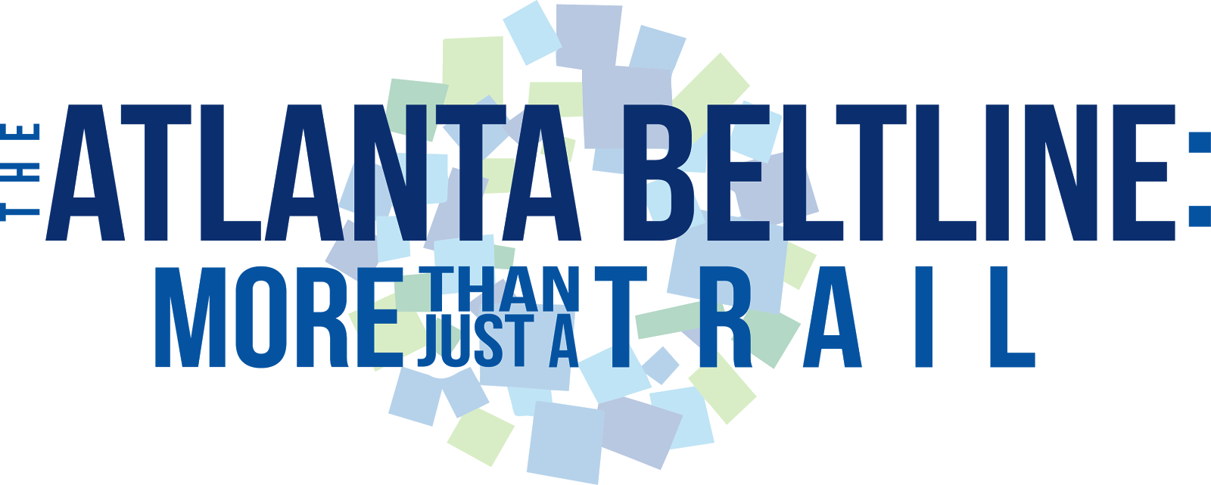

INTRODUCTION
Our campaign theme followed a motto that we took from our initial meeting with the BeltLine crew. The motto was “More Than Just a Trail.” It, to us, said that the BeltLine was more than just a trail in the sense that it was also a museum, a gym, a means of transportation, and a community, and through its being all of these things it was open to people of all kinds. Being more than just a trail means that the BeltLine has many features, but also that it offers things to everyone and no one will be turned away.
The Atlanta BeltLine was certainly more prepared and well-rounded in terms of advertising and social media presence than the other organizations that our class worked with. The BeltLine had a website full of information made with the help of one or more professional graphic designers, an email newsletter, and even an application for smart phones. They were already active on Twitter, Facebook, and Instagram, and had already begun working on Snapchat publicity. Because all of this was set up before we partnered with the Atlanta BeltLine we had to set our sights on making their media presence more effective more so than expanding it to new platforms. Because they had not yet started developing their visions for Snapchat we were able to take over that project and use Hannah’s Photoshop abilities and creative visions to help them enter into the Snapchat domain. We came up with some general ideas of how to improve their branding and formatting and put them into practice in our reformatting of their PowerPoint presentation as a Prezi. Some of our largest goals as a team were to give the Atlanta BeltLine a youthful perspective as members of the generation that some call “millennials,” help bring them into the social media age with our personal experience, and freshen up their advertisement to include more user involvement.

CREATIVE BRIEF
In our meeting with Mrs. Davis and her team, we were informed that the main issue that our project was aimed to resolve was the lack of education and awareness surrounding the BeltLine. Many people are entirely unaware of the existence of the Atlanta BeltLine. For those who do know what it is but have chosen not to visit, more often than not it is due to the fact that they do not know about the ample, diverse opportunities that it has to offer. For this reason, it became apparent to us that it was going to be vital that our campaigns focus on promoting the various ways that the BeltLine can be used to enhance the everyday lives of Atlanta residents. This central idea thus became the main argument within our Creative Brief, and the overarching goal of our Creative Brief then centralized around the objective of exposing the current capabilities of the BeltLine, as well as proposing further development of the initiative.
In crafting a successful creative strategy it is important to acknowledge the challenges that might hinder the tasks at hand. For this reason, it was part of the planning process to set aside a category of our creative brief that summarized these obstacles, so that our team could best prepare for our marketing approach. In our meeting with the BeltLine team they expressed to us that they intend to advertise towards a very large audience. Thus, in essence, all citizens of the city of Atlanta was the target audience of our campaign. This meant that our campaign had to be broad enough to reach a wide array of people, yet unique enough to strike a common chord within the hearts of all Atlanta residents.
Once we determined the goal of our campaign, as well as the general audience that we wished to market towards, we had to determine which executional strategies to use to advertise the BeltLine to the public. We first chose to create a Prezi presentation that will be shown at meetings and other BeltLine events. This presentation is more visually dynamic than the original slideshow, and it lends to the creative spirit of the BeltLine. The next project that we worked on for the Atlanta BeltLine was a social media campaign that will hopefully boost awareness of its presence among the community. This social media strategy is very complex, and includes various components that will hopefully combine in a synergistic manner to yield positive results pertaining to the expansion of clientele for the BeltLine. The final component that we worked on for the BeltLine was a promotional video that can be used as an addition to their “Life on the Atlanta BeltLine” YouTube series, in which a young adult speaks about her favorite aspects of the BeltLine, and how she feels her time on the BeltLine has improved her life.
Since the Atlanta BeltLine is a destination of such artistic freedom, we wanted to put subtle, yet interesting details into the layout of the Creative Brief. For this reason, our Creative Brief features a light grey background and the BeltLine’s signature logo displayed at the top. We utilized typography on the title in order to make the page look more interesting. The title and section headings were written in Bebas Neue, which is a bold, attention-grabbing font, and the body text was written in Minion Pro, a serif font that allows the eye to flow easily through the text. We followed this same format in the style guide except that the body font in the style guide is Times New Roman.
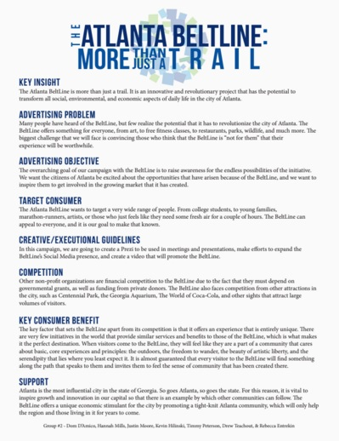

VISUAL DESIGN
In our meeting with them, the BeltLine crew stressed that they do a lot of presentations and wanted to make their presentation aids more visually appealing. From this, Prezi was suggested as a substitute to the power point slides for a younger and more diverse audience. Our Prezi is in the shape of the BeltLine logo with each slide representing a different rectangle of the logo.
The focus of the BeltLine’s advertisement and presentation campaign is to educate more people about the BeltLine because they said that the main reason people do not use the BeltLine is because they do not know what it has to offer. Therefore, our visual design goal is to make the information more apparent and have a focus on what there is now instead of what the future holds. The Power Point was lacking in aesthetic appeal caused by a lack of consistency in parts, a distracting background, a lack of blank space on many slides, pictures that were uninformative or not visually appealing, and a lack of contrast to highlight key information. Our main goal was to keep the information from the slides the same but change the design, adding better layout and contrast to highlight information. A few aspects from the Power Point that we wanted to carry over were the color palette and some design templates that continued from one slide to another. It will expand and enhance the presentation by making it more focused on the key information and more appealing with more attractive pictures and better layout. The pictures will focus more on the BeltLine now instead of on the construction of the BeltLine in the future so that the viewer will be more educated about opportunities available now instead of just what lies ahead. Looking at their Power Point, the main highlight was on the financial impact and the future. Though this is important and should be kept, the use of the BeltLine now is more important so people are not just investing in the future, but in the present.
Halfway through we sent a draft to the BeltLine and they responded with a couple changes including: highlighting “What the BeltLine is”, making the headers deeper colors, changing the order of certain slides, and adding specifics to selected slides. They also responded “Overall, the presentation looks great. Really love how you used the logo as the theme and the slides are evenly filled with content and photos. We also like how you’ve made the information precise and easy to read and will hopefully keep that style throughout.” Due to their comments, we changed the highlighted areas of change and continued to finish the remaining slides. Prezi is very limited in the color palette and customization, so we attempted to keep the color palette the same as the logo, but with a small range of color options the customization was not exact.
Overall a Prezi is a good way to lay out the Power Point in a different and creative way, but the free version is not necessarily the best way because of the constraints in the program. We learned that rotating the slides was less nauseating than having them the same orientation because of the way the program transitions slides. Also the best looking backgrounds are the dark blue and middle shade of blue. The light green is harder on the eyes and could be replaced by other colors. The font is Arimo and is bolded for headers and subheaders, but the other text is not bolded to contrast information. When there are no subheaders, the text is bolded because the difference in size creates the contrast. The layout of the slides is generally text on one side and a picture on the opposite side or one picture below and one picture beside. Each slide has the BeltLine logo in the top right corner even though parts are not visible due to the color scheme. The color palette is in shades of blue and green like the logo. The logo shape of the Prezi was sharpened with Adobe Illustrator and placed as an image into the Prezi. The text color follows the same color palate but uses contrasting colors so the text fits in while not taking away from the presentation.
Here is the starting view of our Prezi along with some sample slides:
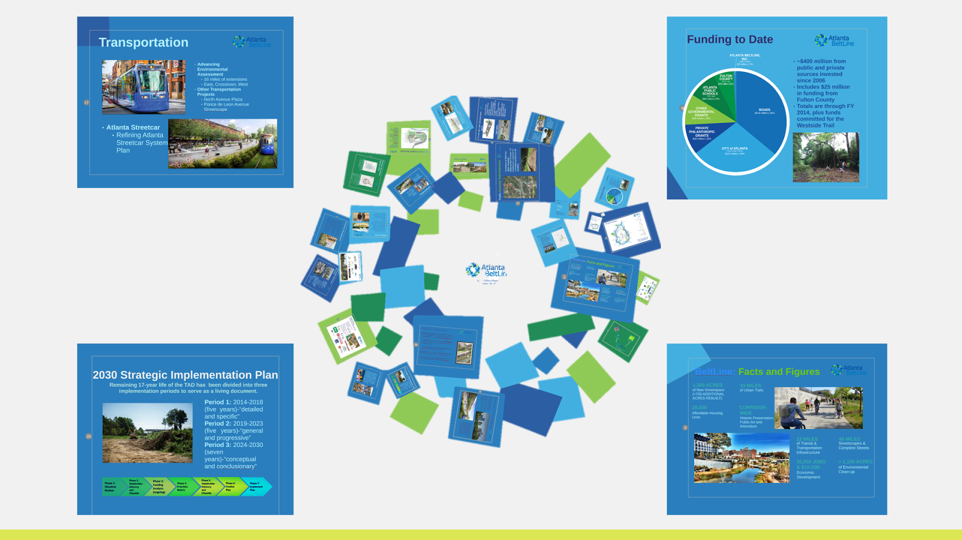
Here is a link to our Prezi: http://prezi.com/uompr9v_o9m0/?utm_campaign=share&utm_medium=copy&rc=ex0share

VIDEO
The video was a large part of our advertising campaign for the Atlanta BeltLine. The BeltLine already has a video series called “Life on the BeltLine,” and the client tasked us with adding to this series. One of the focuses of our entire marketing strategy was emphasizing why a person should use the BeltLine as either a transportation alternative or part of their daily life. After difficulties finding someone that could fit this mold, we shifted our strategy a bit and decided to focus on marketing towards millennials. In our new search, we encountered another problem - many young people know about the BeltLine, but they do not know why they should use it. Many people think the BeltLine is just a walking/running trail, but it is much more than that. It offers a variety of healthy activities and delicious restaurants and, therefore, is a great and affordable way to spend one’s time.

The millennial generation is a group the BeltLine has really been trying to reach for a long time, and we strongly believe that this generation is the group that is going to shape the future of the BeltLine. Our main argument is that the BeltLine is a place for young people too. In the film shooting stage of this advertising campaign, the group decided to find someone we knew that frequently used the Atlanta BeltLine rather than going to the BeltLine to look for someone to interview. We felt that this gave us the power to ensure that the subject of the film was relatable to our target audience, the millennials in Atlanta, and that the film accomplishes the goals set by the client and the group for this part of the advertising campaign. The person we found to be featured in the film is named Neira Selimovic. She is a fellow student at the Georgia Institute of Technology majoring in business, and she frequents the Atlanta BeltLine with her family because she loves the art and the atmosphere of people getting active and enjoying the outdoors. She seemed to us to be a perfect candidate because she is part of the target audience, which will allow her to relate to other members of the target audience, and she has experienced many aspects of the Atlanta BeltLine for herself such as art viewing, eating at the restaurants, and even trying out a fitness or yoga class there. On our set film shooting date, Neira was taken to the overpass near the Ponce City Market and the Piedmont entrance for her interview. B-roll footage was taken of the artwork nearby and of a fitness class and the skate park in order to compliment her responses to some of the questions asked in the interview. All of this footage then entered the film editing stage.

Although the video appropriately conveys our points, there are still some things we would do differently. Primarily, our video struggles with audio quality as we were incapable of acquiring equipment that was needed achieve good audio. In some of our shots, there is a lot of background noise, and unfortunately, our editing could not make up for it/eliminate it entirely. We also could have worked harder to acquire appropriate b-roll. We captured a lot of b-roll on our two shooting dates, but not all of it was appropriate for what we were arguing, so it would have been a dramatic upgrade to be able to get better b-roll. However, we were able to get many good shots that added to the quality of the video. Lastly, we would have used a tri-pod in some of the b-roll as a lot of the footage we got was good, but the shakiness of the camera prevented it from making the final video.

The style and fonts of this video are identical to those found in the first three “Life on the BeltLine” videos because this was a key point of emphasis of the client. Our music was of similar style to the original videos, but a little bit more upbeat to represent the younger generations and maybe interest them more. The music we used was a portion of the song “Buddy” by Bensound. It is royalty free as long as credit is given to www.bensound.com. The editing software we used was Sony Vegas and it allowed for easy editing of transitions which made using b-roll more visually appealing to the viewer as well as for easy stacking of video clips and the removal of unwanted audio from b-roll clips. There were at least 30 raw video clips from each day of shooting, and Vegas made the process of sifting through much easier. Our video was shot in HD by both a camcorder and a GoPro which gave us more than sufficient video quality. Our choice of shots also allowed the video to be more colorful than it may have otherwise been.

Here is a link to our video:
https://www.youtube.com/watch?v=3y_xFRMQJSE

SOCIAL MEDIA
The main goal for this advertising campaign within social media is to spread knowledge of the BeltLine to the general public but, more specifically, to millennials. Social media is routine for millennials to be keeping up with. Constantly, people of this generation are updated with pictures, statuses, tweets, videos, etc. from various social media accounts. For these reasons, social media is a key tool in spreading information to people of the millennial generation. The BeltLine has a presence on the main social media websites for young users: Instagram, Twitter, and Facebook; they also are active on LinkedIn and Google+. The most beneficial aspect of the BeltLine’s use of social media is how informative they make their posts. Instagram posts include pictures of work being done to improve part of the trail, or pictures of meetings being held about the BeltLine, always updating their followers on what the BeltLine is doing and planning on doing. This strategy is great to keep their followers in the loop, however our goal for the advertising campaign is to appeal to as many millennials as possible.
To contact and spread the BeltLine through twitter and Instagram, their presence on those two websites needs to expand from simply informing people on what has happened on the BeltLine, to making them aware of future events and posting in a way that aims to be seen by as many people as possible in order to increase their number of followers. The goal for our ideas on twitter was to increase the user contribution to excite our followers and spread the BeltLine accounts to as many other people as possible to increase their followers. Twitter is perfect for this. The retweet function serves as a useful tool to have more people view tweets and subsequently gain followers. This function exponentially increases the number of people that view a given tweet. However, the tweets from the BeltLine must encourage retweets. Strategies to encourage retweets could include polls that contain two choices and potential giveaways. For the polls, in order to express one’s choice in the vote, the person would retweet the tweet for one option or like it for the other. It is possible to conduct a poll like this because the number of retweets on a tweet as well as the number of likes on a tweet is saved and displayed. This strategy shares the BeltLine account to a thousands of twitter users that would not normally see their account; it also can provide valuable information if the poll conducted uses a legitimate question that needs user contribution to be answered. Additionally, it excites the current followers about the BeltLine with competition, debate, or humor. Another strategy to encourage retweets is to use the retweet function as a method for users to enter a raffle-type giveaway. For example, the tweet could be something like “Retweet to win an Atlanta BeltLine Bike!” This will prompt people to retweet the tweet and again, spread the BeltLine twitter account to as many twitter users as possible. The goal with twitter remains the same with Instagram, but there are different routes to accomplish these goals because of the variations between the two social media websites.
Instagram is a site that allows people to post photos with captions to be displayed on their followers’ active feeds and to be saved into their account. These pictures and captions are the only thing associated with an Instagram account; they are what creates an interesting, active account. Currently, the BeltLine’s Instagram account is, like their twitter, exceptionally informative. The goal of the project is to spread the BeltLine to all of the people that do not know about the trail, especially millennials, and that calls for strategies to be implemented into their use of Instagram. The account is not posting the pictures that hype up the BeltLine to millennials. Right now, there are pictures of construction work being done, meetings being conducted, and events being held. Their profile shows the buzz of the BeltLine with everything going on and improvements being made, but their posts need to be more intriguing for a millennial audience and encouraging for people to share with others in order to add to the BeltLine’s followers. A possible strategy to add user contribution while adding more appealing photos to their profile would be to hold contests for “Photo of the month” which is a competition between BeltLine users for who can take the best photo of their time at the BeltLine for that month and the winners photo is posted to the BeltLine’s Instagram account. This entices BeltLine users to take more photos and to show their friends how great of a picture they took on the BeltLine, which spreads the word while exciting the BeltLine’s current users and making their profile more engaging. For example, a contest could be “Yoga photo of the month” or “Dogs of the BeltLine.” Millennials are young, fresh people who use these social media websites continuously; if there are no eye-catching posts from the BeltLine, they will not even notice the posts because of how many posts they see in a day. The BeltLine’s account must stand out in order to be noticed by young people on social media.
The social media that the BeltLine has not held a presence in yet, but is one of the most used applications by millennials currently is Snapchat. Snapchat, like twitter, has the capability to spread knowledge of the BeltLine to masses quickly. The best method to get involved in Snapchat for the BeltLine is to create a geofilter, which is an icon that is made optional to include in your snapchats when the user is at a certain location. Users of the BeltLine add the icon to their snapchats when using the BeltLine and spread the word about the BeltLine to their friends. Also, if the snapchats make it onto the Atlanta story, then everyone in Atlanta with a snapchat will see that icon and a snapchat of the BeltLine. In addition, when holding special events, the Atlanta BeltLine story could be created, which is a compilation of users snapchats when within a certain location, the BeltLine in this case, viewable by everyone in surrounding areas. Both strategies excite the young people on snapchat and inform masses of snapchat users, who are usually millennials, about the BeltLine who would not otherwise know about the trail.
The suggestions all include user contribution and excitement. Social media websites have the capability to create powerful movements; they hold great potential for reaching out to multitudes of people.
Here is our design for the snapchat geofilter:

ORAL PRESENTATION
The oral presentation we created was a phenomenal way to express our main underlying theme to our advertising strategy, which is to advertise to the millennial generation. The way we had structured the presentation was to start with a brief intro establishing our motivation for our advertisement, which was to focus on the millennial generation as we felt they had the most potential for the BeltLine. Then, we had an overview of our process, briefly detailing our creative brief, our social media campaign, our Prezi, and finally showcasing our video. For each of those segments, the person whose respective job it was presented their part of our advertising strategy.
One of the biggest things we had to focus on when making our presentation was our preparation and rehearsal. At first, we started off with the general outline of the presentation. We organized the outline and wrote our main mission and goals of our advertising strategy. Then, we had decided to organize each segment of the presentation by our respective marketing strategies: the creative brief, the social media campaign, the Prezi, and the video. Each team member wrote and presented the slides corresponding to their respective job. Also, since our seventh man was on the video development team, he also worked on the video slides. On our specific PowerPoint, we used a basic theme with Oswald and Droid Serif font. We made sure to utilize the BeltLine’s colors in the presentation.
In each of our segments, we ensured that we focused on our main goals of advertising to a youthful generation. We gave an overview of our creative brief in the first slide which explained the general design of our marketing strategy. Then we focused on how our Prezi was more simplified and appeals to a modern crowd. Next we had our social media strategy, which obviously caters more to teens in the community, especially the Snapchat geotag. Finally, we presented our video, which we felt would make a great addition to the Life on the BeltLine series. Our presentation completely encompasses our entire advertising strategy, and shows how we are able to focus on the millennial generation.

Here is our PowerPoint:
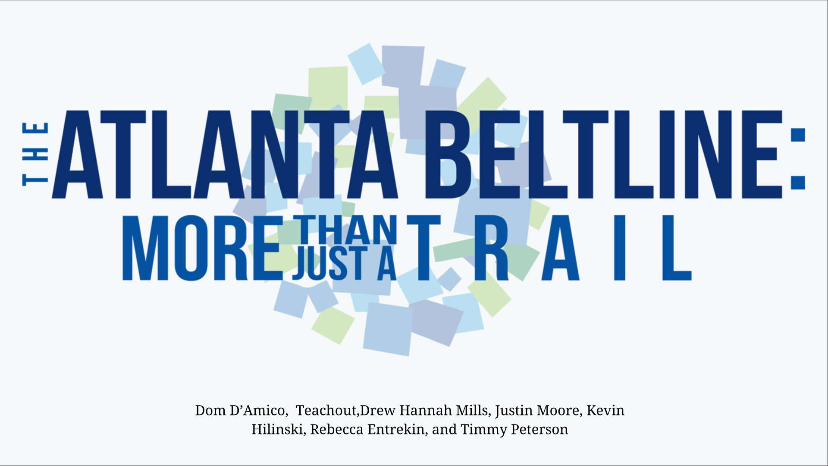
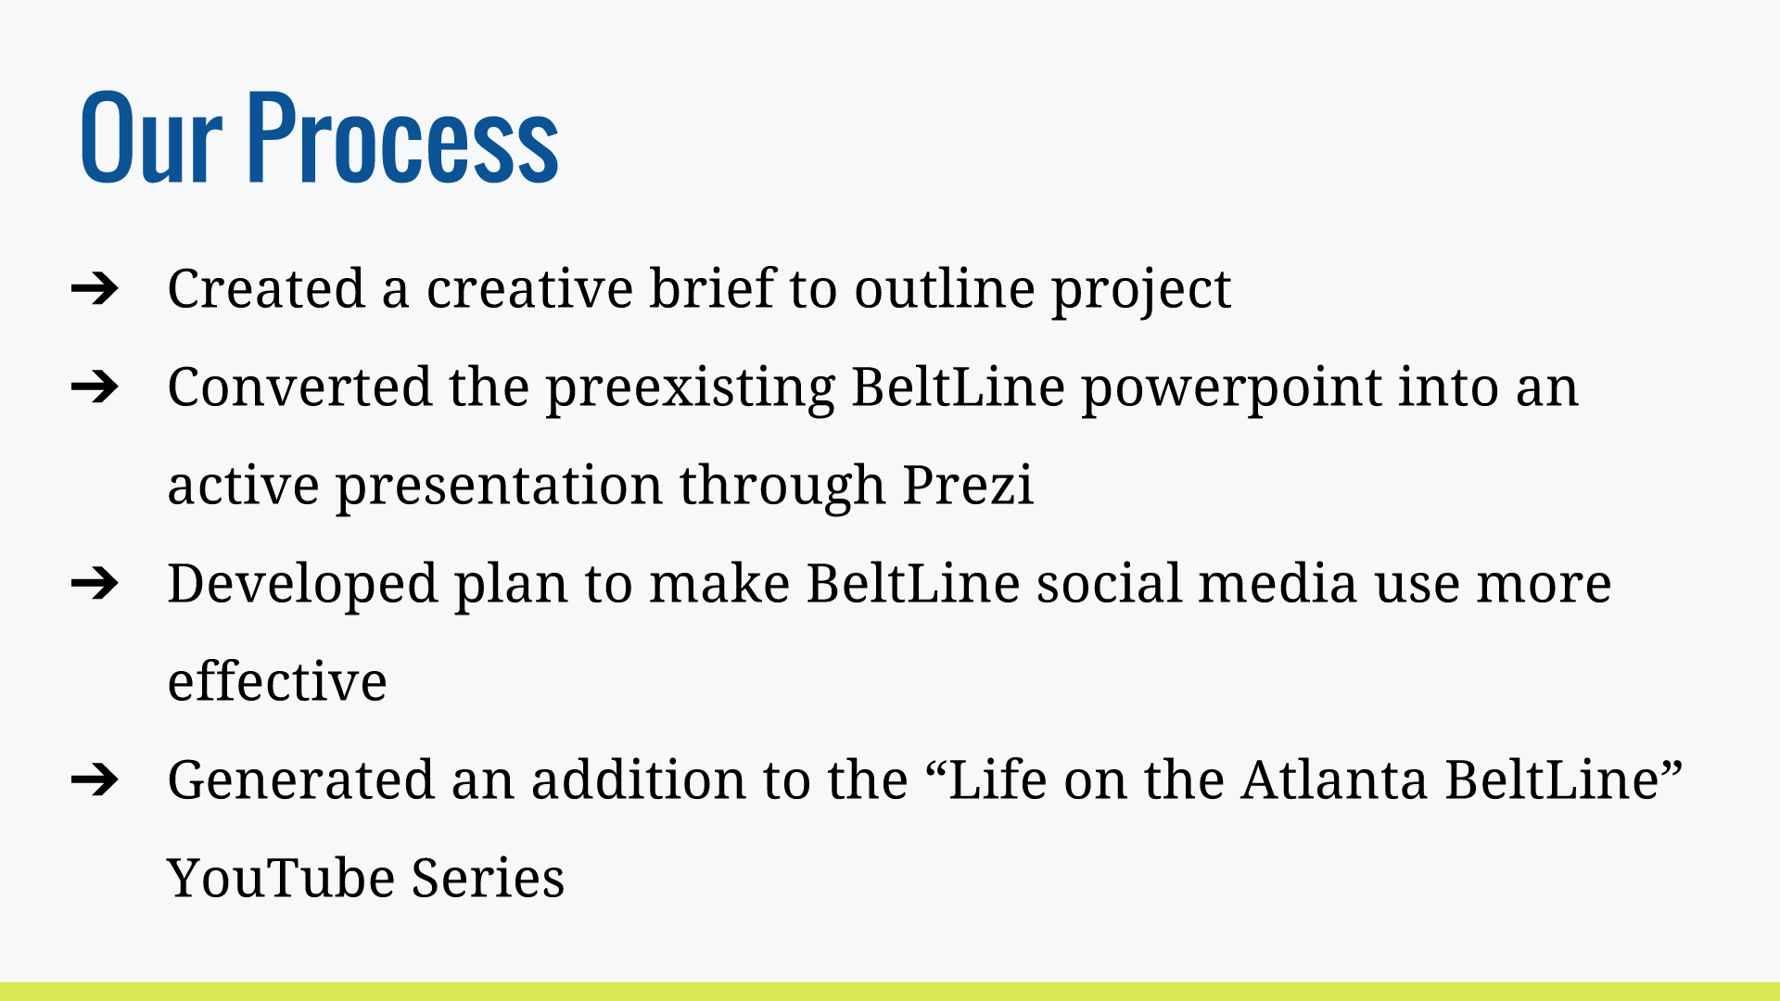
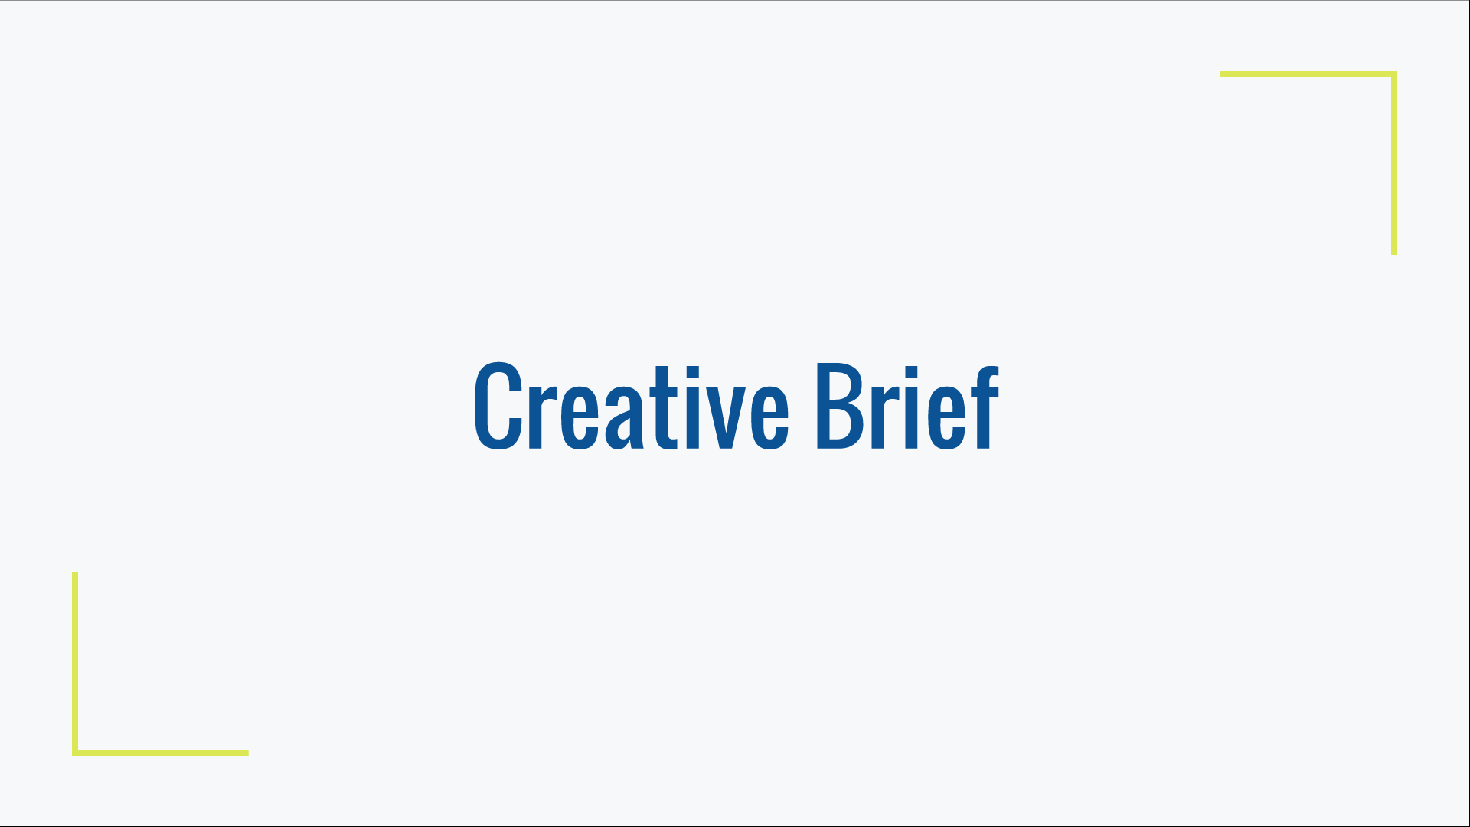
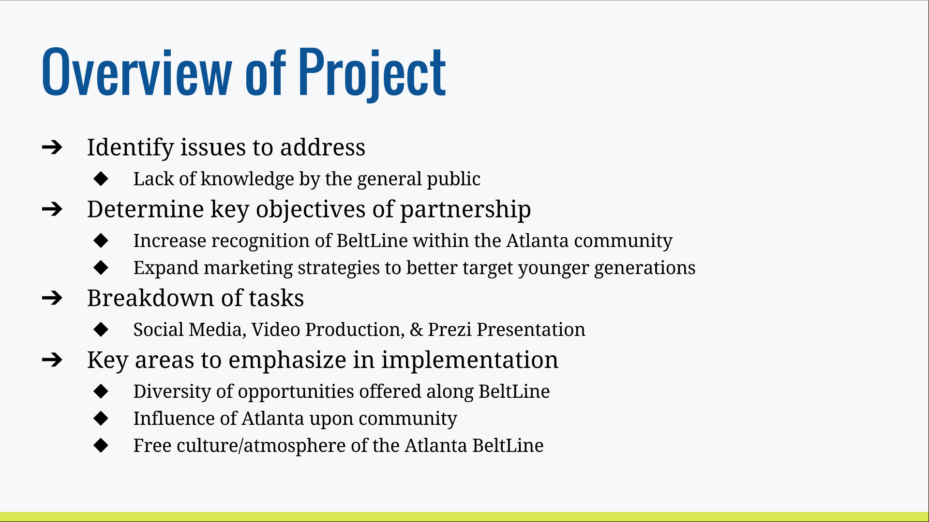
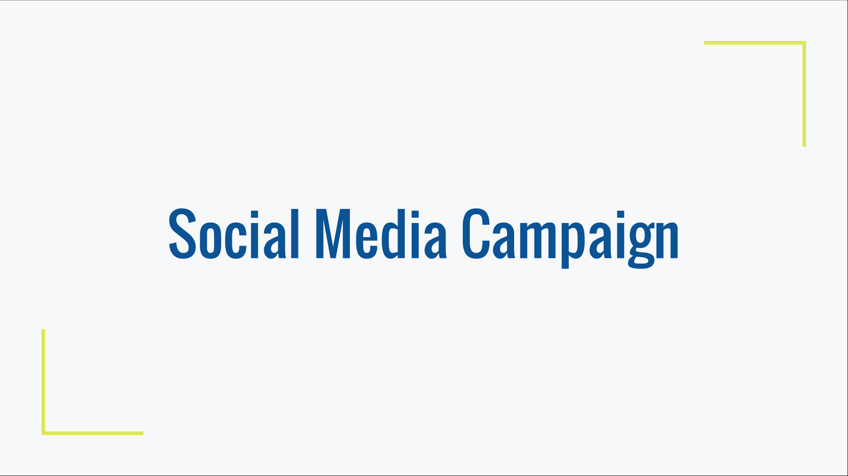
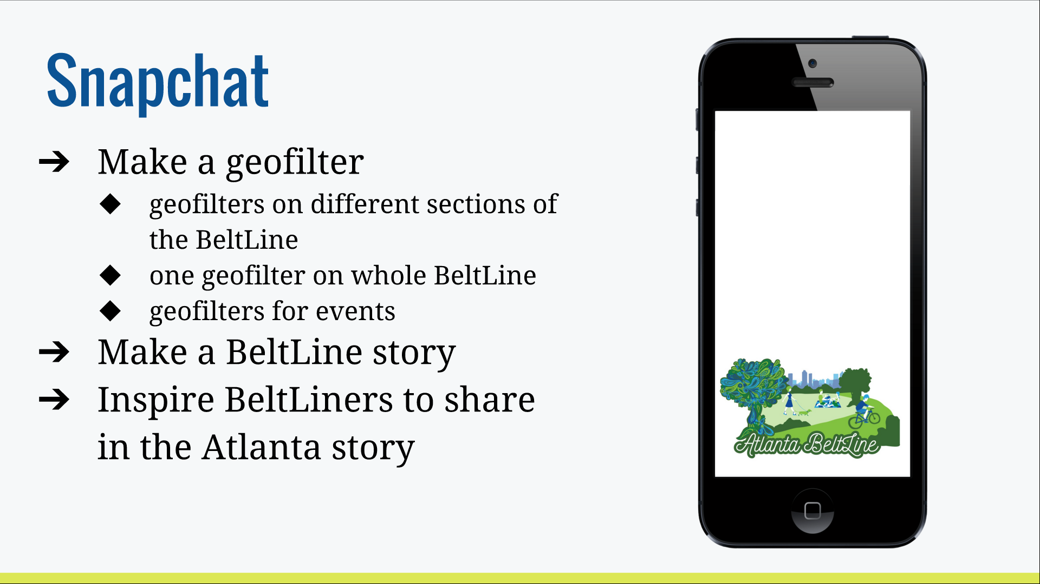
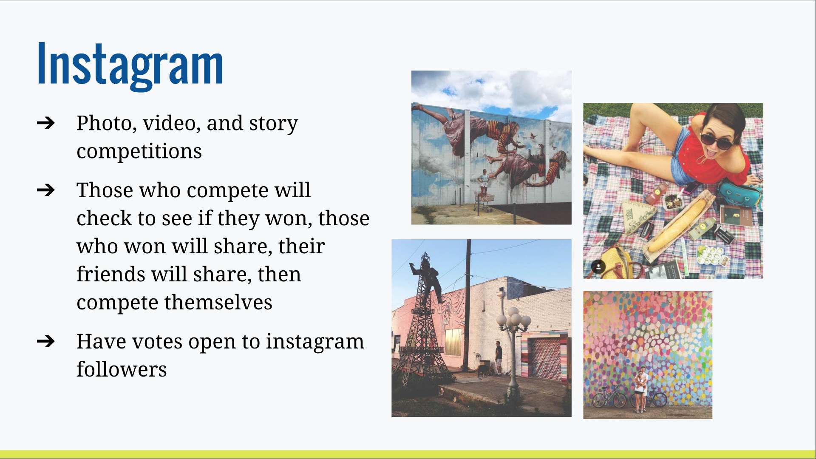
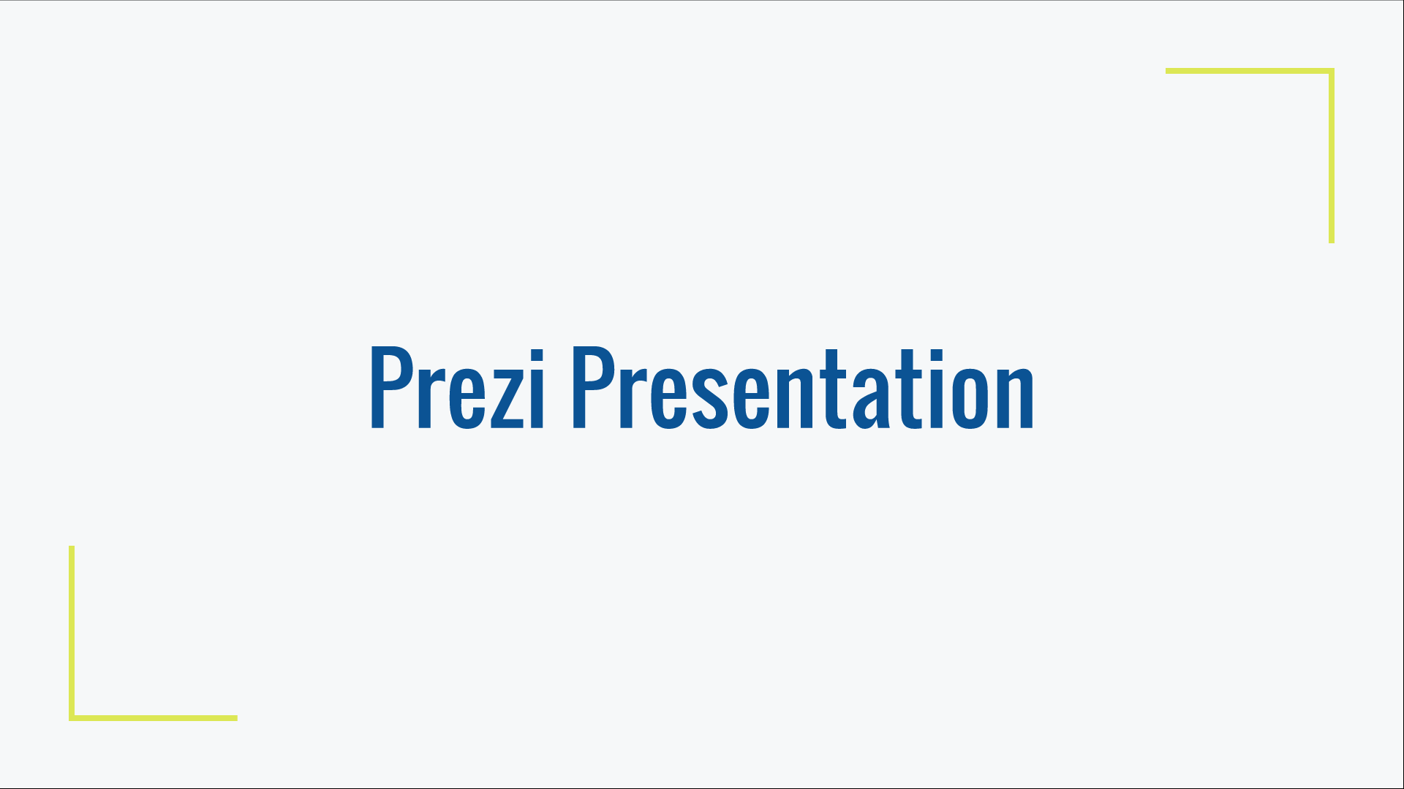
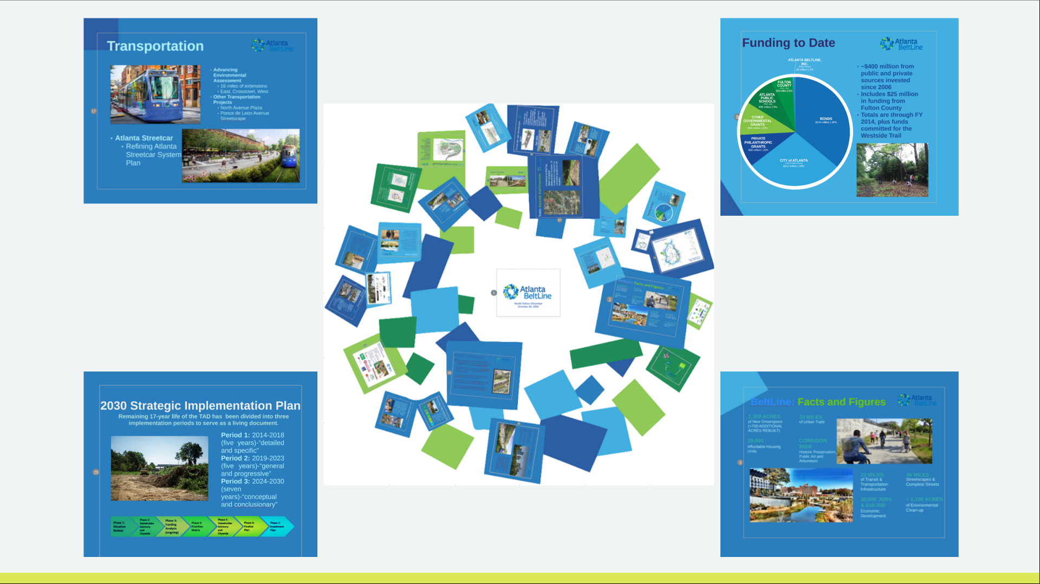
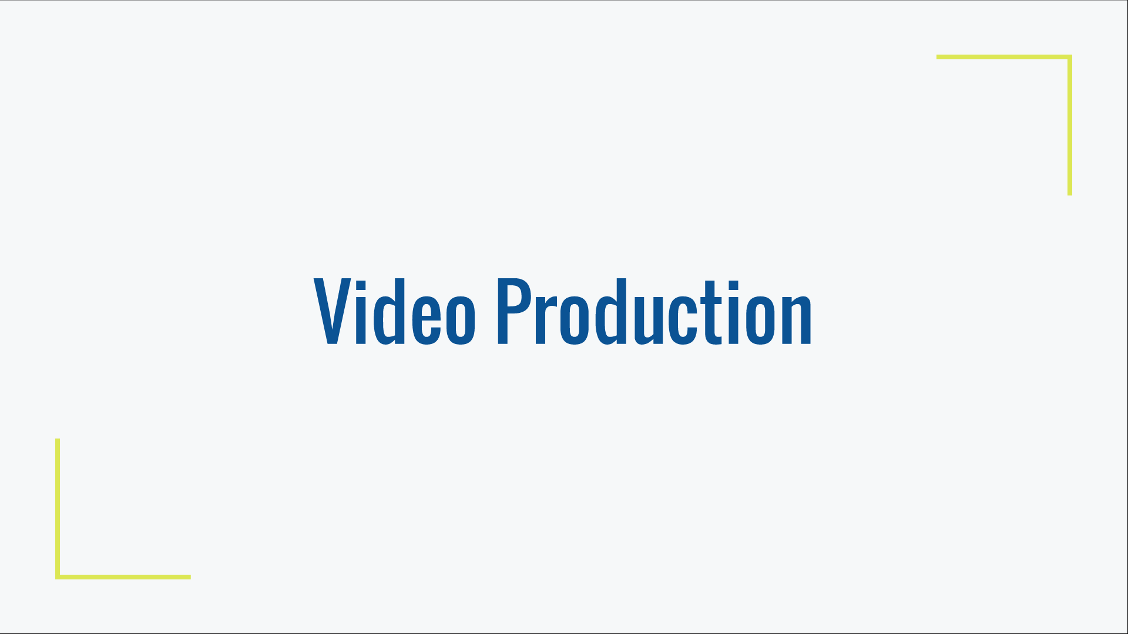
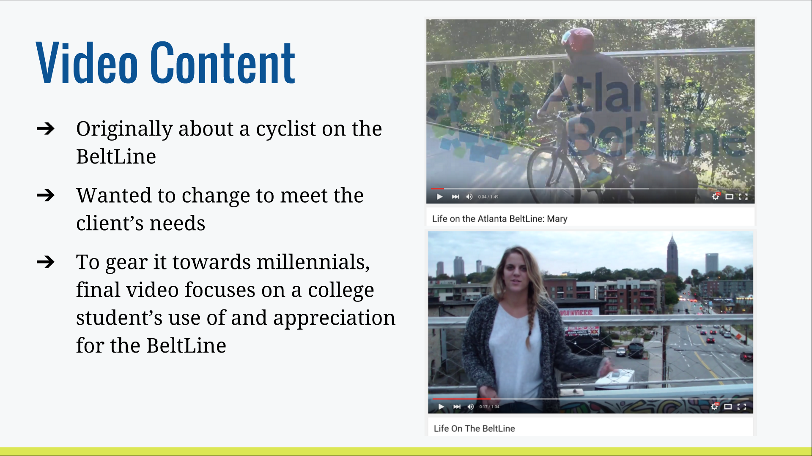
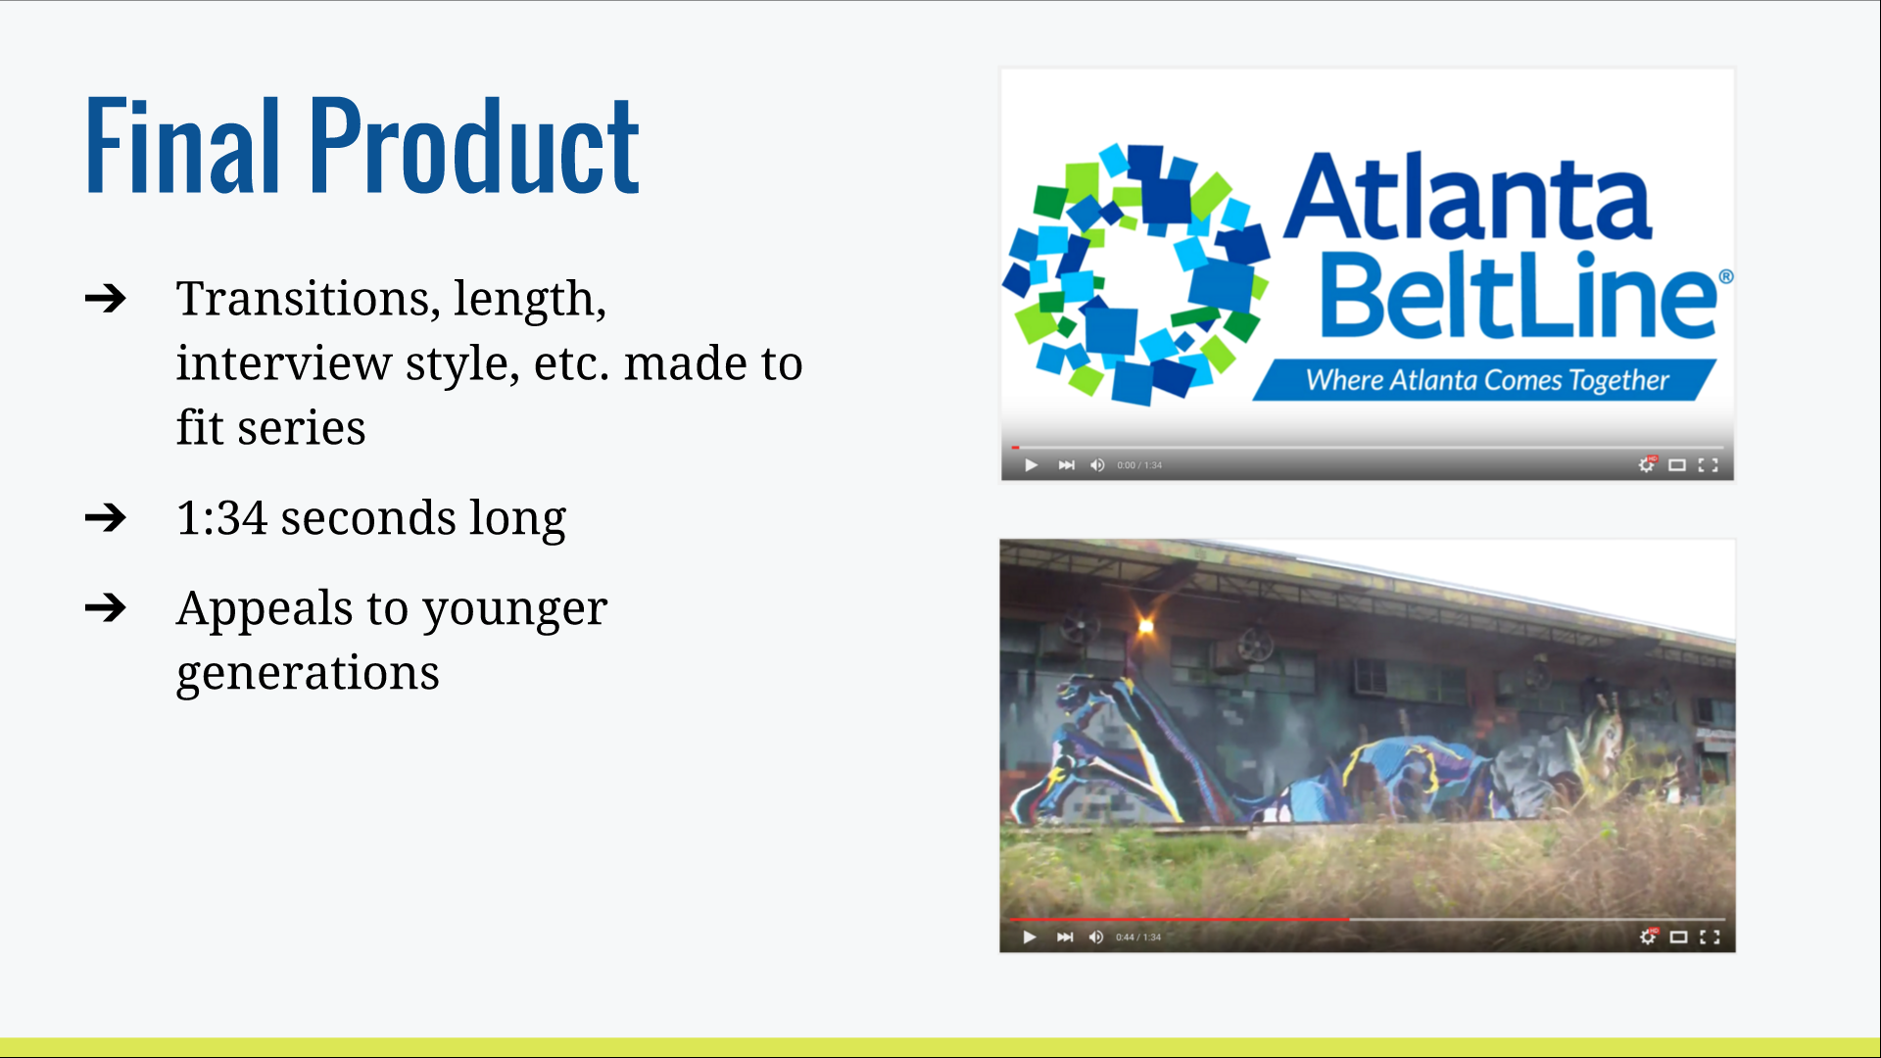
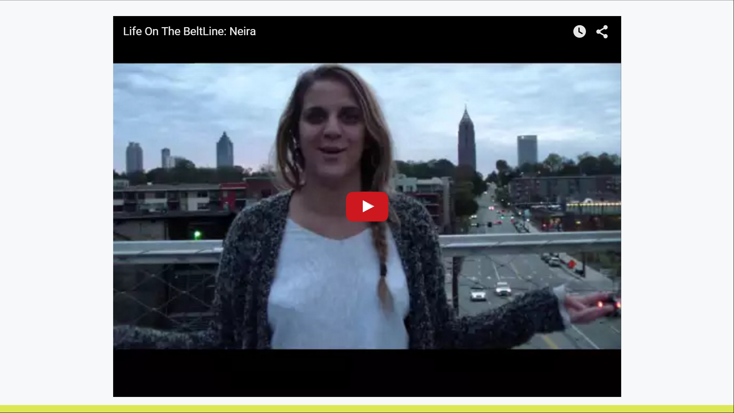
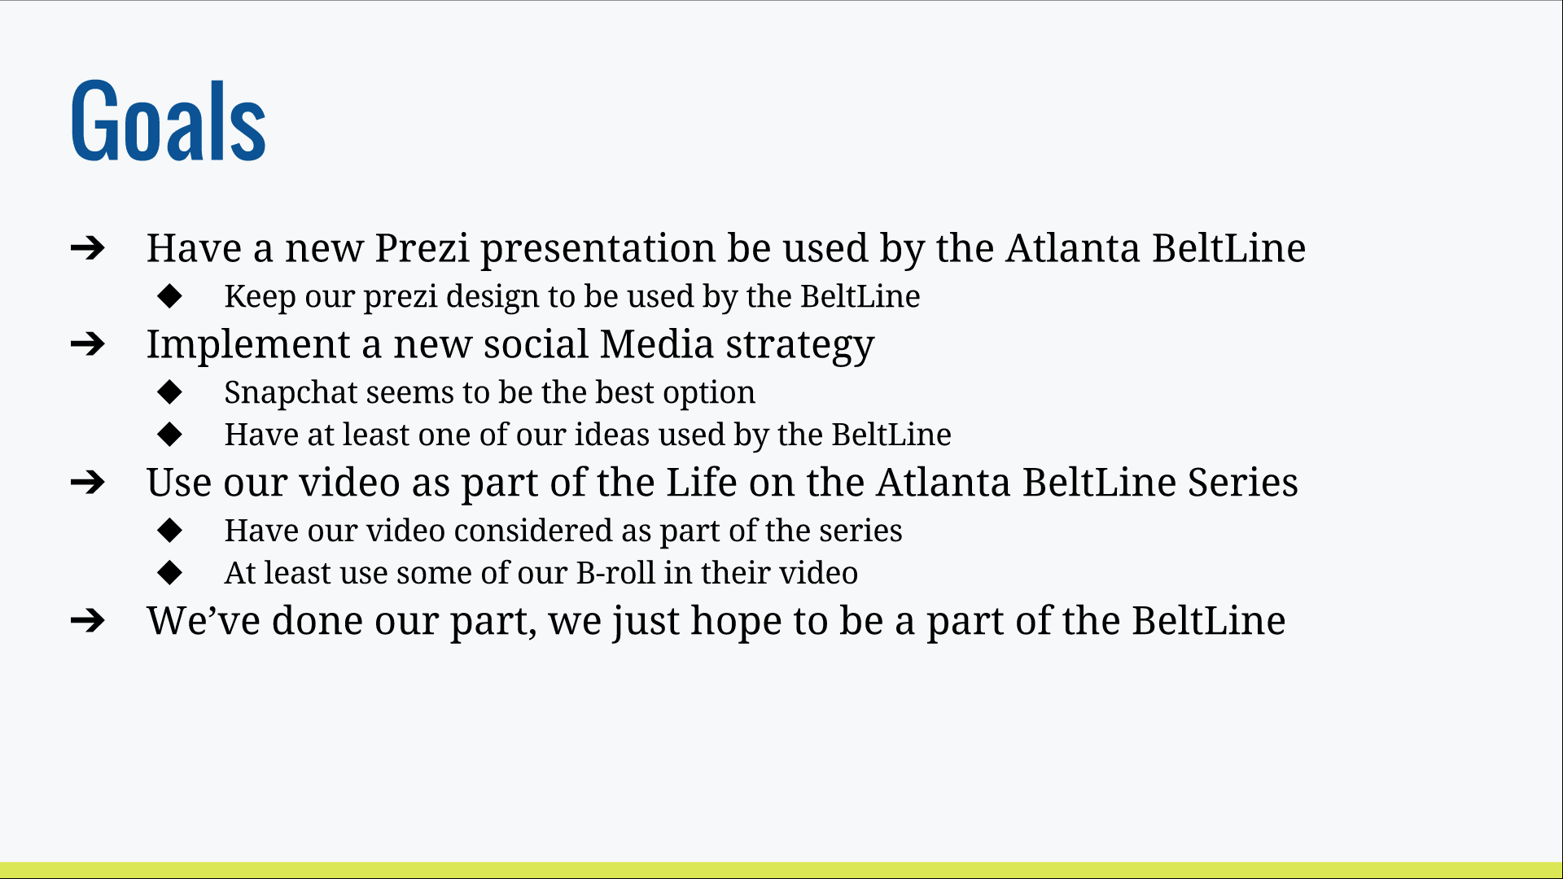

Here is a link to our final presentation: https://docs.google.com/presentation/d/1wKHLQcXmLB6bW2ZpjS4CNfDKiYrrWWHSWaxSkYYJQ_w/edit#slide=id.p

